First Love

Revelation 2:1-7
Key verse 4

“Yet I hold this against you: You have forsaken the love you had at first.”

Introduction

Today’s passage is the first of the seven letters that Jesus told John to write to the seven churches in Asia Minor. In the letter, Jesus first commends the believers in Ephesus for their good deeds. Then he rebukes them for their serious problem and urges them to repent. May God help us to accept and apply the words of Christ to us!

- Read verses 1-3. Who is the sender and who are the recipients of the words to the church of Ephesus? (1) In what aspect was the Ephesian church praised? (2, 3) What can we learn from them?

1-1, Read verses 1-3.

“To the angel of the church in Ephesus write:
These are the words of him who holds the seven stars in his right hand and walks among the seven golden lampstands. 2 I know your deeds, your hard work and your perseverance. I know that you cannot tolerate wicked people, that you have tested those who claim to be apostles but are not, and have found them false. 3 You have persevered and have endured hardships for my name, and have not grown weary.

1-2, Who is the sender and who are the recipients of the words to the church of Ephesus? (1)

“To the angel of the church in Ephesus write: These are the words of him who holds the seven stars in his right hand and walks among the seven golden lampstands.

- The Sender is Jesus Christ. Jesus is the Lord of all churches. These letters show how much Jesus cares about the spiritual condition of his churches.
- Jesus walks among us. He knows what is on our minds. He knows our situations and he cares about us.

- Who are the recipients of the seven letters of Jesus? Each letter is addressed to the “angel” of the church—or the “messenger” of the church (NIV footnotes).
- Some authorities believe that the letters were sent to the spiritual leaders in the church, while others maintain that they were sent to the angels appointed to protect the churches.
- Either way, the words of Jesus are directed to the church of God, that is, all believers.
- And more importantly, the letters are the words of Jesus who holds the seven stars in his right hand and walks among the seven golden lampstands.
- The seven stars are the angels or the messengers of the churches. The seven golden lampstands are the seven churches (1:20).

- Jesus appeared to John in a vision and told him to write letters to the seven churches: to Ephesus, Smyrna, Pergamum, Thyatira, Sardis, Philadelphia and Laodicea (1:11).
- Why seven churches and why these particular ones when there were other churches, some of them bigger and better known (such as Antioch and Corinth)?
- We can find a clue to this question in verse 7, which says, “Whoever has ears, let them hear what the Spirit says to the churches.”
- This statement is repeated at the end of all seven letters. Notice that the Spirit says to the “churches,” not singular but plural.
- In other words, the seven were chosen to represent all churches.
- In the book of Revelation, the number 7 is used for completion, fullness and perfection (e.g., seven stars, seven eyes, seven horns, seven seals, seven trumpets, etc.).
- It is the number of the Holy Spirit. The seven churches represent all churches of Jesus Christ.
- In addition, the seven churches in Asia Minor were chosen probably because their strengths and weaknesses represented those of all churches throughout history--past, present and future.
- Therefore, the messages of Jesus in the letters are directed to not only the churches in Asia Minor in John’s time, but also to all churches in the world throughout history.
- The letters contain Jesus’ commendations, rebukes, encouragements and promises. The contents are very relevant to us today.
- May God help us to have ears to hear so that we may hear what the Spirit says to us!

1-3, In what aspect was the Ephesian church praised? (2, 3)

I know your deeds, your hard work and your perseverance. I know that you cannot tolerate wicked people, that you have tested those who claim to be apostles but are not, and have found them false. 3 You have persevered and have endured hardships for my name, and have not grown weary.

- Ephesus was an important city in the Roman province of Asia.
- It was a great commercial center and a crossroads of the Roman Empire, connecting all her major cities by highways and seaways.
- The city was also known for its worship of the goddess Artemis (or Diana). The great temple of Artemis was larger than two football fields in length.
- It had 127 impressive marble pillars, some of them covered with gold. It was one of the Seven Wonders of the ancient world.

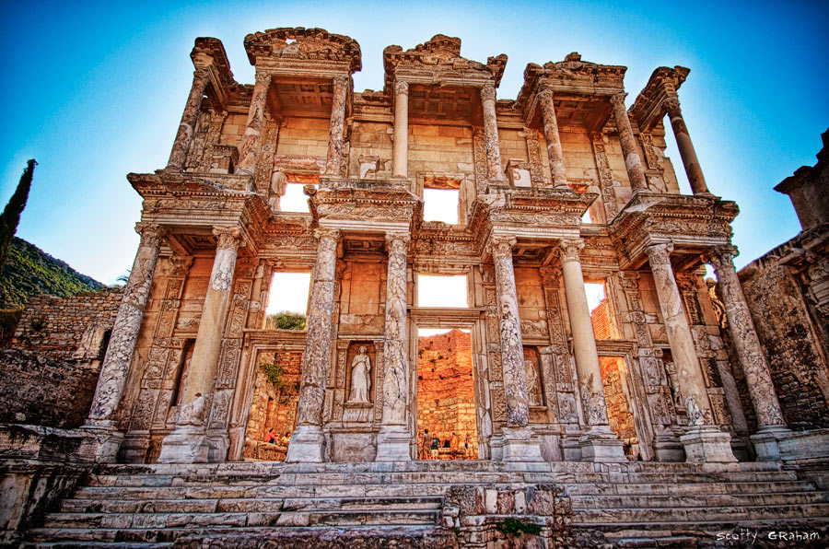

- In this idol-worshiping environment, how did the church in Ephesus please the Lord?
I know your deeds, your hard work and your perseverance. I know that you cannot tolerate wicked people, that you have tested those who claim to be apostles but are not, and have found them false. 3 You have persevered and have endured hardships for my name, and have not grown weary.
- Jesus commends the believers in Ephesus for their deeds. They showed their faith by their actions. Hard work and perseverance characterized their faith.
- They were different from some Christians today who talk, talk, and talk.
- It must not have been easy for the Ephesian believers to live by faith in the midst of an idol worshiping culture.
- They were a minority who lived a holy life among people who loved fun and pleasures.
- They must have been persecuted for not following the trend of their society. But they persevered and endured hardships for Jesus’ name.
- Jesus mentioned their perseverance twice. They did not grow weary. In addition, they did not tolerate wicked people.
- They boldly tested those who claimed to be apostles but were false.
- No doubt they must have studied the word of God diligently with a scholarly attitude in order to develop a sense of spiritual discernment.
- This was important for their faith because there were not only idol-worshipers but many false teachers among them.

1-4, What can we learn from them?

- Our society is not much different from Ephesus in terms of spiritual and moral degradation. Many people worship money and pleasure.
- Ephesus had a huge amphitheater for entertainment. We have many large stadiums devoted to entertainment. We also have many false teachers and false preachers.
- Let us not grow weary as we give fully to the work of the Lord. Let us persevere and endure hardships for Jesus’ name.
- Instead of absorbing any teaching or preaching that we encounter, let us also study the word of God sincerely and diligently so that we can discern false teachers for what they are.

- Read verses 4-5. What was lacking with them? (4) How could they restore their first love? (5) What was Jesus’ warning if they would not repent?

2-1, Read verses 4-5.

Yet I hold this against you: You have forsaken the love you had at first. 5 Consider how far you have fallen! Repent and do the things you did at first. If you do not repent, I will come to you and remove your lampstand from its place.

2-2, What was lacking with them? (4)

4 Yet I hold this against you: You have forsaken the love you had at first.

- The Christians in Ephesus must have been very happy when they first accepted Jesus as their personal Savior. They had been eager to serve Christ.
- They were willing to sacrifice themselves to show their love for Christ. But over time, their love for Christ became cold.
- They no longer loved Jesus with all their hearts as they had done at first. Their love grew cold.

Matthew 24:10-12 reads,
At that time many will turn away from the faith and will betray and hate each other,11 and many false prophets will appear and deceive many people. 12 Because of the increase of wickedness, the love of most will grow cold,

- It is like a marriage life. A couple that has been married for a long time doesn't always have the same thrill of excitement they had when they first dated.
- That excitement has matured into a depth of love that makes it even better than the first love. It is a desirable path.
- But often times couples end up forgetting their first love and come close to the danger of divorce without recovering it.

But I have this against you, that you have left your first love. (NASB-New American Standard Bible)

- The distinction between leaving and losing is important. Something can be lost quite by accident, but leaving is a deliberate act, though it may not happen suddenly.
- Furthermore, when we lose something we don't know where to find it; but when we leave something or walk(drift) away, we know where to find it.

- Let us think about how this church had been pioneered.
- The church of Ephesus was pioneered by Paul (Ac 18:19-21) in his second missionary journey. He spent three years there in his third missionary journey, focusing on discipleship training in the lecture hall of Tyrannus (Ac 19).
- The church began as a humble ministry. The believers resisted the popular culture of the city, known for its sexual immorality and the worship of the goddess Artemis.
- Their number was small but their influence was great. Those who used to practice magic burned their books.
- The silversmiths who used to make money selling trinkets of the goddess Diana lost their source of income. But now the church grew and became large.
- And the second-generation believers seemed to have been influenced by the culture of the city. They lost their purity and love for Christ.
- They compromised with the world. They were busy with various church activities, but lacked a deep love for Christ.
- Many activities that are not motivated to please the Lord are meaningless before God, no matter how impressive they may be.
- To the eyes of people, their church was vibrant with many impressive programs. There was always something going on in the church.
- Though they had left their first love, everything looked great on the outside.
- Imagine, if you would have attended a service of the church at Ephesus, you might have thought, "They are doing so much, and they really guard the truth."
- But to Jesus, the most important thing was missing--their love.
- They had forsaken their first love. They didn’t know that hard work was not a substitute for love.
- We should work hard for Jesus out of our love for him. But we should not be mistaken to think that keeping ourselves busy means that we love Jesus.

- The Ephesian church was a doctrinally pure church. Sometimes a focus on doctrinal purity may make a congregation cold and intolerant of diversity.
- Our relationship with our Lord Jesus can get cold if we take him for granted and neglect our personal time with him because of our busy daily life.
- We tend to lose our first love if we focus on ourselves or what we have rather than the Lord.
- We lose our enthusiasm when we forget the grace of salvation and depend on ourselves.
- When you were first saved, how enthusiastic and excited were you to meet Jesus personally and invite others to Jesus?
- No doubt you were happy to sing praises of him, study his word with an eager, learning mind, and share your personal testimony with others.
- You were happy to live for his name’s sake. But over time we all experience a decline in our zeal for Christ.
- Things tend to become routine. We still love Jesus, but the fire in us does not burn as intensely as it did before.

2-3, How could they restore their first love? (5)

Consider how far you have fallen! Repent and do the things you did at first. If you do not repent, I will come to you and remove your lampstand from its place.

- “Remember therefore from where you have fallen” (NKJV).
- Remember how you used to spend time in His Word? Remember how you used to pray? Remember the joy in getting together with other Christians? Remember how excited you were about telling others about Jesus?

- To restore the sparkle of our love for Christ, we must first remember the joy and gratitude we had when we first met Him.
- And we must repent instead of blaming others or despairing or rationalizing. We must learn to accept the personal responsibility for our actions.
- To repent is to admit our wrong, turn away from our sinful ways and walk with Christ.
- For instance, the prodigal son in Luke 15 said, “I will set out and go back to my father and say to him: Father, I have sinned against heaven and against you”

- Finally, we must do what is right in order to restore our first love. Feeling sorry about what happened is not enough.
- We must bear the fruit of our repentance, that is, we must show our repentance by doing what is right before God.
- He wants us to obey his words. In John 14:15 Jesus says, “If you love me, you will do what I command.”

2-4, What was Jesus’ warning if they would not repent?

If you do not repent, I will come to you and remove your lampstand from its place.

- This was a very serious matter. Jesus warned them that if they did not repent, they would lose the main function of the church, that is, to keep the lamp of God burning for the people around them.
- Jesus told them that he would come and remove their lampstand, if they did not repent.

- Read verses 6-7. What did they hate? (6) Who were the Nicolaitans? (14, 15) What will be given to those who are victorious? (7) How can we be victorious to the end?

3-1, Read verses 6-7.

6 But you have this in your favor: You hate the practices of the Nicolaitans, which I also hate. 7 Whoever has ears, let them hear what the Spirit says to the churches. To the one who is victorious,I will give the right to eat from the tree of life, which is in the paradise of God.

3-2, What did they hate? (6)

6 But you have this in your favor: You hate the practices of the Nicolaitans, which I also hate.

- Jesus told the Ephesians that they still had some good in them—they hated the practices of the Nicolaitans.

3-3, Who were the Nicolaitans? (14, 15)

14 Nevertheless, I have a few things against you: There are some among you who hold to the teaching of Balaam, who taught Balak to entice the Israelites to sin so that they ate food sacrificed to idols and committed sexual immorality. 15 Likewise, you also have those who hold to the teaching of the Nicolaitans.

- The Nicolaitans promoted the Gnostic ideas and tempted many believers to compromise with the world.
- Instead of holding on to the teachings of Jesus, some of them held to the teachings of Balaam and the Nicolaitans.
- They abandoned the word of God and turned to false teachings. The story of Balaam and Balak is found in Numbers 22-25.
- Some Bible scholars believe that they were the followers of Nicolas who had been one of the seven deacons listed in Acts 6, but later abandoned his faith to teach the Gnostic ideas.
- These people abused the grace of Jesus by teaching people to use the freedom in Christ to indulge in sin with impunity.
- Their doctrine was the doctrine of compromise. Following the Gnostic ideas, they taught the separation of spirit and body.
- They not only taught that sexual immorality was okay but encouraged them to practice it.
- We can see why Jesus hated their practices. Hate is a strong word. But Jesus commended the Ephesians for hating the practices of the Nicolaitans.
- He said he also hated their practices. To overcome the temptation to compromise with the world, we must have a strong resolve to resist.
- We must hate it. If we gave in just a little bit, we would be in the middle of it before we know it.
- We must hate the practices of this evil world. We must hate compromise. We learn here that we should hate what our Lord hates.
- We must learn to say no to a compromising life, instead of saying, “It’s not too bad” or “It won’t hurt my faith.”

3-4, What will be given to those who are victorious? (7)

Whoever has ears, let them hear what the Spirit says to the churches. To the one who is victorious,I will give the right to eat from the tree of life, which is in the paradise of God.

- We should not rationalize our sinful deeds. We need to restore our personal relationship with Christ through our personal struggle with the word of God and prayer.
- We should have ears to hear the word of Christ.
- Jesus gives a wonderful promise that to the one who is victorious in this battle, he will give the right to eat from the tree of life, which is preserved for us in the paradise of God.

3-5, How can we be victorious to the end?

- Instead of relying on our own wits and wisdom, we humbly rely on the guidance of the Holy Spirit who is the counselor for us to be led into the truth always.
- The Holy Spirit leads us to righteousness, sin, and judgment(John 16).
- May the Lord help us to be led with the Spirit of truth in these confusing times so that we may be victorious to the end.

Conclusion

Jesus praised the Ephesian believers for their good deeds: their hard work, perseverance, spiritual discernment, and refusal to compromise with the Nicolaitans. But he held one critical thing against them: they had forsaken their first love. Jesus urged them to remember, repent, and return to their first love. May God help us to remember the grace and love of our Lord Jesus! May God help us repent and return to our first love so that everyday is like the first time we met Christ!

One word: First Love!

