LOOK, I AM COMING SOON

Revelation 22:1-21
Key verse 12
“Look, I am coming soon! My reward is with me, and I will give to each person according to what they have done.

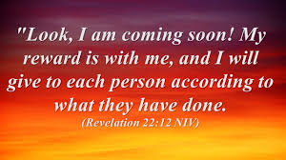
Introduction
We learned in Luke 2 that God fulfilled His promise to send His One and Only Son, Jesus as the Messiah. Two faithful prophet and prophetess were privileged to see Him in the temple. Now we are waiting for Jesus’ second coming. But in reality when we hold onto gospel truth, we will be persecuted by God’s enemies. We are tempted to fall into fear and compromise. This spiritual warfare seems endless. But the book of Revelation tells us that Christ, the Lamb, will destroy all of God’s enemies completely and eternally. Furthermore, he will create a new heaven and new earth where he dwells with his people forever. This will surely happen when Jesus comes again. Jesus’ repeated his promise, “Look, I am coming soon!” May the Lord help us to renew our faith in Jesus and His 2nd coming!

- Read verses 1-9. Describe the promised city. (1-5) What did the angel say to John? (6-7) How did the angel correct John? (8-9)

1-1, Read verses 1-9.
Then the angel showed me the river of the water of life, as clear as crystal, flowing from the throne of God and of the Lamb 2 down the middle of the great street of the city. On each side of the river stood the tree of life, bearing twelve crops of fruit, yielding its fruit every month. And the leaves of the tree are for the healing of the nations. 3 No longer will there be any curse. The throne of God and of the Lamb will be in the city, and his servants will serve him. 4 They will see his face, and his name will be on their foreheads. 5 There will be no more night. They will not need the light of a lamp or the light of the sun, for the Lord God will give them light. And they will reign for ever and ever.

John and the Angel
6 The angel said to me, “These words are trustworthy and true. The Lord, the God who inspires the prophets, sent his angel to show his servants the things that must soon take place.”
7 “Look, I am coming soon! Blessed is the one who keeps the words of the prophecy written in this scroll.”
8 I, John, am the one who heard and saw these things. And when I had heard and seen them, I fell down to worship at the feet of the angel who had been showing them to me. 9 But he said to me, “Don’t do that! I am a fellow servant with you and with your fellow prophets and with all who keep the words of this scroll. Worship God!”

1-2, Describe the promised city. (1-5)
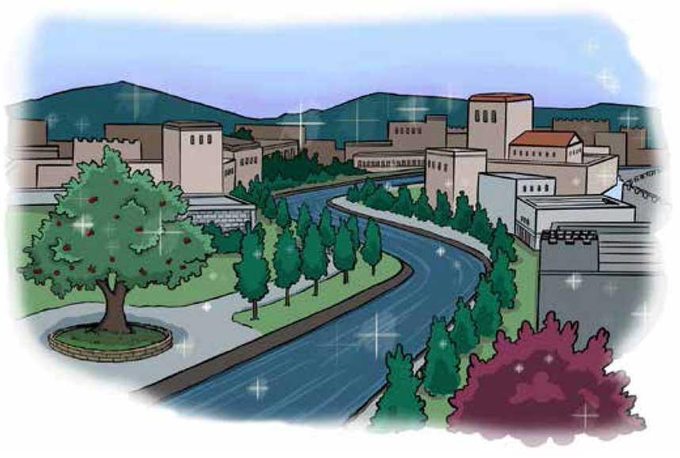
Then the angel showed me the river of the water of life, as clear as crystal, flowing from the throne of God and of the Lamb 2 down the middle of the great street of the city. On each side of the river stood the tree of life, bearing twelve crops of fruit, yielding its fruit every month. And the leaves of the tree are for the healing of the nations. 3 No longer will there be any curse. The throne of God and of the Lamb will be in the city, and his servants will serve him. 4 They will see his face, and his name will be on their foreheads. 5 There will be no more night. They will not need the light of a lamp or the light of the sun, for the Lord God will give them light. And they will reign for ever and ever.

- Although it’s appearances are glorious, what counts is that the curse is gone. Since the fall, man and creation have lived under curse in Genesis 3:16-19.
- The throne of God and of the Lamb will be in the city. It is a throne of righteousness and of grace.
- His servants shall serve Him. Interestingly, Heaven will be a place of work and service for God’s people. But it is a blessed service rather than an arduous toil.
- They shall see His face. Heaven will be a place where God’s people see His face, a place of intimate, face to face fellowship with God.
- Moses was denied the privilege of seeing God face to face (Exodus 33:20-23), but everyone in heaven shall see His face. Praise the Lord!
- We shall see His face. We shall see Him literally and physically, with their risen bodies, actually look into the face of Jesus.
- Our personal knowledge about God and Jesus will be complete to the full degree. We now know something about God. But we will know Him in great detail.
- Apostle Paul pointed out that for now we see in a mirror, dimly. On that day there will be nothing that obscures our vision of Jesus.
- We will see Jesus clearly because sin is done away with. We will see Jesus clearly because care and worry are gone and idols are done away with.
- His name shall be on their foreheads. Heaven will be a place where God’s people will forever be clearly identified with their God without an identity crisis.
- There shall be no more night there. Heaven will be a place where the darkness of this age will be forever gone.
- The light is not artificial, even reflection from the sun Rather God Himself is the very light. Jesus says, “I am the light of the world”
- They shall reign forever and ever. Heaven will be a place where God’s people enjoy an eternal reign. It will never end.

1-3, What did the angel say to John? (6-7)
The angel said to me, “These words are trustworthy and true. The Lord, the God who inspires the prophets, sent his angel to show his servants the things that must soon take place.”
7 “Look, I am coming soon! Blessed is the one who keeps the words of the prophecy written in this scroll.”
- These words are faithful and true. The angel that showed John all this reminds John that it is true. John is assured that it is in fact faithful and true.
- The things must shortly take place. “Look, I am coming soon!” Jesus Himself breaks in here.
- The early church expected Jesus’ return soon. But God wants to keep all generations expectant, watching, and ready for His return any time.
- Blessed is he who keeps the words of the prophecy written in this scroll. This blessing reminds us that prophecy gives us a word to keep.
- The main intent of prophecy is to lead us to trust and obey God humbly and absolutely, and apply His truth to the way we live instead of discussing merely.

1-4, How did the angel correct John? (8-9)

I, John, am the one who heard and saw these things. And when I had heard and seen them, I fell down to worship at the feet of the angel who had been showing them to me. 9 But he said to me, “Don’t do that! I am a fellow servant with you and with your fellow prophets and with all who keep the words of this scroll. Worship God!”

- John was overwhelmed and bowed before an angel in worship. In the same way, the angel reminded John that only God is to be worshipped.

Read verses 10-15. What did the angel tell John to do? (10-11) What is Jesus’ repeated message and what will he do? (7, 12) What is Jesus’ “I AM” statement? (13)? Who will be blessed and how (14)? How are those on the outside described (15)?

2-1, Read verses 10-15.

Then he told me, “Do not seal up the words of the prophecy of this scroll, because the time is near. 11 Let the one who does wrong continue to do wrong; let the vile person continue to be vile; let the one who does right continue to do right; and let the holy person continue to be holy.”
12 “Look, I am coming soon! My reward is with me, and I will give to each person according to what they have done. 13 I am the Alpha and the Omega, the First and the Last, the Beginning and the End.
14 “Blessed are those who wash their robes, that they may have the right to the tree of life and may go through the gates into the city. 15 Outside are the dogs, those who practice magic arts, the sexually immoral, the murderers, the idolaters and everyone who loves and practices falsehood.

2-2, What did the angel tell John to do? (10-11)

Then he told me, “Do not seal up the words of the prophecy of this scroll, because the time is near. 11 Let the one who does wrong continue to do wrong; let the vile person continue to be vile; let the one who does right continue to do right; and let the holy person continue to be holy.”

- A warning is given by the angel. Do not seal the words of this prophecy of this scroll, because the time is near.
- Because Jesus is coming so suddenly, there won’t be time for change. There will be no time for last minute repentance, but there is time now.
- If what you have read in the words of warnings of Revelation hasn’t changed you, there isn’t much hope either.

2-3, What is Jesus’ repeated message and what will he do? (7, 12)
“Look, I am coming soon! My reward is with me, and I will give to each person according to what they have done.

2-4, What is Jesus’ “I AM” statement? (13)?
13 I am the Alpha and the Omega, the First and the Last, the Beginning and the End.

My reward is with Me. Jesus will give to everyone according to his work. But it does not mean that we are saved by our works. Living by faith produces works.

It is the fruit of a man’s life which indicates what he really believes. Doing His commandments does not earn us eternal life.

But it is evidence that we have been granted eternal life. Besides, there is an inherent blessing in doing His commandments, because they are good for us.

I am the Alpha and the Omega, the Beginning and the End, the First and the Last. He reminds us just who He is.

If we really know and understand who Jesus is, we will not have any trouble being ready for His return.

The title the First and the Last is also irrefutable proof that Jesus is Yahweh, the Lord. I, the Lord, am the first; and with the last I am He. (Isaiah 41:4)

2-4, Who will be blessed and how (14)?
14 “Blessed are those who wash their robes, that they may have the right to the tree of life and may go through the gates into the city.

2-5, How are those on the outside described (15)?
15 Outside are the dogs, those who practice magic arts, the sexually immoral, the murderers, the idolaters and everyone who loves and practices falsehood.

- Blessed are those who washed their robes. They have the right to the tree of life. And they may go through the gates to the city. What a glorious moment!
- Outside are the dogs, those who practice magic arts, the sexual immoral, the murderers, the idolaters, and everone who loves an practices falsehood.

- Read verses 16-21. For whom was Jesus’ testimony given? (16a) What does verse 16b show about Jesus? What do the Spirit and the bride say? (17) Why should no one add to or subtract from Jesus’ words? (18-19) What are John’s final greetings? (20-21)

3-1, Read verses 16-21.
“I, Jesus, have sent my angel to give you[a] this testimony for the churches. I am the Root and the Offspring of David, and the bright Morning Star.”
17 The Spirit and the bride say, “Come!” And let the one who hears say, “Come!” Let the one who is thirsty come; and let the one who wishes take the free gift of the water of life.
18 I warn everyone who hears the words of the prophecy of this scroll: If anyone adds anything to them, God will add to that person the plagues described in this scroll. 19 And if anyone takes words away from this scroll of prophecy, God will take away from that person any share in the tree of life and in the Holy City, which are described in this scroll.
20 He who testifies to these things says, “Yes, I am coming soon.”
Amen. Come, Lord Jesus.
21 The grace of the Lord Jesus be with God’s people. Amen.

3-2, For whom was Jesus’ testimony given? (16a)
“I, Jesus, have sent my angel to give you[a] this testimony for the churches.

- I, Jesus, have sent My angel to testify to you. Jesus authenticates this testimony for the churches. His words in this book are all true!
- Thus the very God of all inspiration, and of all inspired men, reiterates and affirms the highest authority for all that is herein written.
- The Book of Revelation is written to the churches. This book is not a private affair, knowable only by an elite, rather it is for all believers.
- It’s also worth noting that this is the first reference to the church since the letters to the seven churches in Revelation 2-3.

3-3, What does verse 16b show about Jesus?
I am the Root and the Offspring of David, and the bright Morning Star.”

- The Root and offspring of David. This is a precious Messianic title. Isaiah 11:1 reads, “A shoot will come up from the stump of Jesse; from his roots a Branch will bear fruit.”
- It shows that Jesus is both the Creator(Root, Originator) of King David and His descendent. (Matthew 22:41-46)
- The Bright Morning Star. This is another Messianic title from the Old Testament (Numbers 24:17) and the New Testament (Revelation 2:28).
- Just as the Morning Star (generally held to be the planet Venus) shines and welcomes the new day, so does Jesus.
- Why is Venus called “the Morning Star” or “the Evening Star?” Venus shines so brightly that it is the first “star” to appear in the sky after the Sun sets, or the last to disappear before the Sun rises. Its orbital position changes, thus causing it to appear at different times of the night throughout the year.

3-4, What do the Spirit and the bride say? (17)
17 The Spirit and the bride say, “Come!” And let the one who hears say, “Come!” Let the one who is thirsty come; and let the one who wishes take the free gift of the water of life.

- Come! Who can come? The one who hears can come to Jesus, but they can’t come unless they hear.
- And the one who is thirsty can come to Jesus, but they can’t come unless they feel their thirst.
- And the one who wishes can come, but they can’t come unless God works in their heart to desire Him.
- Whoever desires, let him take the free gift of the water of life. This is an open invitation to receive salvation from Jesus.
- He will not exclude anyone who comes to Him. An invitation is both an opportunity and a responsibility. If we decline it, we will be blamed for it.

3-5, Why should no one add to or subtract from Jesus’ words? (18-19)
18 I warn everyone who hears the words of the prophecy of this scroll: If anyone adds anything to them, God will add to that person the plagues described in this scroll. 19 And if anyone takes words away from this scroll of prophecy, God will take away from that person any share in the tree of life and in the Holy City, which are described in this scroll.

- If anyone adds... if anyone takes away. This means that there is a high price to pay for tampering with this Book specifically, and the Scriptures in general.

3-6, What are John’s final greetings? (20-21)
20 He who testifies to these things says, “Yes, I am coming soon.”
Amen. Come, Lord Jesus.
21 The grace of the Lord Jesus be with God’s people. Amen.

- He who testifies to these things says, “Yes, I am coming soon.” Amen. Come, Lord Jesus! The grace of our Lord Jesus Christ be with you all. Amen.
- Surely I am coming quickly. To the very end, the Book of Revelation emphasizes readiness and watchfulness.
- If we miss this practical lesson from the Book of Revelation – the lesson of readiness – then we miss the essential message(SPIRIT) of the book!!
- The grace of our Lord Jesus Christ be with you all(God’s people). Amen. The book (and the Bible) ends with a word of grace, and grace for all.

Conclusion
We have a simple question like, “do we desire Jesus and His salvation and His second coming?” Then come. Can each of us say, “Now, Lord, I desire to be saved, give me a new heart; I desire to give up my sins; I desire to be a follower, I desire to believe and desire to obey. But I have no strength to do this. I have the desire, give me the power.” If this is our desire, then we are freely invited to come, if we are only willing. There is no barrier between us and Jesus except our stubborn will. “Let him take the water of life freely” When we desire, when we come, then we must take. All of this world’s religion can be summed up in the idea that you must bring something to give unto the gods. The essence of Christianity is summed up in the idea that God invites us to take the water of life freely. We can’t bring anything to save or justify or commend ourselves before God, but we can take the salvation He offers. Praise the Lord! May the Lord help us to be more than willing daily so that we may welcome Jesus anytime as good and faithful servants in serving campus mission and world mission continually!
One word: Come Lord!

