MAKING A BINDING AGREEMENT

Nehemiah 9:38-10:39
Key Verse 9:38

“In view of all this, we are making a binding agreement, putting it in writing, and our leaders, our Levites and our priests are affixing their seals to it.”

Introduction

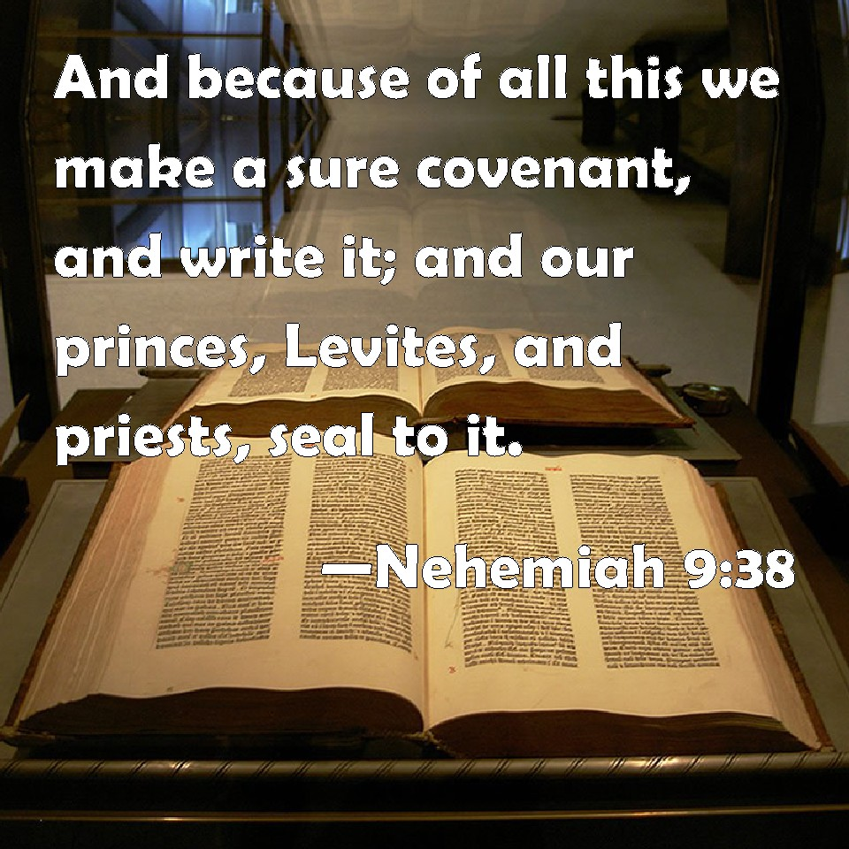

After confessing all their sins in chapter 9, in this chapter 10, the Israelites made a binding agreement to observe the Law regarding marriage, Sabbath and offering for temple. It was their willing decision to live new life as God’s holy people. They didn’t just confess words of repentance but took practical actions to make their repentance real and restore their right relationship with God. We can think about what kind decisions we should make and what kind practical actions we need to take to live as God’s holy people.

1. Read verses 9:38-10:29. What did the people do after confessing all their sins? (38a) Who affixed their seal on a binding agreement? (38b, 10:1-27) Who were the rest of the people who joined and agreed too?(10:28-29)

1-1. Read verses 9:38-10:29.

1-2. What did the people do after confessing all their sins? (38a)

“In view of all this, we are making a binding agreement, putting it in writing.

· They made binding agreement, putting it in writing.
· They made the agreement because they had realized they had become so miserable because they disobeyed God’s command.
“Our kings, our leaders, our priests and our ancestors did not follow your law; they did not pay attention to your commands or the statutes you warned them to keep.”(9:34)
- They knew the cause of their failure and what they needed to do to restore relationship with God and His blessing.
- The true repentance is not just being sorrowful for our sins but coming back to God by recommitting ourselves to his words and commands.
- The real fruit of repentance is to make decision to live by obeying God’s words and taking practical action accordingly.
- “putting it in writing”- It could be good idea to write down our decision for change and share it with others to confirm our repentance and decision.

1-3. Who affixed their seal on a binding agreement? (38b, 10:1-27)

our leaders, our Levites and our priests are affixing their seals to it.”

· Leaders(1a, 14-27), Levites(9-13), priests(1b-8) were political and spiritual leaders of Israel people.
- They were representatives of the people. It means all people participated in the agreement.
- Leaders set a good example first to leave their sins and customs of the world and live a holy life before.

· Affixed their seal – it was the sign of their decision to live new life committing themselves to the words of God leaving behind their past life.
- They declared their decision publicly by sealing the agreement.
- It was their decision to come back to God’s command that they had broken for a long time.
- Their decision to live according to the word of God was the true restoration of their spiritual life.

1-4. Who were the rest of the people who joined and agreed too?(10:28-29)

The rest of the people—priests, Levites, gatekeepers, musicians, temple servants and all who separated themselves from the neighboring peoples for the sake of the Law of God, together with their wives and all their sons and daughters who are able to understand—²⁹ all these now join their fellow Israelites the nobles, and bind themselves with a curse and an oath to follow the Law of God given through Moses the servant of God and to obey carefully all the commands, regulations and decrees of the Lord our Lord.

· The rest of people : priests, Levites, gatekeepers, musicians, temple servants, and all who separated themselves from the neighboring people, people who joined fellow Israelites.
· They were also the heads of families who signed for the agreement.
· They bound themselves with a curse and oath to follow the Law of God and to obey carefully all the commands, regulations and decrees of the LORD our Lord

- They signed the agreement with the oath that they would receive curse if they would break the agreement.
- They made so serious decision with serious attitude even binding themselves with a curse before God.
- Our decision for repentance should be serious not casual. If our decision is casual we could go back to our old sin easily. We should make serious decision before God to make real change for our spiritual life.

2. Read verses 30-34. What did they promise? (30) What did they decide about the Sabbath and every seventh year? (31) What responsibility did they assume in serving the house of God? (32-33) How did they determine who brought the contributions of wood? (34)

2-1. Read verses 30-34.

“We promise not to give our daughters in marriage to the peoples around us or take their daughters for our sons.³¹ “When the neighboring peoples bring merchandise or grain to sell on the Sabbath, we will not buy from them on the Sabbath or on any holy day. Every seventh year we will forgo working the land and will cancel all debts.³² “We assume the responsibility for carrying out the commands to give a third of a shekel^{[b]} each year for the service of the house of our God:³³ for the bread set out on the table; for the regular grain offerings and burnt offerings; for the offerings on the Sabbaths, at the New Moon feasts and at the appointed festivals; for the holy offerings; for sin offerings^{[c]} to make atonement for Israel; and for all the duties of the house of our God.³⁴ “We—the priests, the Levites and the people—have cast lots to determine when each of our families is to bring to the house of our God at set times each year a contribution of wood to burn on the altar of the Lord our God, as it is written in the Law.

2-2. What did they promise? (30)

“We promise not to give our daughters in marriage to the peoples around us or take their daughters for our sons.

· They promised not to practice intermarriage with the people who didn’t belong to Israelites according to God’s command.
· They had made an agreement not to marry people who didn’t belong to Israelite earlier through Ezra’s leadership (Ezra 9,10), but they might resume the intermarriage.
· Stopping intermarriage was necessary to protect Israelite from the evil and corrupted influence from people outside and keep them pure as God’s holy people.

- God warned the danger of intermarriage “Be careful not to make a treaty with those who live in the land; for when they prostitute themselves to their gods and sacrifice to them, they will invite you and you will eat their sacrifices. ¹⁶ And when you choose some of their daughters as wives for your sons and those daughters prostitute themselves to their gods, they will lead your sons to do the same. (Exodus 34:16)

· It is so important to build up house church through biblical marriage to protect us from corrupted influence of the world and the community of God’s people.
· It is also important to be careful about having any kind relationship with those who don’t serve God being aware of their influence.
· We should be careful to protect ourselves from the corrupt influence of the world so that we may keep ourselves holy before God.

2-3. What did they decide about the Sabbath and every seventh year? (31)
“When the neighboring peoples bring merchandise or grain to sell on the Sabbath, we will not buy from them on the Sabbath or on any holy day. Every seventh year we will forgo working the land and will cancel all debts

· They decided to stop buying things and doing business on Sabbath to observe the days to be holy according to God’s command.
- Observing Sabbath was one of the most important commands (Exodus 20:8-11). God gave the command for them to keep close relationship with him through worship and thanksgiving on the holy day of Sabbath.
- By violating the Sabbath, they neglected worshipping God and filled their heart with desire for money and things of this world.
- Keeping Sabbath holy was the basic for their relationship with God but when they broke the basic duty to keep it, their whole spiritual life got broken down.
- It is so crucial for us to keep the Lord’s Day holy for our spiritual life.
· They also decided to forgo working the land (Ex23:10,11 ; Lev 25:2-7)
· Cancel all debts every seventh year (Dt 15:1-3)
- God wanted his people to be generous toward their brothers who were in need through the law and build up loving community. But they didn’t obey the law. Rather they exploited their brothers even charging high interest. It caused serious conflicts among them breaking the unity.
- People in the world build up relationship based on self interest. But God’s people should build up relationship based on care, love, and generosity so that they may keep unity and loving relationship in the Lord.

2-4. What responsibility did they assume in serving the house of God? (32-33)

³² “We assume the responsibility for carrying out the commands to give a third of a shekel each year for the service of the house of our God:³³ for the bread set out on the table; for the regular grain offerings and burnt offerings; for the offerings on the Sabbaths, at the New Moon feasts and at the appointed festivals; for the holy offerings; for sin offerings to make atonement for Israel; and for all the duties of the house of our God

· They restored the responsibilities in serving the house of God that they had neglected for a long period of time.
- Temple was the center of their spiritual life. When they maintained the temple well following God’s law, their spiritual condition was good and they were blessed. But when they neglected the temple service, they got corrupted getting away from God.
- After coming back from exile, the Israelites rebuilt the temple but later they didn’t do offering for temple maintenance. As a result, Levites and priests who served the temple left their duty and the temple was abandoned.

- To restore their responsibility and maintain the temple properly they decided to do three things;

1) Collecting offering (a third of shekel)
2) offering first born for priest
3) offering tithe for Levites.

- They decided to offer a third of a shekel for the temple.
- Even though their economic situation was difficult, they still wanted to do offering to manage the temple.
- Just as Temple was the center of their spiritual life, church is the center of our spiritual life. It is necessary to do proper offering to maintain the church well. When church is not maintained well, our spiritual life can’t be maintained well.

2-5. How did they determine who brought the contributions of wood? (34)

“We—the priests, the Levites and the people—have cast lots to determine when each of our families is to bring to the house of our God at set times each year a contribution of wood to burn on the altar of the Lord our God, as it is written in the Law.

· They casted lots to determine the turns to bring a contribution of wood to the house of God.
· God commanded the Israelite that the fire must be kept burning on the altar all the time.

¹² The fire on the altar must be kept burning; it must not go out. Every morning the priest is to add firewood and arrange the burnt offering on the fire and burn the fat of the fellowship offerings on it. ¹³ The fire must be kept burning on the altar continuously; it must not go out. (Lev 6:12-13)

- To keep the altar burning with fire they need huge amount of wood.
- They shared burden to provide the wood taking turns. And the burden was shared fairly. It is important for us to share burden to serve God’s work together and let all people participate in serving the work.
- God also wants our love and service for him to keep burning all the time just as the altar kept burning with fire all the time.

3. Reads 35-39. What did they decide about their firstborn and the firstfruits of the ground? (35-37a) What did they decide about tithes? (37b-38) What else did the people of Israel bring to the storerooms in the temple and why? (39)

3-1. Reads 35-39.

“We also assume responsibility for bringing to the house of the Lord each year the firstfruits of our crops and of every fruit tree.³⁶ “As it is also written in the Law, we will bring the firstborn of our sons and of our cattle, of our herds and of our flocks to the house of our God, to the priests ministering there.³⁷ “Moreover, we will bring to the storerooms of the house of our God, to the priests, the first of our ground meal, of our grain offerings, of the fruit of all our trees and of our new wine and olive oil. And we will bring a tithe of our crops to the Levites, for it is the Levites who collect the tithes in all the towns where we work. ³⁸ A priest descended from Aaron is to accompany the Levites when they receive the tithes, and the Levites are to bring a tenth of the tithes up to the house of our God, to the storerooms of the treasury. ³⁹ The people of Israel, including the Levites, are to bring their contributions of grain, new wine and olive oil to the storerooms, where the articles for the sanctuary and for the ministering priests, the gatekeepers and the musicians are also kept.“We will not neglect the house of our God.”
·

3-2. What did they decide about their firstborn and the first fruits of the ground? (35-37a)

³⁵ “We also assume responsibility for bringing to the house of the Lord each year the first fruits of our crops and of every fruit tree.³⁶ “As it is also written in the Law, we will bring the first born of our sons and of our cattle, of our herds and of our flocks to the house of our God, to the priests ministering there.³⁷ “Moreover, we will bring to the storerooms of the house of our God, to the priests, the first of our ground meal, of our grain offerings, of the fruit of all our trees and of our new wine and olive oil.

· They decided to bring the first fruits of their crops and every fruit tree according to God’s command( Ex 34:26, Lev 19:24 Dt 26:2)
· They also decided to bring first born of their sons and cattle, herds and flocks to the house of God according to God’s command. (Ex 34:19 ; Ex 13:13-15)
- God commanded to offer their first born to help them to remember that God is the Creator. Offering first son means to offer their whole family and people to God.
- The origin of offering first born came from the event in which God didn’t kill the first born of Israelite while he killed the entire first born of Egypt.
- Bringing the first born of their sons to the priest meant to offer other things at the temple to redeem their sons.
- Animals being first born was offered as they were.
· The first born and first fruits were offered to the priest for their living so that they might serve their duty at the temple continually. So offering them was so important to maintain their temple.

3-3. What did they decide about tithes? (37b-38)

³⁷ “Moreover, we will bring to the storerooms of the house of our God, to the priests, the first of our ground meal, of our grain offerings, of the fruit of all our trees and of our new wine and olive oil. And we will bring a tithe of our crops to the Levites, for it is the Levites who collect the tithes in all the towns where we work. ³⁸ A priest descended from Aaron is to accompany the Levites when they receive the tithes, and the Levites are to bring a tenth of the tithes up to the house of our God, to the storerooms of the treasury

· They decided to bring a tithe of their crops to Levites.
· The tithe was used to support Levites.(Numbers 18:21)
· At that time many Levites left their duty because people didn’t bring tithe and Levites couldn’t survive. It was so important to bring their tithe to support the Levite to serve their duty. When Levites were well supported for their duty, Israelite kept spiritual condition observing God’s command. But Levites left their duty because of lack of support through tithe Israelite got corrupted and got in trouble.
· A priest accompanied if he Levites received the tithes to make sure the distribution of tithe was fair.
· A tenth of the tithes was brought to the storerooms of temple as priests’ portion.

3-4. What else did the people of Israel bring to the storerooms in the temple and why? (39)

The people of Israel, including the Levites, are to bring their contributions of grain, new wine and olive oil to the storerooms, where the articles for the sanctuary and for the ministering priests, the gatekeepers and the musicians are also kept.“We will not neglect the house of our God.”

· They brought contributions of grain, new wide, and olive oil to the storerooms.
· The people brought their contributions to the storerooms to support priests, gatekeepers and musicians who served the temple.
· “We will not neglect the house of our God”
- Israelite had neglected the temple for a long time seeking their interest first. It means they had neglected God.
- Now they restored their love for God and desire to serve him. They demonstrated their desire to serve God through their practical offering for the temple, the house of God.
· Through restoring the maintenance of the temple, Nehemiah and Ezra helped God’s people to restore their spiritual order and worship to God.

In summary, Israelite revived themselves to live as God’s holy by doing three things;

1) Being separated themselves from the people around them – our relationship with the world
2) Reestablishing social justice and brotherhood relationship among themselves – our relationship with other believers in the church
3) Restoring temple service through offering- our relationship with God.

We should manage these three relationships according to the word of God to establish our spiritual life before God.

Conclusion

God wants us to live as His holy people being separated from sin and corruption of this world. We need to make a firm decision to live according to the words of God and take practical action to complete our repentance. May God help us to live as God’s holy people obeying his commands in this sinful generation so that we may live truly blessed life and become salt and light of this world.

One word, “We are making binding agreement”

