DAUGHTER, YOUR FAITH HAS HEALED YOU

Mark 5:21-34
Key Verse: 5:34

He said to her, “Daughter, your faith has healed you. Go in peace and be freed from your suffering.”

Introduction
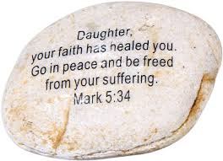

Today’s passage begins two people. One was a synagogue ruler and the other, a nameless woman in the crowd. Their stories are remarkable because of the unusual way in which they both came to Jesus and received his blessing. Of the hundreds who had been with Jesus on that day, these two revealed extraordinary faith. Jesus saw in them the true character of faith— the kind of faith God is always looking for. And then Jesus made sure that everyone else recognized these two people’s faith so that everyone might learn the kind of faith that pleases God and brings blessing with it. We will divide into two lessons. We will first study about the partial story of Jairus and the complete story of a nameless woman in the crowd.

1. Read verses 21-24. Why might the large crowd have gathered around Jesus? (21) Who was Jairus? (22a) What was his attitude toward Jesus? (22b) What was his desperate problem and what did he ask Jesus to do? (23) How did Jesus respond to Jairus' request? (24)

1-1, Read verses 21-24.

When Jesus had again crossed over by boat to the other side of the lake, a large crowd gathered around him while he was by the lake. 22 Then one of the synagogue leaders, named Jairus, came, and when he saw Jesus, he fell at his feet. 23 He pleaded earnestly with him, “My little daughter is dying. Please come and put your hands on her so that she will be healed and live.” 24 So Jesus went with him. A large crowd followed and pressed around him.

1-2, Why might the large crowd have gathered around Jesus? (21)

When Jesus had again crossed over by boat to the other side of the lake, a large crowd gathered around him while he was by the lake.

- Mark tells us that a large crowd had been gathering around Jesus on the shore where he arrived.
- Later on in the story, Mark also points out that the crowds were so large that they were pressing against Jesus.
- Men and women from all walks of life had come to meet Jesus. Jesus was very popular. He had shown compassion to most unlikely people.
- By now, Jesus had also had major confrontation with the religious leaders. They had been angered by his words and actions.
- They had also been thinking about killing him.What angered the religious leaders about Jesus was the very thing that drew the crowds to him even more.
- But regardless of the risks, the crowds kept coming to him, because Jesus welcomed them always.

1-3, Who was Jairus? (22a)

22 Then one of the synagogue leaders, named Jairus, came,
- But Mark tells us that the story here begins with a man of power and influence. He stands as a unique person among his peers.
- Jairus might have heard about Jesus and His ministry of healing. He could have had a silver lining about her daughter.
- In fact God the Father in Heaven sent His One and Only Son Jesus Christ to help the helpless in this world. Maybe Jairus might have seen God’s compassion.
- We are not sure if Jairus knew why Jesus came to this earth and Jesus gave up his power and glory in heaven and was born in a manger.
- Jesus gave up the highest position to be our Savior. Jairus, who was willing to risk his career to save his daughter, has the image of Jesus.
- Fathers must know that a man is not a father simply because he has children. A man is a father when he loves his children more than himself, and is willing to sacrifice himself for them.

1-4, What was his attitude toward Jesus? (22b)

and when he saw Jesus, he fell at his feet.

1-5, What was his desperate problem and what did he ask Jesus to do? (23)

23 He pleaded earnestly with him, “My little daughter is dying. Please come and put your hands on her so that she will be healed and live.”

- Jairus had faith in Jesus on top of his heart for his daughter. He was certain that Jesus could heal his daughter.
- All fathers are limited. Even though they love their children, they cannot solve their children’s life problems.
- But Jesus is Almighty God and our Everlasting Father. Jesus can heal any disease and solve any problem.
- Jairus was a man of high position in society. He may not have been a proud and arrogant man. But he was a synagogue ruler.
- And therefore, he must have enjoyed all the benefits of being a man who commands honor and respect.
- He didn’t have to bow down to anyone, and he surely did not need to plead for anything. He was a happy man as a synagogue ruler.
- Then one day, the apple of his eye became ill. Doctors were saying that they could do no more for her.
- They were sure that she was dying. It was one of those crises beyond hope. He was helpless. He could have given up.
- There was one alternative left. He knew about Jesus and what Jesus was doing wherever he went. He had heard of the healings and the compassion of Jesus.
- But it wasn’t so easy for him to go in that direction. Jesus was an outcast, rejected by the religious leaders.
- To seek Jesus out meant to abandon everything in his life— especially his position as a religious leader in his community. It would mean abandoning his honor.
- Was it worth abandoning everything for the sake of that chance his daughter might have with Jesus? It was because he loved his daughter and would do anything to see her well again. It may remind us of 1 John 3:16;
“This is how we know what love is: Jesus Christ laid down his life for us. And we ought to lay down our lives for our brothers and sisters.”
- So Jairus went to Jesus. It was his first step of faith. He came to Jesus. Then he knelt down before Jesus— and this in the view of all people.
- Then, Jairus pleaded with Jesus to come lay his hand on his daughter so that she might be healed and live.
- And Jairus had faith in Jesus. He believed in Jesus’ compassion. He believed that Jesus would receive him and honor his plea.

1-6, How did Jesus respond to Jairus' request? (24)

24 So Jesus went with him.

- With this simple faith in Jesus, Jairus came to Jesus and pleaded with him. When Jesus heard such a plea, Jesus immediately went with him.
- Jesus must have changed his whole plan in order to honor this man’s faith and desire. Praise Jesus!

2. Read verses 25-29. Who hid in the crowd and intercepted Jesus? (24, 25a, 27a) Describe her condition. (25-26) What did she think and what did she do? (27b-28) What happened? (29) What can we learn from her?

2-1, Read verses 25-29.

And a woman was there who had been subject to bleeding for twelve years. 26 She had suffered a great deal under the care of many doctors and had spent all she had, yet instead of getting better she grew worse. 27 When she heard about Jesus, she came up behind him in the crowd and touched his cloak, 28 because she thought, “If I just touch his clothes, I will be healed.” 29 Immediately her bleeding stopped and she felt in her body that she was freed from her suffering.

2-2, Who hid in the crowd and intercepted Jesus? (24, 25a, 27a)

A large crowd followed and pressed around him. 25 And a woman was there 27 When she heard about Jesus,

- The author Mark continues with another intercepted story before he brings us back to Jairus’ story. There was a woman who also came to Jesus with a desperate need for healing.

2-3, Describe her condition. (25-26)

25 And a woman was there who had been subject to bleeding for twelve years. 26 She had suffered a great deal under the care of many doctors and had spent all she had, yet instead of getting better she grew worse.

- She was nameless. And for years she had suffered quietly with a shameful problem of bleeding.
- By the very law of her people, she could have divorced from her husband, and she was ostracized from all society, and must not come into contact with her old friends; she was excommunicated from the services of the synagogue, and thus shut out from the women’s courts in the temple.
- For years she saw doctors but none could help her, though she spent all she had. She was beyond cure, and she may have resigned herself to living with her problem the rest of her life.
- According to our advanced medical technology, the most common cause is still unknown. Known causes would be abnormal uterine bleeding due to polyps, fibroids(myomas), endometriosis, medication, infection and some forms of contraception. Treatment can be medications, or dilatation and curettage (D&C) to remove the uterine lining. But in Jesus’ time people didn’t know how to treat it.
2-4, What did she think and what did she do? (27b-28)

she came up behind him in the crowd and touched his cloak, 28 because she thought, “If I just touch his clothes, I will be healed.”

- But something happened to ignite hope in her. When she heard about Jesus, she came up behind him in the crowd and touched his cloak, because she thought, ‘If I just touch his clothes, I will be healed.’”
- Like Jairus she too had heard of Jesus. And she too realized that the only alternative to suffering and shame was to seek Jesus.
- In reality though, it wasn’t easy to come to Jesus. If she was discovered, she would be stoned because like the leper, she was also considered an “unclean” woman.
Lev 15:25-31 reads,
“‘When a woman has a discharge of blood for many days at a time other than her monthly period or has a discharge that continues beyond her period, she will be unclean as long as she has the discharge, just as in the days of her period. 26 Any bed she lies on while her discharge continues will be unclean, as is her bed during her monthly period, and anything she sits on will be unclean, as during her period.27 Anyone who touches them will be unclean; they must wash their clothes and bathe with water, and they will be unclean till evening. 28 “‘When she is cleansed from her discharge, she must count off seven days, and after that she will be ceremonially clean. 29 On the eighth day she must take two doves or two young pigeons and bring them to the priest at the entrance to the tent of meeting. 30 The priest is to sacrifice one for a sin offering and the other for a burnt offering. In this way he will make atonement for her before the Lord for the uncleanness of her discharge. 31 “‘You must keep the Israelites separate from things that make them unclean, so they will not die in their uncleanness for defiling my dwelling place,[b] which is among them.’”

- Even if there was a way to come to Jesus, she couldn’t tell him about it for shame.
- So, she planned to sneak to where Jesus was, touch his clothes, then sneak back home undetected. And that’s what she did. But it did not go as she had planned.

Matthew 9:20-21 reads,
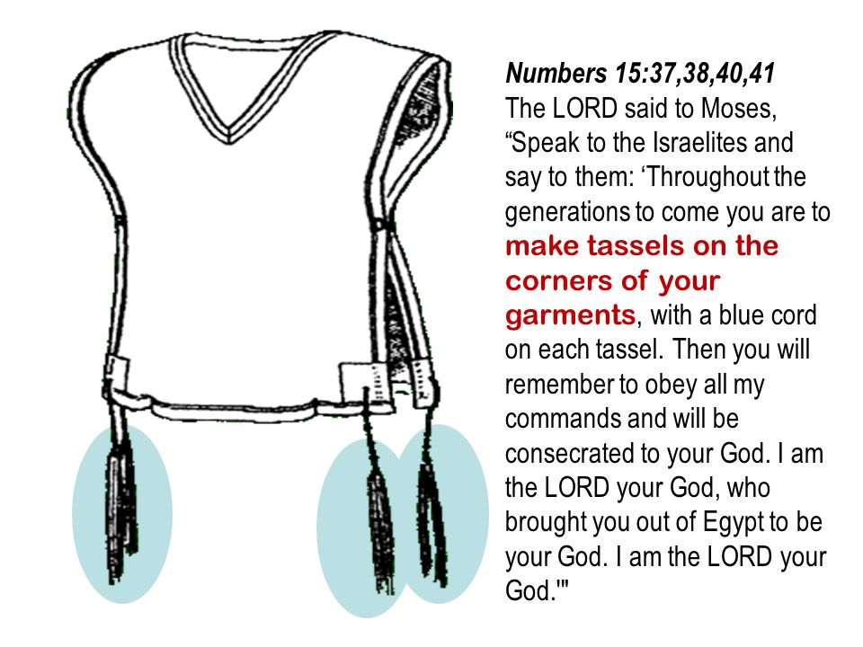
20 Just then a woman who had been subject to bleeding for twelve years came up behind him and touched the edge of his cloak. 21 She said to herself, “If I only touch his cloak, I will be healed.”
According to Matthew’s gospel, she touched the hem of His garment(KJV), and that actually means one of the borders of the outer garment that all Jews wore. “Every devout Jew wore an outer robe with four tassels on it, one at each corner. These tassels were worn in obedience to the command in Numbers 15:38-40, and they were to signify to others, and to remind the man himself, that the wearer was a member of the chosen people of God.”

2-5, What happened? (29)

29 Immediately her bleeding stopped and she felt in her body that she was freed from her suffering.

- When she touched His garment, Jesus wasn’t made unclean; the woman was made whole. When we come to Jesus with our sin and lay it upon Him, it doesn’t make Him a sinner, but it makes us clean.

2-6, What can we learn from her?

- Since we have no evidence in the Bible that Jesus healed this way before, it seems that the woman acted at least partially on superstition.
- Yet she did believe in the healing power of Jesus, and the border of His garment served as a point of contact for that faith.
- There were many things that we could find wrong with this woman’s faith. Nevertheless, her faith was in Jesus, and the object of faith is much more important than anything else!

3. Read verses 30-34. Why was this woman's touch different from that of the pressing crowd? (30) Why did Jesus keep looking for the woman? (31-32) Why was it so important for her to make a confession? (33) How did Jesus bless her? (34)

3-1, Read verses 30-34.

30 At once Jesus realized that power had gone out from him. He turned around in the crowd and asked, “Who touched my clothes?” 31 “You see the people crowding against you,” his disciples answered, “and yet you can ask, ‘Who touched me?’ ” 32 But Jesus kept looking around to see who had done it. 33 Then the woman, knowing what had happened to her, came and fell at his feet and, trembling with fear, told him the whole truth. 34 He said to her, “Daughter, your faith has healed you. Go in peace and be freed from your suffering.”

3-2, Why was this woman's touch different from that of the pressing crowd? (30)

30 At once Jesus realized that power had gone out from him. He turned around in the crowd and asked, “Who touched my clothes?”
3-3, Why did Jesus keep looking for the woman? (31-32)

31 “You see the people crowding against you,” his disciples answered, “and yet you can ask, ‘Who touched me?’ ”32 But Jesus kept looking around to see who had done it.

- Jesus knew that power had gone out from him. Jesus asked who touched him. His disciples pointed out that many people had touched him.
- Obviously, they did not know what had happened. Only the woman and Jesus really knew what had happened.
- Here, Mark seems to highlight the personal nature of faith. Although many people touched Jesus, only the woman’s touch released his power.
- Many people may hang around Jesus. But only the touch of faith releases Jesus’ power. Jesus pays attention to those who have faith.
- Jesus was determined to find her. So Jesus stopped and looked around again and again to see who had done it. The woman was some distance away by then.
- It had been her plan to touch Jesus’ garment, obtain healing, and hurry back to her own place. She was afraid of public exposure.
- She felt that others would despise or condemn her. She just wanted to get away as fast as she could. But, Jesus said, “Who touched me?”
- The woman stopped in her tracks. She knew that Jesus was speaking to her. She had to decide if she continued to hide herself, or go back.

3-4, Why was it so important for her to make a confession? (33)

33 Then the woman, knowing what had happened to her, came and fell at his feet and, trembling with fear, told him the whole truth.

- Still, Jesus persisted. Finally the woman came forward, fell on her knees before Jesus, and trembling with fear, told the whole truth.
- Here, the whole truth is that she was an unclean woman who had been healed by Jesus. This confession gave glory to God, revealing God’s power and love.
- Those who heard her could praise God. Those who heard her were encouraged to have faith in God.
- The woman “felt” in her body that she was healed. However, she needed more than this subjective experience to have a healthy spiritual life.
If you declare with your mouth, “Jesus is Lord,” and believe in your heart that God raised him from the dead, you will be saved. 10 For it is with your heart that you believe and are justified, and it is with your mouth that you profess your faith and are saved. (Romans 10:9-10)
- She needed to confess with her mouth what Jesus had done for her. We can confess their faith in Jesus by writing and sharing Bible testimonies or going out campus to invite students with our personal testimonies.

3-5, How did Jesus bless her? (34)

34 He said to her, “Daughter, your faith has healed you. Go in peace and be freed from your suffering.”

- After her confession, Jesus said to her, “Daughter, your faith has healed you. Go in peace and be freed from your suffering.” Jesus called her “Daughter.”
- Jesus welcomed her into a personal, intimate relationship with him. As Jairus loved his own daughter, Jesus loved this woman dearly, as his own daughter.
- Jesus also said, “…your faith has healed you.” Jesus did not say that his garment had healed her, or that he had healed her, but that her faith had healed her.
- In fact, she initiated contact with Jesus through her faith. She overcame obstacles to come to Jesus by faith. Jesus gave full credit to the woman’s faith.
- We can obtain Jesus’ blessing by faith. We don’t need to suffer in a state of illness. When we “just touch” Jesus with faith, Jesus heals us.

Conclusion
Through this passage we have learned that Jesus is pleased with our faith. Jairus overcame his obstacles, mainly his own pride, to come to Jesus. Then a woman overcame her hindering doubt and shame in order to come to Jesus. When she was challenged to come out and confess her faith, she obeyed and was blessed by Jesus. Raising our physical and spiritual children, often times we faced difficulties unexpectedly. But we pray that our faith may increase day by day to come to Jesus by faith. Amen.
One word; Who touched me?

