STRETCH OUT YOUR HAND

Mark 3:1-12
Key Verse 5

He looked around at them in anger and, deeply distressed at their stubborn hearts, said to the man, “Stretch out your hand.” He stretched it out, and his hand was completely restored

Introduction
This passage shows another conflict between Jesus and the religious leaders in regard to the law of Sabbath. Jesus must have known that the religious leaders could have attacked if he would heal a man with a shriveled hand on the Sabbath day. But anyway Jesus healed the man in order to teach them the truth and demonstrated his almighty power of restoration. Praise Jesus and His unswerving heart of compassion and love for the poor and the sick. May the Lord help us to learn of Him in our daily lives so that we may follow His footsteps.

1. Read verses 1-4. Who was there when Jesus went into the synagogue? (1) What did some people look for? (2) What did Jesus say to the man with the shriveled hand? (3) What question did Jesus then ask? (4)

1-1. Read verses 1-4.

Another time Jesus went into the synagogue, and a man with a shriveled hand was there. ² Some of them were looking for a reason to accuse Jesus, so they watched him closely to see if he would heal him on the Sabbath. ³ Jesus said to the man with the shriveled hand, “Stand up in front of everyone.”⁴ Then Jesus asked them, “Which is lawful on the Sabbath: to do good or to do evil, to save life or to kill?” But they remained silent.

1-2. Who was there when Jesus went into the synagogue? (1)

· Another time Jesus went into the synagogue, and a man with a shriveled hand was there.

- A man with shriveled hand : the muscle of hand and arm became numb and paralyzed and even got shrunk and dried. It was his right hands (Luke 6:6) which was the symbol of man’s power. He might have had nerve damage in the past.
- This man was disabled. It was very possible that his life and his heart got shriveled too with the shriveled hand.
- This man was in the synagogue to worship God. He might be there to get healed by Jesus as well. It was still good for him to come to God and worship Him instead of complaining to God about his shriveled hand. He found hope in Jesus.

1-3. What did some people look for? (2)

· Some of them were looking for a reason to accuse Jesus, so they watched him closely to see if he would heal him on the Sabbath

- Some of them were thought to be Pharisees. (6)
- They were looking for a reason to accuse Jesus. They were there not to learn from Him but with evil motive to accuse Him.
- They watched him closely to see if he would heal him on the Sabbath- they criticized Jesus’ discipleships because they took the grain. Now they wanted to find more clear evidence that Jesus violated the law of Sabbath.
- According to their tradition healing a man during Sabbath is unlawful because they thought it was still work
- For example) According to their Sabbath traditions, if you cut your finger, you could stop the bleeding but you could not put ointment on the cut. You could stop it from getting worse, but you weren't allowed to make it better.

1-4. What did Jesus say to the man with the shriveled hand? (3)

· Jesus said to the man with the shriveled hand, “Stand up in front of everyone.”

- “Stand up in front of everyone’. Jesus confronted their evil intention and untruthful belief and misunderstanding about the Sabbath.
- Jesus knew that they were looking for a chance to accuse him especially through the man of shriveled hand and he would be in danger if he would heal the man. But he fought for the truth against the evil and untruth even risking his life.
- If he had given up fearing their threat, the truth can’t stand and people would have suffered under wrong teaching losing opportunity to be healed and saved.
- There are so many false teachings and ideas against the truth of God. We should fight for the truth boldly not fearing the threat of this world.

1-5. What question did Jesus then ask? (4)

· Then Jesus asked them, “Which is lawful on the Sabbath: to do good or to do evil, to save life or to kill?”

- Jesus challenged them telling them what he was doing and what they were doing.
- To do good or to do evil, to save life or to kill: Jesus told them he was doing what is good, that was to serving God’s will and saving people but they were doing what’s evil against God’s will.
- Jesus was saving life on Sabbath but they were doing harmful things to people and even trying to kill Jesus.
- When we don’t know what God wants, we could do evil and kill people with the law that God gave us or with the name of religion.
· But they remained silent.
- They didn’t respond. They couldn’t answer because what Jesus said was right. Also they didn’t want to repent what they were doing. People know what is right but they remain silent because they don’t want to repent.

2. Read verses 5-6. What caused Jesus deep distress and what did he say to the man? (5a) What happened to the man? (5b) What was the Pharisees’ response? (6)

2-1. Read verses 5-6.

⁵ He looked around at them in anger and, deeply distressed at their stubborn hearts, said to the man, “Stretch out your hand.” He stretched it out, and his hand was completely restored. ⁶ Then the Pharisees went out and began to plot with the Herodians how they might kill Jesus.

2-2. What caused Jesus deep distress and what did he say to the man? (5a)

· He looked around at them in anger and, deeply distressed at their stubborn hearts, said to the man, “Stretch out your hand.”

- Jesus got angry at them because of the all the evil things they were doing
- He deeply distressed because they didn’t repent, nor accept the truth with stubborn heart.
- When we don’t accept the word of God and don’t repent with stubborn heart and keep doing evil, Jesus is angry and distressed.
- We have to soften our hearts and listen to him when the word is God is given to us.

2-3. What happened to the man? (5b)
· He stretched it out, and his hand was completely restored

- The man stretched out his hand obeying Jesus’ word. He didn’t become timid by the pressure of Pharisees or other people. Rather simply obeyed Jesus’ word.
- By simply obeying Jesus’ command we can experience his power.
- The shriveled hand was completely restored. Jesus healed his hand completely and immediately.
- Jesus healed him with his word. His word has the same power that the words that God spoke had when he created the world.
- Jesus has the power to restore any distorted or broken things that lost its original form.
- Jesus can heal us and restored our broken God’s image completely with his mighty power.
- We can just stretch out our shriveled parts to him asking his healing. He can let us to live powerful and blessed life through his healing power.

2-4. What was the Pharisees’ response? (6)

· Then the Pharisees went out and began to plot with the Herodians how they might kill Jesus.

- The Pharisees and the Herodians didn’t have good relationship because of their different political position. But the Pharisees began to work together with the Herodians to kill Jesus.
- Instead of repenting evil things they were doing they plotted to kill him. Their heart became more stubborn
- What they were doing was so hypocritical and evil.

3. Read verses 7-12. Why did many people follow Jesus? (7-8) What did Jesus tell his disciples to do? (9-10) How did the impure spirits react when they saw Jesus, and what was Jesus’ response to them? (11-12)

3-1. Read verses 7-12.

⁷ Jesus withdrew with his disciples to the lake, and a large crowd from Galilee followed. ⁸ When they heard about all he was doing, many people came to him from Judea, Jerusalem, Idumea, and the regions across the Jordan and around Tyre and Sidon. ⁹ Because of the crowd he told his disciples to have a small boat ready for him, to keep the people from crowding him. ¹⁰ For he had healed many, so that those with diseases were pushing forward to touch him. ¹¹ Whenever the impure spirits saw him, they fell down before him and cried out, “You are the Son of God.” ¹² But he gave them strict orders not to tell others about him.

3-2. Why did many people follow Jesus? (7-8)

· Jesus withdrew with his disciples to the lake but still a large crowd from Galilee followed him. The crowd following Jesus kept growing.

· When they heard about all he was doing, many people came to him from Judea, Jerusalem, Idumea, and the regions across the Jordan and around Tyre and Sidon

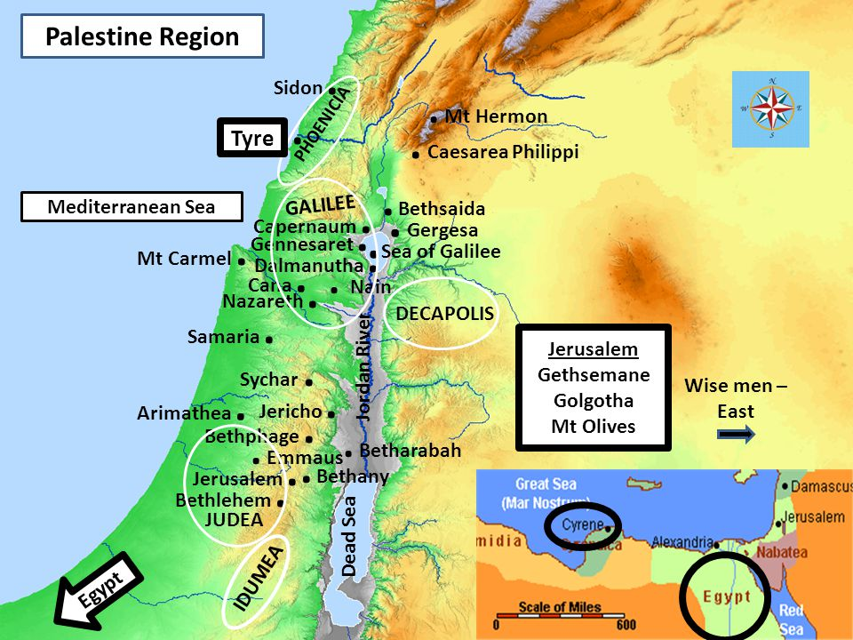
- The news about Jesus kept spreading beyond the Judean territory to gentile regions and many people came to Jesus from Judea and across the Jordan and around Tyre and Sidon.

- Despite of the religious leaders’ persecution, Jesus’ public ministry kept growing and even gentile world people wanted to get help from Jesus. It shows that Jesus is the savior for all people on earth both Jews and gentiles.

- Nothing can stop the work of God and spreading the good news of Jesus Christ.

3-3. What did Jesus tell his disciples to do? (9-10)

· Because of the crowd he told his disciples to have a small boat ready for him, to keep the people from crowding him. For he had healed many, so that those with diseases were pushing forward to touch him

- Jesus wanted to keep a distance between him and the crowd by sitting a boat. People might crowd Jesus to get healed and get some help or to see him.
- Jesus didn’t want to do his messianic ministry just satisfying people’s need. Rather keeping him away from the people Jesus focused on preaching the word of God to them which was the true solution for their problems.
- Jesus doesn’t want us to approach him considering him just as a healer. He wants us to believe him as the Savior and listen to his word.

3-4. How did the impure spirits react when they saw Jesus, and what was Jesus’ response to them? (11-12)

· Whenever the impure spirits saw him, they fell down before him and cried out, “You are the Son of God.”

- They were overwhelmed by the power and authority of Jesus and couldn’t fall down before him.
- ‘You are the Son of God’- Even the evil spirits recognized Jesus. As the ones who existed in the spiritual realm they knew who Jesus was clearly. But they recognized him not to accept him to be saved but recognized him in fear and terror as the one who would destroy them.
· But he gave them strict orders not to tell others about him- Jesus didn’t want to be witnessed by the evil spirits because whatever they did would be harmful for his ministry.

Conclusion

Jesus is the Lord of Sabbath and it is lawful to do good and save life on Sabbath. The true intention of the law and Sabbath is to do good and save life. And Jesus has the power to restore all our shriveled parts inside and out. May God help us to stretch out our shriveled hands by faith in Jesus. What is more, through this passage there are so many people who hold their problems like a man of shriveled hand without knowing what to do with their agony. But when the love of God is tasted once, many people will come to Jesus Christ because He is the source of love! It reminds us of a song ‘My Song Is Love Unknown’ by Samuel Crossman. “Why, what has my Lord done, To cause this rage and spite? He made the lame to run And gave the blind their sight. What injuries! Yet these are why, What injuries, yet these are why The Lord Most High so cruelly dies.”

One word, “Stretch out your hand.”

