THE CRUCIFICTION, DEATH, AND BURIAL OF JESUS

Mark 15:16-47
Key Verse 25

It was nine in the morning when they crucified him.

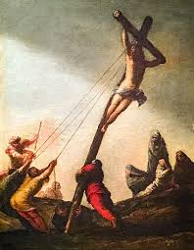
Introduction
In the previous passage, Jesus was tried before Pilate. Pilate knew that Jesus was innocent but he betrayed his conscience and granted the Jews’ demand to crucify Jesus. Jesus was mocked at the hands of the Roman soldiers, crucified at Golgotha, dead on the cross, buried and remained in the tomb and then gloriously resurrected. By going through unbearable suffering and horrible death, Jesus truly revealed his passion for us. As we study today’s passage, let us remember Jesus’ suffering and death on the cross for us so that we may accept God’s great love and forgiveness in our hearts. Let us also be passionate in our worship of Jesus and in our proclamation of him.

- Read verses 16-24. What did the soldiers do to Jesus before his crucifixion? (16-20) Who was forced to carry the cross? (21) Why do you think Jesus refused to take the wine with myrrh? (22, 23) What did people do immediately after crucifying Jesus? (24)

1-1, Read verses 16-24.
The soldiers led Jesus away into the palace (that is, the Praetorium) and called together the whole company of soldiers. 17 They put a purple robe on him, then twisted together a crown of thorns and set it on him. 18 And they began to call out to him, “Hail, king of the Jews!” 19 Again and again they struck him on the head with a staff and spit on him. Falling on their knees, they paid homage to him. 20 And when they had mocked him, they took off the purple robe and put his own clothes on him. Then they led him out to crucify him. 21 A certain man from Cyrene, Simon, the father of Alexander and Rufus, was passing by on his way in from the country, and they forced him to carry the cross. 22 They brought Jesus to the place called Golgotha (which means “the place of the skull”). 23 Then they offered him wine mixed with myrrh, but he did not take it. 24 And they crucified him. Dividing up his clothes, they cast lots to see what each would get.

1-2, What did the soldiers do to Jesus before his crucifixion? (16-20)
16 The soldiers led Jesus away into the palace (that is, the Praetorium) and called together the whole company of soldiers. 17 They put a purple robe on him, then twisted together a crown of thorns and set it on him. 18 And they began to call out to him, “Hail, king of the Jews!” 19 Again and again they struck him on the head with a staff and spit on him. Falling on their knees, they paid homage to him. 20 And when they had mocked him, they took off the purple robe and put his own clothes on him. Then they led him out to crucify him.

- As soon as Pilate handed Jesus over to be crucified, the Roman soldiers took charge of Jesus and led him away into the palace known as the Praetorium.
- Then the whole company of soldiers gathered around Jesus and mocked him. First they dressed him like a king of the Jews by putting a scarlet robe on him.
- They twisted together a crown of thorns and set it one Jesus’ head. The blood was oozing out from many parts of his head. Then they mocked Jesus.
- They called out to Jesus, “Hail, king of the Jews!” they struck Jesus on the head with a staff again and again and spat on him again and again.
- They also pretend to pay homage to him by falling on their knees. These soldiers were heartless and abusive. They made fun of him.
- They didn’t know what they were doing. After mocking and mistreating Jesus, the soldiers led Jesus out to crucify him.

1-3, Who was forced to carry the cross? (21)

A certain man from Cyrene, Simon, the father of Alexander and Rufus, was passing by on his way in from the country, and they forced him to carry the cross.

- Jesus had to carry his own cross to the execution site. By now from head to toe Jesus’ body was lacerated by the soldiers’ flogging and scourging.
- He was dehydrated and exhausted. Particularly because of the severe flogging, Jesus was so weakened that he could not carry the heavy cross.
- The soldiers found a passer-by, Simon from Cyrene from North Africa who came to Jerusalem to celebrate the Passover.
- From a human's point of view, he was an unlucky man. Simon then carried the heavy cross all the way to Golgotha together with Jesus.
- Simon eye-witnessed Jesus’ crucifixion and death that changed him forever. He became a great man of God and so did his sons, Alexander and Rufus.
- Perhaps when Simon shared his life testimony, he always said, “I carried Jesus’ cross to Golgotha and witnessed his crucifixion for my sin. I thank Jesus!”

1-4, Why do you think Jesus refused to take the wine with myrrh? (22, 23)
22 They brought Jesus to the place called Golgotha (which means “the place of the skull”). 23 Then they offered him wine mixed with myrrh, but he did not take it.
- The soldiers brought Jesus to Golgotha, the execution site. Then they offered Jesus wine mixed with myrrh before crucifixion.
- It was a painkiller but Jesus refused it to take all our pains and sufferings upon himself. Isaiah 53:4 reads, “Surely he took up our pain and bore our suffering.”

1-5, What did people do immediately after crucifying Jesus? (24)
24 And they crucified him. Dividing up his clothes, they cast lots to see what each would get.

- Crucifixion was the Roman’s most severe and painful form of execution only for non-Roman criminals, rebels or slaves.
- The executioners stripped the criminal and attached him with nails and leather thongs to a crossbeam of the cross and then left the victim there until dead.
- In this way Jesus was crucified and took excruciating pain in our places. While Jesus was suffering on the cross, the soldiers gambled for Jesus’ clothes.
- These soldiers make us think how far human beings can go in being inhumane, heartless and indifferent.
- What a stark contrast between Jesus who suffered and died for others and the soldiers who for a petty gain enjoyed gambling beneath the cross.

- Read verses 25-32. At what time was Jesus crucified? (25) What was the written notice of the charge against Him? (26) Who was crucified together with Jesus? (27) What insults were hurled at Jesus? (28-32)

2-1, Read verses 25-32.
25 It was nine in the morning when they crucified him. 26 The written notice of the charge against him read: the king of the jews.
27 They crucified two rebels with him, one on his right and one on his left. [28] [a] 29 Those who passed by hurled insults at him, shaking their heads and saying, “So! You who are going to destroy the temple and build it in three days, 30 come down from the cross and save yourself!” 31 In the same way the chief priests and the teachers of the law mocked him among themselves. “He saved others,” they said, “but he can’t save himself! 32 Let this Messiah, this king of Israel, come down now from the cross, that we may see and believe.” Those crucified with him also heaped insults on him.

2-2, At what time was Jesus crucified? (25)
25 It was nine in the morning when they crucified him.
- The Jewish daytime hours began with dawn and ended with sundown, which began the next day.
https://www.agapebiblestudy.com/charts/jewishtimedivision.htm
- The Romans began their day at midnight and counted 12 hours to high 12 noon and then 12 more hours from noon to the next midnight. We keep Roman time.

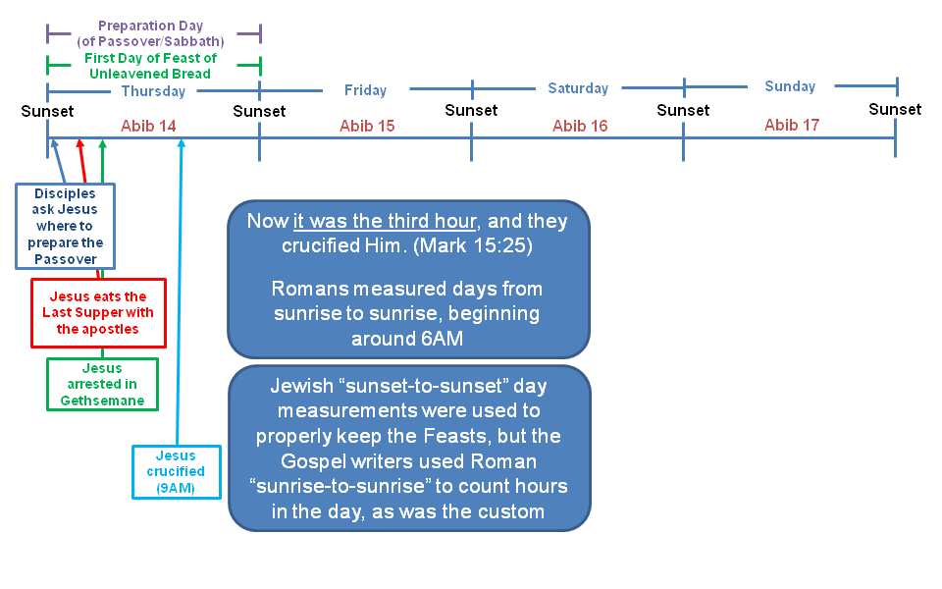

2-3, What was the written notice of the charge against Him? (26)
26 The written notice of the charge against him read: the king of the jews.

- It was nine in the Morning when they crucified him. The written notice of the charge against him read: The King of the Jews.
- The King of the Jews to the Jews meant the promised Messiah. The King of the Jews to Romans meant the rebellion against the emperor of Rome.
- The religious leaders knew these meanings well. So they fabricated the charge, accusing Jesus as a political criminal—self imposed king, rebellion against Rome.

2-4, Who was crucified together with Jesus? (27)
27 They crucified two rebels with him, one on his right and one on his left.

- Two rebels were crucified with Christ on that day. Jesus was condemned and crucified because he was the King of the Jews, the Messiah.
- Yes, the King of the Jews, the Messiah had to die in obedience by God’s set purpose to save sinners like us as a criminal.
- Isaiah 53:12 says, “…he poured out his life unto death, and was numbered with the transgressors.”

2-5, What insults were hurled at Jesus? (28-32)
[28] [a] 29 Those who passed by hurled insults at him, shaking their heads and saying, “So! You who are going to destroy the temple and build it in three days, 30 come down from the cross and save yourself!” 31 In the same way the chief priests and the teachers of the law mocked him among themselves. “He saved others,” they said, “but he can’t save himself! 32 Let this Messiah, this king of Israel, come down now from the cross, that we may see and believe.” Those crucified with him also heaped insults on him.

- Those who passed by hurled insults at Jesus, shaking their heads and saying, “So! You who are going to destroy the temple and build it in three days, come down from the cross and save yourself!”
- The religious leaders mocked Jesus saying, “Hah! He saved others, but he can’t save himself! Let this Messiah, this king of Israel, come down now from the cross, that we may see and believe.”
- Even one of the criminals heaped insults on him. In this way, Jesus was mocked and insulted at the last moment of his life on the cross.
- The point of their insults was “Save yourself!” What a great temptation for Jesus it was! Jesus could have called upon angels to rescue Him.
- He could come down from the cross and save himself and punish the mockers. But if he saved himself, God’s work to save sinners would be completely spoiled.
- Human beings could not have salvation and eternal life in the kingdom of God. “Save yourself! Save yourself! Come from down the cross!”
- It was Satan’s great temptation to Jesus. It is our human nature to save ourselves first. We try to save ourselves from pain, suffering or death at any cost.
- We all want ease, comfort and pleasure. Our nature in us strongly pressures us to save ourselves.
- Our nature urges us not to sacrifice our lives for God and for others. But God’s saving work can only be done when we don’t save ourselves.

- Read verses 33-39. What does the unusual darkness reveal about Jesus’ crucifixion? (33) How did Jesus cry out? (34) What did those standing nearby say about Jesus? (35, 36) What happened in the temple at the time of Jesus’ death? (37, 38) Describe the Centurion’s confession. (39)

3-1, Read verses 33-39.
33 At noon, darkness came over the whole land until three in the afternoon. 34 And at three in the afternoon Jesus cried out in a loud voice, “Eloi, Eloi, lema sabachthani?” (which means “My God, my God, why have you forsaken me?”).[b]
35 When some of those standing near heard this, they said, “Listen, he’s calling Elijah.”
36 Someone ran, filled a sponge with wine vinegar, put it on a staff, and offered it to Jesus to drink. “Now leave him alone. Let’s see if Elijah comes to take him down,” he said.
37 With a loud cry, Jesus breathed his last.
38 The curtain of the temple was torn in two from top to bottom. 39 And when the centurion, who stood there in front of Jesus, saw how he died,[c] he said, “Surely this man was the Son of God!”

3-2, What does the unusual darkness reveal about Jesus’ crucifixion? (33)
33 At noon, darkness came over the whole land until three in the afternoon.

3-3, How did Jesus cry out? (34)
34 And at three in the afternoon Jesus cried out in a loud voice, “Eloi, Eloi, lema sabachthani?” (which means “My God, my God, why have you forsaken me?”).

- It was noon. Darkness came over the whole land for 3 hours from noon till 3 pm. It was supposed to be the brightest time of a day.
- But even nature was mourning over the death of the Son of God Jesus. “And at three in the afternoon Jesus cried out in a loud voice, ‘Eloi, Eloi, lema sabachthani?’ (which means ‘My God, my God, why have you forsaken me?’).”
- On the cross, Jesus was silent. He bore extreme pain and unbearable mocking silently. Even when his hands were nailed to the cross, he said nothing.
- Jesus was silent even when all people including his own disciples forsook him. But now he cries out, “My God, my God, why have you forsaken me?”
- Jesus cried out because his love relationship with God was broken because he took all our sins on himself.
- This was the moment when God did not spare his own Son, but gave him up for us all as our sin offering (Ro 8:32).
- Jesus died to restore the relationship between God and us. Jesus died to restore our relationship with others and restart a dynamic love relationship with others.

3-4, What did those standing nearby say about Jesus? (35, 36)
35 When some of those standing near heard this, they said, “Listen, he’s calling Elijah.”
36 Someone ran, filled a sponge with wine vinegar, put it on a staff, and offered it to Jesus to drink. “Now leave him alone. Let’s see if Elijah comes to take him down,” he said.

3-5, What happened in the temple at the time of Jesus’ death? (37, 38)

37 With a loud cry, Jesus breathed his last.
38 The curtain of the temple was torn in two from top to bottom.

- The curtain of the temple separated the Most Holy Place from the Holy Place. No one was permitted to enter it except the high priest.
- The high priest was allowed to enter it once a year with the blood of a lamb on the Day of Atonement.
- But on the cross Jesus died for us once and for all, offering himself as the perfect atoning sacrifice for all mankind for the forgiveness of sins.
- God forsook his own Son in order to save us from all the consequences of sin, including eternal damnation.
- 1 John 4:10 says, “This is love: not that we loved God, but that he loved us and sent his Son as an atoning sacrifice for our sins.”

3-6, Describe the Centurion’s confession. (39)

39 And when the centurion, who stood there in front of Jesus, saw how he died,[c] he said, “Surely this man was the Son of God!”

- The Roman centurion was in charge of the execution squad, and had seen many criminals die.
- But even his hardened heart melted after seeing Jesus’ death. He saw the death of the Son of God. So he cried out publicly, “Surely this man was the Son of God!”
- His testimony was short but was recorded as one of the most important parts of the gospel accounts.
- This was a fulfillment of what Jesus said in John 12:32, “And I, when I am lifted up from the earth, will draw all men to myself.”

- Read verses 40-47. Who were some women watching the scene of Jesus’ crucifixion? (40, 41) What did Joseph of Arimathea do with the body of Jesus? (42-46) Who witnessed it? (47)

4-1, Read verses 40-47.

40 Some women were watching from a distance. Among them were Mary Magdalene, Mary the mother of James the younger and of Joseph,[d] and Salome. 41 In Galilee these women had followed him and cared for his needs. Many other women who had come up with him to Jerusalem were also there.
42 It was Preparation Day (that is, the day before the Sabbath). So as evening approached, 43 Joseph of Arimathea, a prominent member of the Council, who was himself waiting for the kingdom of God, went boldly to Pilate and asked for Jesus’ body. 44 Pilate was surprised to hear that he was already dead. Summoning the centurion, he asked him if Jesus had already died. 45 When he learned from the centurion that it was so, he gave the body to Joseph. 46 So Joseph bought some linen cloth, took down the body, wrapped it in the linen, and placed it in a tomb cut out of rock. Then he rolled a stone against the entrance of the tomb. 47 Mary Magdalene and Mary the mother of Joseph saw where he was laid.

4-2, Who were some women watching the scene of Jesus’ crucifixion? (40, 41)

40 Some women were watching from a distance. Among them were Mary Magdalene, Mary the mother of James the younger and of Joseph,[d] and Salome. 41 In Galilee these women had followed him and cared for his needs. Many other women who had come up with him to Jerusalem were also there.

- The women were watching from a distance. They followed Jesus to the end. They stood beneath the cross and cried.
- They had the privilege to witness Jesus’ glorious death as well as his burial. They were beautiful women of God just like mothers of faith and prayer among us.

4-3, What did Joseph of Arimathea do with the body of Jesus? (42-46)

42 It was Preparation Day (that is, the day before the Sabbath). So as evening approached, 43 Joseph of Arimathea, a prominent member of the Council, who was himself waiting for the kingdom of God, went boldly to Pilate and asked for Jesus’ body. 44 Pilate was surprised to hear that he was already dead. Summoning the centurion, he asked him if Jesus had already died. 45 When he learned from the centurion that it was so, he gave the body to Joseph. 46 So Joseph bought some linen cloth, took down the body, wrapped it in the linen, and placed it in a tomb cut out of rock. Then he rolled a stone against the entrance of the tomb.

- Another person who experienced a change of heart by witnessing Jesus’ death was Joseph of Arimathea, which is a city in Judea.
- It was Preparation Day (that is, the day before the Sabbath). So as evening approached, Joseph of Arimathea was a prominent member of the Council.
- He was waiting for the kingdom of God, went boldly to Pilate and asked for Jesus’ body. He was a secret disciple of Jesus.
- He wanted to save his respectable position in the Jewish society. But after witnessing Jesus’ death, his fear was gone.
- He boldly went to Pilate and asked for Jesus’ body. After embalming Jesus’ dead body, he wrapped it in a linen cloth.
- He placed it in his own new tomb and rolled a large stone against the entrance of the tomb.

4-4, Who witnessed it? (47)
47 Mary Magdalene and Mary the mother of Joseph saw where he was laid.

Conclusion

Jesus did not save himself in order to save us from our sins. He was forsaken in our place, taking the wages of sin upon himself. He offered his life as the atoning sacrifice for my sins and your sins. Galatians 3:13 says, “Christ redeemed us from the curse of the law by becoming a curse for us, for it is written: ‘Cursed is everyone who is hung on a pole.’” Jesus received God’s judgment on the cross so as to take away the wrath of God from us so that we could have the right to become children of God. Therefore trusting in Jesus’ death on the cross for our sins, let us come to Jesus and receive his forgiveness and live a new life.

One word: Surely This Man!

