JESUS WAS TRIED BEFORE PILATE

Mark 15:1-15
Key Verse 15

“Wanting to satisfy the crowd, Pilate released Barabbas to them. He had Jesus flogged, and handed him over to be crucified.”

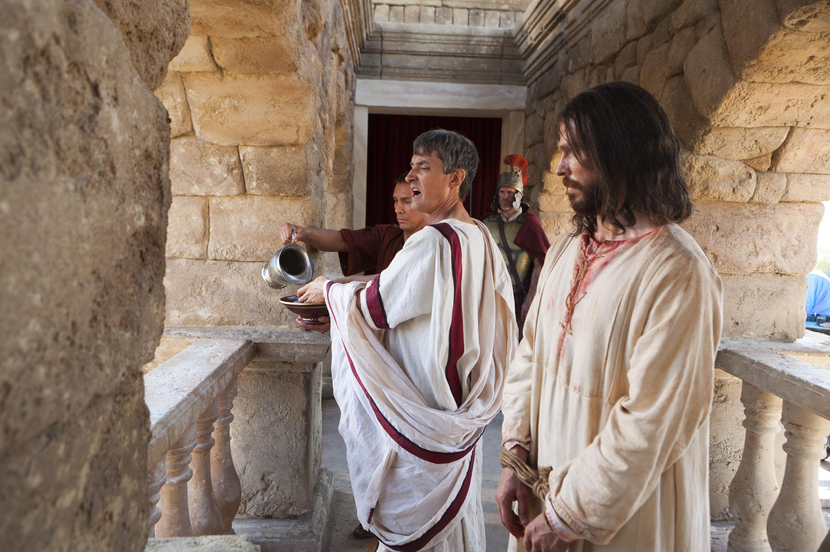
Introduction
Last week, we studied about Peter’s denial of Jesus up to 3 times. We will study the reason why Pilate could not but sentence Jesus death on the cross. We also want to know Jesus who clearly identifies Himself as the King of the Jews. May the Lord help us follow Jesus who courageously identified Himself as the King of the Jews, our Eternal King. Amen.

- Read verses 1-5. What plans did the religious leaders make after arresting Jesus? (1) Describe the meeting between Jesus and Pilate. (2-5)

1-1, Read verses 1-5.
Very early in the morning, the chief priests, with the elders, the teachers of the law and the whole Sanhedrin, made their plans. So they bound Jesus, led him away and handed him over to Pilate.
2 “Are you the king of the Jews?” asked Pilate.
“You have said so,” Jesus replied.
3 The chief priests accused him of many things. 4 So again Pilate asked him, “Aren’t you going to answer? See how many things they are accusing you of.”
5 But Jesus still made no reply, and Pilate was amazed.

1-2, What plans did the religious leaders make after arresting Jesus? (1)
Very early in the morning, the chief priests, with the elders, the teachers of the law and the whole Sanhedrin, made their plans. So they bound Jesus, led him away and handed him over to Pilate.

- Here Jesus’ trial was illegal for so many reasons. It was held at a private residence, at night and during a festival, all of which was against Jewish law.
- The witnesses couldn’t agree and at least two had to in order to convict, but they got what they wanted and pronounced him to die.
- Unfortunately for them, the Sanhedrin had no governmental power in the region. So Jesus was handed over to the Roman authority in the region.

Who is Pilate?
- Pontius Pilate was appointed by the Roman Emperor Tiberius as the governor of Judea, who served in that role from AD 26-36.
- Pilate's duties were primarily military; however, Pilate's troops were meant more as a police than a military force.
- As Roman governor, he was head of the judicial system. He had the power to inflict capital punishment, and was responsible for collecting tributes and taxes.
- As governor, Pilate had the right to appoint the Jewish High Priest and Pilate retained the same high priest, Caiaphas, for his entire tenure.
- Pilate initially arrived in the region. Against Jewish law, Pilate brought the banners that had the image of Caesar on them.
- The Romans were to view Caesar as a deity, but the Jews would see the banners as idol worship since they bore the image of Caesar.
- A large number of Jews came to Caesarea to protest more aggressively than our “black lives matter” protests.
- As Pilate would learn, the Jews were more than willing to die than to accept the banners. So, Pilate relented.
- But later when he tried to take temple funds to build an aqueduct to Jerusalem, there was another protest. He let his soldiers kill them.
- The Gospel of Luke mentions "whose blood Pilate had mingled with their sacrifices" (Luke 13:1).
- There was a false prophet who was claiming to show his followers sacred vessels hidden by Moses on Mt. Gerizim, which were supposed to hold sacred texts.
- Pilate sent an army to track down and kill the pilgrims. The Samaritans complained to the governor of Syria, who then told Emperor Tiberius. The emperor ended up removing Pilate and replaced him by Marcellus.

1-3, Describe the meeting between Jesus and Pilate. (2-5)

“Are you the king of the Jews?” asked Pilate. “You have said so,” Jesus replied. 3 The chief priests accused him of many things. 4 So again Pilate asked him, “Aren’t you going to answer? See how many things they are accusing you of.” 5 But Jesus still made no reply, and Pilate was amazed.

- When they brought Jesus to Pilate, they had to make a political charge against Jesus, because Pilate had a very limited in a Jewish religious charge.
- They accused Jesus of being a political revolutionary, “the king of the Jews.” In this way they handed him over to Pilate.
- Pilate asked, “Are you the king of the Jews?” “Yes, it is as you say,” Jesus replied. When Jesus stood before Pilate the charges were no longer religious but political.
- The title “the king of the Jews” was messianic but at the time, it also carried a strong political meaning.
- Anyone who claimed to be the king of the Jews, a messiah figure, was taken very seriously by the Romans as a political threat as Caiaphas had pointed out.
John 18:14 reads,
Caiaphas was the one who had advised the Jewish leaders that it would be good if one man died for the people
- People like Theudas and Judas the Galilean had made such claims, caused civil unrest, and then were crushed by the Romans.
Acts 5:36, 37 reads,
Some time ago Theudas appeared, claiming to be somebody, and about four hundred men rallied to him. He was killed, all his followers were dispersed, and it all came to nothing. 37 After him, Judas the Galilean appeared in the days of the census and led a band of people in revolt. He too was killed, and all his followers were scattered.
- If Jesus was found guilty of setting himself up as the king of the Jews, the Romans would execute him.
- Jesus’ answer to Pilate’s question was a life and death matter. But Jesus did not try to explain the spiritual meaning of “the king of the Jews.”
- He just told him, “Yes, it is as you say.” Jesus is the king of the Jews. He was not a political king but a spiritual one.
- Jesus was not afraid of Pilate and he was not afraid to die. Jesus decided to go to the cross in obedience to his Father’s will. He was full of the Holy Spirit by prayer!
- Maybe Pilate never expected that Jesus would reply in such a way, so he was completely overcome by his spiritual authority which shook his political position.
- Pilate felt that terrible disaster had fallen upon him. He trembled because his wife had a nightmare about Jesus and told him, “Don’t have anything to do with Jesus of Nazareth” (Mt 27:19).
- He was trembling, but Jesus was peaceful. When the chief priests sensed that Pilate was not firm, they began to accuse Jesus of many things in order to agitate Pilate’s indecisive behavior.
- Pilate who was pushed into a corner asked, “Aren’t you going to answer? See how many things they are accusing you of.”
- But Jesus still made no reply. Pilate must have amazed at the authority of Jesus. In his heart, he wanted to release him.
- So he began to exercise his political skill. He did what any Politician would do, he started to look for a compromise.

- Read verses 6-8. What was the custom at the festival? (6) What crime did Barabbas commit? (7) What did the crowd ask of Pilate? (8)

2-1, Read verses 6-8.
6 Now it was the custom at the festival to release a prisoner whom the people requested. 7 A man called Barabbas was in prison with the insurrectionists who had committed murder in the uprising. 8 The crowd came up and asked Pilate to do for them what he usually did.

2-2, What was the custom at the festival? (6)
6 Now it was the custom at the festival to release a prisoner whom the people requested.
- This was the time. Pilate saw his chance for a way out, so he asked the people, “Do you want me to release to you the king of the Jews?”
- He said this because he knew that it was out of envy that the chief priests had handed Jesus over to him.
- And he surely believed that the people would like to free Jesus, who had been so dear to them.

2-3, What crime did Barabbas commit? (7)
A man called Barabbas was in prison with the insurrectionists who had committed murder in the uprising.

- Barabbas (/bəˈræbəs/; Aramaic: ישוע בר אבא‎ Yeshua Bar ʾAbbaʾ, literally "son of the father" or "son of the teacher") is an insurrectionary. - wikipedia

2-4, What did the crowd ask of Pilate? (8)
8 The crowd came up and asked Pilate to do for them what he usually did.

- The crowd could have asked what is right instead of being pressured by the Chief priests and their scheme.
- But they had no idea about what was really going on and ended up participating in crucifying the innocent King of the Jews, Jesus Christ.
- Later Peter preached the message of repentance based on what they had done to Jesus. They accepted their wrongdoing and repented of their sins accordingly.

- Read verses 9-15. What did Pilate try to do for Jesus? (9, 10) What was the crowd’s reply under the influence of the chief priests? (11-13) What did Pilate end up doing to Jesus? (14, 15)

3-1, Read verses 9-15.
9 “Do you want me to release to you the king of the Jews?” asked Pilate, 10 knowing it was out of self-interest that the chief priests had handed Jesus over to him. 11 But the chief priests stirred up the crowd to have Pilate release Barabbas instead.
12 “What shall I do, then, with the one you call the king of the Jews?” Pilate asked them.
13 “Crucify him!” they shouted.
14 “Why? What crime has he committed?” asked Pilate.
But they shouted all the louder, “Crucify him!”
15 Wanting to satisfy the crowd, Pilate released Barabbas to them. He had Jesus flogged, and handed him over to be crucified.

3-2, What did Pilate try to do for Jesus? (9, 10)
9 “Do you want me to release to you the king of the Jews?” asked Pilate, 10 knowing it was out of self-interest that the chief priests had handed Jesus over to him.

- Three times in this passage by Pilate, Jesus is called as the king of the Jews. He is more than that, though; Jesus is king of everything.
- But he is not a king that lords his power and position over everyone. Jesus is a king who serves and covers over all of our sin.
- Pilate wanted to appease the crowd and not start something at the time of the festival. If something happened, it could easily get really bad.
- We’ve already seen that Pilate was fine with killing protesters, but it could get really out of hand with the amount of people visiting Jerusalem for Passover.

3-3, What was the crowd’s reply under the influence of the chief priests? (11-13)
11 But the chief priests stirred up the crowd to have Pilate release Barabbas instead. 12 “What shall I do, then, with the one you call the king of the Jews?” Pilate asked them. 13 “Crucify him!” they shouted.

- Pilate was greatly frustrated by the madness of the people, stirred up by the religious leaders, who were determined to destroy Jesus.
- Then Pilate became helpless, saying “What shall I do, then, with the one you call the king of the Jews?” The crowd responded to him by shouting, “Crucify him!”
- Jesus stayed the path knowing what he was doing was right. He could have spoken up and pleaded his case, but he remained silent.
- The religious leaders were supposed to be bringing people to God and showing others how to live with righteousness, but they were murderers.
- They were trying to kill, while Jesus was on the path to give us life everlasting. The religious leaders were selfish, but Jesus was selfless.
- The crowd was focused on their own goal, with little thought of anything else, but Jesus was thinking about everyone as he marched closer to the cross.
- Barabbas was a troublemaker, an insurrectionist and a murderer. His crimes deserved death, even death on the cross.
- His name was son of the father, but the true Son of the Father took his place. Barabbas was freed and Jesus took Barabbas’ cross as his own.
- The disciples were faithless, but Jesus never stopped being faithful to them. They abandoned him in his greatest time of need, but Jesus never abandoned them.

3-4, What did Pilate end up doing to Jesus? (14, 15)

14 “Why? What crime has he committed?” asked Pilate.
But they shouted all the louder, “Crucify him!”
15 Wanting to satisfy the crowd, Pilate released Barabbas to them. He had Jesus flogged, and handed him over to be crucified.

- Still Pilate did not know what was wrong with him. But they shouted all the louder, “Crucify him!” “Crucify him!” The crowds welcomed Jesus during his triumphal entry and now they were shouting to crucify Jesus.
- Now Pilate became sandwiched between Jesus, an innocent man and the mad crowds manipulated by the religious authorities.
- He was daunted and alarmed because of their stubbornness. When his skills did not work as he wanted, he became desperate.
- He gave in to the madness of the people. He gave in to their demand to save his political career.
- Soon Pilate became like an actor who plays the role of an evil man. Wanting to satisfy the crowd, he released Barabbas to them.
- On the contrary, he had Jesus flogged and handed over to be crucified. Pilate knew the truth but did not follow the truth to save his job.
- Pilate was not a victim of circumstances, he simply failed to obey the truth and do the right thing to release Jesus.
- Pilate handed him over to them to be crucified. But history testifies that Pilate did not condemn Jesus to death. Pilate condemned himself to eternal condemnation.

- So, Pilate gave the crowd Barabbas and handed Jesus over to be flogged and crucified. It seems like a tragedy.
- Jesus was completely innocent but was condemned to die in the most horrible way. He did nothing but so did Pilate, he did nothing to save him.
- Pilate had all authority to free Jesus at any time. He could have freed both Barabbas and Jesus, if he wanted to, but he was afraid and caved.
- He knew it was wrong and could have spited the religious leaders by releasing him, but instead he gave in.
- It was God’s plan for Jesus to innocently suffer at the hands of the Romans. It was God’s plan for Jesus to be pierced and hung on a tree.
- He was going to the cross to bring us salvation from our sins. He was going there to take our place.
- Like Pilate, oftentimes we have given in to a crowd and followed along even though we knew it was wrong.
- Like the religious leaders we can be blinded by our own self-interest and make decisions that are devastating to others.
- Like the crowd, we can be so focused on our objective that we lose track of everything else because we are unwilling to see the truth.
- Like Barabbas, we have caused trouble that led to people being harmed. People may have hailed us as heroes, but in truth, we cause trouble.
- Like the disciples, when things get tough, we are silent and are nowhere to be found.

Conclusion
Through today’s passage, we learned that Jesus could have had himself released but he deliberately allowed his trial to take him to his death by saying, “Yes, it is as you said.” Jesus identified Himself as the King of the Jews before Pilate in order to save us. May God help us to accept what Jesus did for us and have a clear identity as his servant. May God help us not to follow Pilate in this passage but to follow Jesus’ sacrificial love for us. May God bless us to accept Jesus’ amazing love. One word: Yes, it is as you said!

