What is Your Name?

Luke 8:26-39
Key verse 30

Jesus asked him, “What is your name?”
“Legion,” he replied, because many demons had gone into him.

Introduction

This passage reveals who Jesus truly is. In the previous passage, Jesus commanded the storm. Today’s passage shows that Jesus subdued the power of demons. We often end up focusing on situations instead of looking at Jesus. May the Lord help us to rely on Jesus humbly and experience His absolute power in our daily lives. May the Lord help us to observe what Jesus has done for a crazy man and apply the same principle to our campus mission. Amen.

- Read verses 26-29. Where did Jesus and his disciples land? What kind of place was this? (26) Who met them and how was his condition? (27, 29b) What might have made him to be demon-possessed? What did this man do when he saw Jesus? (28) Why? (29a) What do his actions reveal about Jesus?

1-1, Read verses 26-29.

26 They sailed to the region of the Gerasenes, which is across the lake from Galilee. 27 When Jesus stepped ashore, he was met by a demon-possessed man from the town. For a long time this man had not worn clothes or lived in a house, but had lived in the tombs. 28 When he saw Jesus, he cried out and fell at his feet, shouting at the top of his voice, “What do you want with me, Jesus, Son of the Most High God? I beg you, don’t torture me!” 29 For Jesus had commanded the impure spirit to come out of the man. Many times it had seized him, and though he was chained hand and foot and kept under guard, he had broken his chains and had been driven by the demon into solitary places.

1-2, Where did Jesus and his disciples land?

the region of the Gerasenes, which is across the lake from Galilee.
Matthew 8:28, When he arrived at the other side in the region of the Gadarenes, two demon-possessed men coming from the tombs met him. They were so violent that no one could pass that way.

(From Wikipedia) Gergesa is a place on the eastern side of the Sea of Galilee located near the modern city of Jerash, Jordan that is described in the New Testament Gospels of Mark, Matthew, and Luke. According to the Gospel of Matthew, in Gergasa Jesus drove Legion or Demons out of two Possessed men and into a herd of pigs. Gergesenes means "those who come from pilgrimage or fight." Many New Testament manuscripts refer to the "Country of the Gadarenes" or "Gerasenes" rather than the Gergesenes. Both Gerasa and Gadara were cities to the east of the Sea of Galilee. They were both Gentile cities filled with citizens who were culturally more Greek than Semitic; this would account for the pigs in the biblical account. A third city, Hippos, was similar in character to Gadara and Gerasa, and it may fit the biblical account even better.
After this, Jesus traveled about from one town and village to another, proclaiming the good news of the kingdom of God. (Luke 8:1)
While a large crowd was gathering and people were coming to Jesus from town after town, (Luke 8:4a)
Thus, Jesus might have planned that the disciples needed a time of retreat. He also might some personal time with God in prayer. Jesus and his disciples sailed to the region of the Gerasenes which was one of the ten towns of Decapolis.
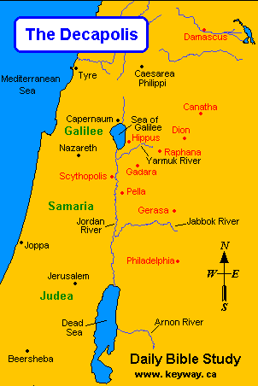

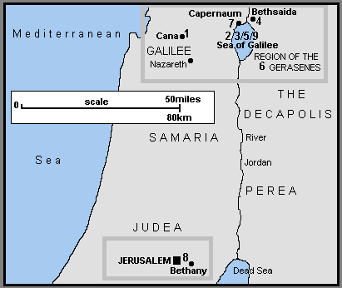
Matthew 4:23-25 read,
Jesus went throughout Galilee, teaching in their synagogues, proclaiming the good news of the kingdom, and healing every disease and sickness among the people. 24 News about him spread all over Syria, and people brought to him all who were ill with various diseases, those suffering severe pain, the demon-possessed, those having seizures, and the paralyzed; and he healed them.25 Large crowds from Galilee, the Decapolis, Jerusalem, Judea and the region across the Jordan followed him.

Jesus who is the Chief Shepherd might have had this place in mind for prayer and wanted to help a young man suffering from demon possession.

1-3, What kind of place was this? (26)
Greek immigrants had colonized this area, and the 14th Roman Legion also occupied this territory in the name of the Roman Emperor.
Jesus and his disciples may have arrived in the wee hours of the late night due to the storm, so they were probably very exhausted.

1-4, Who met them and how was his condition? (27, 29b)
When Jesus stepped ashore, he was met by a demon-possessed man from the town. For a long time this man had not worn clothes or lived in a house, but had lived in the tombs. Many times it had seized him, and though he was chained hand and foot and kept under guard, he had broken his chains and had been driven by the demon into solitary places.

1-5, What might have made him to be demon-possessed?

We don’t know exactly but we can imagine what might have made him to be demon possessed. According to verse 27, he hated to stay in a house. He might have been influenced by his bad friends talking about some freedom, with whom he tried drugs, smoking, or drinking experimentally. His brain that was not grown fully was most likely altered due to substance abuse at an early tender age and he became a slave of being high. As a high risk teenager, he could dream more aggressive adventures and watched youtube to learn how to be away from home and survive by himself. One day without his parents’ permission, he implemented what he had in mind and went to the places where Roman soldiers had a drinking party, asking for money to run away. Then he might have sought unlimited freedom. He most likely lived according to his feelings and enjoyed unlimited freedom. This might happen when he was almost becoming of legal age.

According to his high risk behavior and his propensity to seek instant gratification, he must have had hard time to secure a stable job contrary to his expectation. Although he had chance to learn how to get a job through so called, job interview session in a skill-Gerasene class, still his selfish brain was hindering him from staying at one place. He might hate to stay with a boss who set rules and regulations. He had to move on to get what he wants ‘in the moment’. His parents put security camera to watch him and even locked him in. However nothing would work as long as his life continued in dishonesty and lack of self-control.

His whole family became codependent addicts because of him. They must have good intentions to protect him but they became obsessive-compulsive and felt defeated. Despite their frustration and sacrificial efforts, he must have continued on a destructive path. At last they must have felt choiceless and helpless in the relationship for it was impossible to break away from the vicious cycle. This man must have been kicked out of school and been fired from job after job. Most likely he was finally kicked out of his home; however, his parents might have crossed their fingers that he would come back to his own senses when he hit rock-bottom. In this way they might pray that he might shorten his reckless life and come back home someday. In short he must have become an outcast of human society. Nobody bothered him who withdrew himself in the graveyard. He even threw his clothes which seemed to bother him also. But that was a problem. He was not able to get out of himself.

1-6, What did this man do when he saw Jesus? (28)

When he saw Jesus, he cried out and fell at his feet, shouting at the top of his voice, “What do you want with me, Jesus, Son of the Most High God? I beg you, don’t torture me!”
When he cried out and fell at his feet, he seemed to be paying homage and asking for help. At the same time, he rejected him violently. It seems that his personality was torn in two. It seems that he loved Jesus, and at the same time, he hated Jesus.

1-7, Why? (29a)

For Jesus had commanded the impure spirit to come out of the man.
He was hated by the people. But Jesus must have loved him with hope. Jesus must have seen him as a most dear one and one who was created in the image of God no matter how terrible he might have been. Jesus really wanted to help him.
In order for Jesus to help him, he made a correct diagnosis. It was a spiritual problem rather than physical or mental problems. Demon are Satan’s agents, also called unclean spirits. Demons attacked him and subdued him and made him their prisoner. Demons controlled him with absolute command.

1-8, What do his actions reveal about Jesus?

Jesus did not see him as a crazy or abnormal man. Jesus first had commanded the impure spirit to come out of the man. Jesus saw him spiritually and cast out demons in him. Instead of making friends with him, Jesus solemnly commanded the impure spirit to get out of the man. So what he said, “What do you want with me, Jesus, Son of the Most High God? I beg you, don’t torture me!” must have stemmed from the impure spirit in him.
When we see people who do terrible things, we can only despair, not knowing what is really going on inside their head. That was the very case with the townspeople. When this man became abnormal, they treated him as psychiatric patient and had a doctor prescribe the toxic medications without second thoughts. They were willing to call law enforcement officers to have him incarcerated. In the prison, it was out of control. And he was transferred to electric shock therapy and gamma radiation to damage his brain for good. Nowadays, though methods and approaches are different and became sophisticated, treatment of abnormal men is basically the same. People see such people only medically and scientifically.

- Read verse 30. What did Jesus say to the man? Why do you think Jesus asked his name? (Jn 10:3) How did he reply? What does this mean?

2-1, Read verse 30.

Jesus asked him, “What is your name?” “Legion,” he replied, because many demons had gone into him.

2-2, What did Jesus say to the man?

“What is your name?”

First of all Jesus wanted to remind him of his name. Biblically, a name symbolizes one’s whole man. A name represents one’s inner character. When Moses asked God, “What is your name?” he replied, “I AM WHO I AM” (Exo 3:14).

2-3, Why do you think Jesus asked his name? (Jn 10:3)

The gatekeeper opens the gate for him, and the sheep listen to his voice. He calls his own sheep by name and leads them out.

Jesus must have valued him as a lost sheep. Who knows? Jesus considered so many people as 99 sheep and left them to seek this wounded man as his dear sheep.

As parents are moaning and crying for their wild child, they even forget other children for their hearts go out to him or her all the time. Jesus is our loving parent and shepherd who can not give up his sheep no matter how far one goes in terms of committing sins. Praise Jesus who is the Good Shepherd for each of us!

2-4, How did he reply?

“Legion”

2-5, What does this mean?

The principal unit of the Roman army comprising up to 6000 foot soldiers with cavalry

He could not say his name. Here again the Demons answered on behalf of him. When he lived according to so called unlimited freedom but in fact according to his own sinful nature, demons began to enter his heart one by one. Many unclean spirits came into his heart. Finally they are too many to count. It looked hopeless and helpless. However there is a silver lining. Only Jesus can help them including this man on the passage.

Jesus must be intended to expose what is his true color by asking his name. As a result before Jesus’ solemn and divine question, no unclean spirits or evil beings can hide. It is like the momentum when God asked a question to the first Adam, “Where are you?” By calling his name, Jesus wanted to restore the love relationship with him. This crazy man must have listened both what Jesus asked and what the demons replied. He must have desired earnestly to restore God’s image.

- Read verses 31-37. What did the demons beg of Jesus? (31) Why did Jesus consent? What can we learn from Jesus? What happened to the pigs and the man? (33, 35) Why did Jesus have to leave? (34, 35-37) What does this reveal about him?

3-1, Read verses 31-37.

31 And they begged Jesus repeatedly not to order them to go into the Abyss. 32 A large herd of pigs was feeding there on the hillside. The demons begged Jesus to let them go into the pigs, and he gave them permission. 33 When the demons came out of the man, they went into the pigs, and the herd rushed down the steep bank into the lake and was drowned. 34 When those tending the pigs saw what had happened, they ran off and reported this in the town and countryside, 35 and the people went out to see what had happened. When they came to Jesus, they found the man from whom the demons had gone out, sitting at Jesus’ feet, dressed and in his right mind; and they were afraid. 36 Those who had seen it told the people how the demon-possessed man had been cured. 37 Then all the people of the region of the Gerasenes asked Jesus to leave them, because they were overcome with fear. So he got into the boat and left.

3-2, What did the demons beg of Jesus? (31, 32)

And they begged Jesus repeatedly not to order them to go into the Abyss. 32 A large herd of pigs was feeding there on the hillside. The demons begged Jesus to let them go into the pigs, and he gave them permission.

3-3, Why did Jesus consent?

Because these pigs were not Jesus’, it didn’t seem to make sense. However Jesus valued one man’s life so much that he could forget the whole business of the region.

3-4, What can we learn from Jesus?

Maybe Jesus intended to teach a valuable lesson. No matter what the consensus of the world might be, the truth is that one person’s life is more precious than the whole universe.

3-5, What happened to the pigs and the man? (33, 35)

When the demons came out of the man, they went into the pigs, and the herd rushed down the steep bank into the lake and was drowned. 34 When those tending the pigs saw what had happened, they ran off and reported this in the town and countryside, 35 and the people went out to see what had happened. When they came to Jesus, they found the man from whom the demons had gone out, sitting at Jesus’ feet, dressed and in his right mind; and they were afraid.

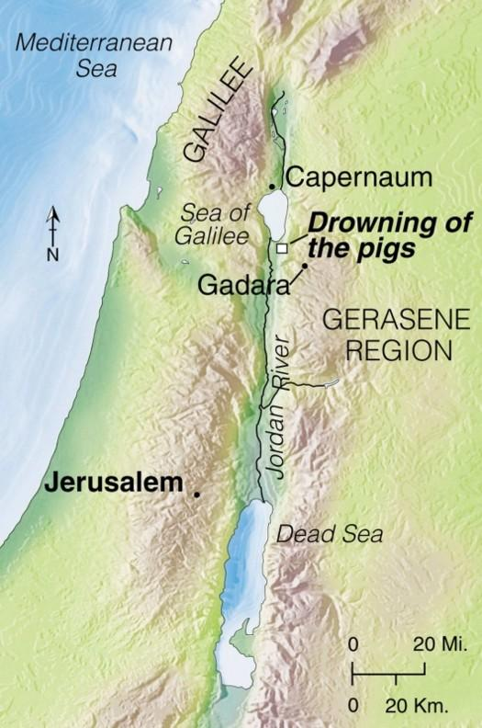

3-6, Why did Jesus have to leave? (34, 35-37)

and the people went out to see what had happened. When they came to Jesus, they found the man from whom the demons had gone out, sitting at Jesus’ feet, dressed and in his right mind; and they were afraid. 36 Those who had seen it told the people how the demon-possessed man had been cured. 37 Then all the people of the region of the Gerasenes asked Jesus to leave them, because they were overcome with fear. So he got into the boat and left.

In short, they were very fearful of further financial loss. What they were thinking about was their financial aspect rather than the value of one life. So rather than being thankful and praising God, they asked Jesus to leave without delay.

3-7, What does this reveal about him?

Jesus intended to retreat with his disciples. But they ended up meeting with a demon possessed man and they could not have slept at all. Although it was scary to serve him, he had chance to observe what Jesus had done for him. They must have learned the mind of God in Jesus Christ. When we are extremely tired or in despair, our true colors may be revealed. Praise Jesus our Lord who set a good example for us to learn.

**It reminds us of a couple of passages.

John 10:11-18 read,

“I am the good shepherd. The good shepherd lays down his life for the sheep. 12 The hired hand is not the shepherd and does not own the sheep. So when he sees the wolf coming, he abandons the sheep and runs away. Then the wolf attacks the flock and scatters it. 13 The man runs away because he is a hired hand and cares nothing for the sheep. 14 “I am the good shepherd; I know my sheep and my sheep know me— 15 just as the Father knows me and I know the Father—and I lay down my life for the sheep. 16 I have other sheep that are not of this sheep pen. I must bring them also. They too will listen to my voice, and there shall be one flock and one shepherd. 17 The reason my Father loves me is that I lay down my life—only to take it up again. 18 No one takes it from me, but I lay it down of my own accord. I have authority to lay it down and authority to take it up again. This command I received from my Father.”

Mark 10:45 also reads,

45 For even the Son of Man did not come to be served, but to serve, and to give his life as a ransom for many.”

- Read verses 38-39. What did the man beg of Jesus? What did Jesus tell him to do? What did he do? How much do you think Jesus has done for you? How much do you share about this with others?

4-1, Read verses 38-39.

38 The man from whom the demons had gone out begged to go with him, but Jesus sent him away, saying, 39 “Return home and tell how much God has done for you.” So the man went away and told all over town how much Jesus had done for him.

4-2, What did the man beg of Jesus?

The man healed was so grateful to Jesus for his healing. He personally experienced God’s love through Jesus. He could not miss Jesus. He wanted to follow him for good.

4-3, What did Jesus tell him to do?

“Return home and tell how much God has done for you.”

What Jesus wanted him to do was to become a thankful man who acknowledges God’s grace through Jesus always. Unthankfulness may have been the cause of all his problems. As a powerful prevention, Jesus prescribed the best medicine for him. In this way Jesus helped him to use his freedom for the right purpose. Imagine his testimony!

“You know, I was a crazy Gerasene demoniac with selfish brain. But see, now I am a new creation in Jesus Christ. Do you want to who Jesus is? Let me tell you about him and what he has done for me.”

4-4, What did he do?

So the man went away and told all over town how much Jesus had done for him.

4-5, How much do you think Jesus has done for you?

Personal application

4-6, How much do you share about this with others?

Personal application

In Conclusion,

Two Bible passages may fit for the conclusion. 1 Corinthians 15:10 reads, “But by the grace of God I am what I am, and his grace to me was not without effect. No, I worked harder than all of them—yet not I, but the grace of God that was with me.” 1 Timothy 1:15-17 read, “Here is a trustworthy saying that deserves full acceptance: Christ Jesus came into the world to save sinners—of whom I am the worst. 16 But for that very reason I was shown mercy so that in me, the worst of sinners, Christ Jesus might display his immense patience as an example for those who would believe in him and receive eternal life. 17 Now to the King eternal, immortal, invisible,the only God, be honor and glory for ever and ever. Amen.”

One Word: What is your name?

