There is no one greater than John

Luke 7:18-35
Key Verse 28

“I tell you, among those born of women there is no one greater than John; yet the one who is least in the kingdom of God is greater than he.”

Introduction

This passage is about John the Baptist, who sent his disciples to Jesus to ask who Jesus really is. Jesus recognized John’s work and his mission from God’s point of view. Although John is great and a true prophet, he is a friend of the bridegroom, but those who taste the grace of Jesus have a great privilege as the brides of Jesus by his blood, though we are the least in his kingdom. May the Lord bless us with the passage to adopt Jesus’ right view so that we may not be victimized by any distorted views, but acknowledge that God’s way is right and continue to serve God’s kingdom confidently.

1. Read verses 18-20. When John’s disciples told him about Jesus’ work, why does John send his disciples to ask Jesus a question (Mt 11:2) Why might this question be important for him?

1-1, Read verses 18-20.

John’s disciples told him about all these things. Calling two of them, ¹⁹ he sent them to the Lord to ask, “Are you the one who is to come, or should we expect someone else?” ²⁰ When the men came to Jesus, they said, “John the Baptist sent us to you to ask, ‘Are you the one who is to come, or should we expect someone else?’”

1-2, When John’s disciples told him about Jesus’ work, why does John send his disciples to ask Jesus a question? (Mt 11:2)

John’s disciples told him about all these things.

This passage begins with the disciples of John the Baptist reporting on Jesus' ministry. In the early part of chap. 7, Jesus healed the servant of a Roman centurion by His word. Jesus also met a grieving widow on her way to bury her only son. However Jesus touched the coffin, saying, "Young man, I say to you, get up!" The man came back to life and was given to his mother.

John's disciples must have been told of other powerful things such as Jesus' teaching and discipleship ministry. They had never seen such work.

When John, who was in prison, heard about the deeds of the Messiah, he sent his disciples (Mt 11:2)

At that time, John was in prison. John had rebuked King Herod for he had taken his brother's wife to be his own. Instead of repenting his sin, Herod put John in prison. (Lk 3:19-20)

Being put in prison must have been hard for John and his disciples. Jesus could have done something for John to rescue him from Herod, and brought justice. But he did not rescue him; rather he continued to proclaim the gospel by going to Galilee. (Mk 1:14)

What Jesus was doing is what the Messiah is supposed to do according to the Old Testament. (Isaiah 61:1, 2) John wanted to confirm if Jesus is the Messiah to come. Or John would have intended to help his disciples who might have lost their faith.

1-3, Why might this question be important for him?

He had a sense of mission as the forerunner of the Messiah, so it was very important for him to know who the Messiah is.

At a time of struggling and doubt, John's disciples went to Jesus to ask this necessary question. “Was Jesus the one whom God promised to send into the world to save all peoples?” For these disciples, the answer would determine their life direction.

Likewise situations in our lives do not appear to be the way we would have expected. We face difficulties, hardships, and things we cannot understand even though we are struggling to please the Lord.

We may also face misunderstandings from loved ones, ministries that are stagnant, financial problems, struggles with our children, struggles with our health, struggles with our future direction, struggles with sins, and the list goes on.

When we are pressed with doubt, we should not complain about people or give up. Instead of focusing on ourselves or problems, like John's disciples who went to Jesus, we must also honestly come to Jesus in prayer and Bible study with the question, "Are you the one?" Receiving Jesus' answer will solve our inner agonies and solidify our devotion.

2. Read verses 21-23. What is Jesus doing at that very time? (21) Why is Jesus’ work relevant to John’s question? (Lk 4:18, Isa 35:5-6; 61:1-2) How does Jesus reply to the messengers? (22-23) Why do you think it is important for anyone to not stumble on account of Jesus? (23)

2-1, Read verses 21-23.

At that very time Jesus cured many who had diseases, sicknesses and evil spirits, and gave sight to many who were blind. ²² So he replied to the messengers, “Go back and report to John what you have seen and heard: The blind receive sight, the lame walk, those who have leprosy are cleansed, the deaf hear, the dead are raised, and the good news is proclaimed to the poor. ²³ Blessed is anyone who does not stumble on account of me.”

2-2, What is Jesus doing at that very time? (21)

At that very time Jesus cured many who had diseases, sicknesses and evil spirits, and gave sight to many who were blind.

John's disciples witnessed firsthand what Jesus was doing. To answer their question, Jesus started with what they were observing.

2-3, Why is Jesus’ work relevant to John’s question? (Lk 4:18, Isa 35:5-6; 61:1-2)

“The Spirit of the Lord is on me, because he has anointed me to proclaim good news to the poor. He has sent me to proclaim freedom for the prisoners and recovery of sight for the blind, to set the oppressed free, (Lk 4:18)

Then will the eyes of the blind be opened and the ears of the deaf unstopped. Then will the lame leap like a deer, and the mute tongue shout for joy.
Water will gush forth in the wilderness and streams in the desert. (Isa 35:5-6)

The Spirit of the Sovereign Lord is on me, because the Lord has anointed me to proclaim good news to the poor. He has sent me to bind up the brokenhearted, to proclaim freedom for the captives and release from darkness for the prisoners, to proclaim the year of the Lord’s favor and the day of vengeance of our God, to comfort all who mourn (Isa 61:1-2)

Jesus did not directly answer their question, but he pointed out what was happening in his ministry. He phrased it in such a way that would remind John's disciples what the Old Testament said about the work of the Messiah, especially in the book of Isaiah.

In short, Jesus was doing what the Bible already said the Messiah would do. (Lk 24:44) Jesus is the one who was to come.

John's disciples could have complete confidence about this because Jesus was doing what God had exactly foretold about the Messiah.

2-4, How does Jesus reply to the messengers? (22-23)

So he replied to the messengers, “Go back and report to John what you have seen and heard: The blind receive sight, the lame walk, those who have leprosy are cleansed, the deaf hear, the dead are raised, and the good news is proclaimed to the poor. Blessed is anyone who does not stumble on account of me.”

The name of the game here is whether or not it was for John's disciples to accept it. “Blessed is the man who does not fall away on account of me.”

Jesus' way of working is not always what we might expect. But let's not fall away because of our own expectations or way of thinking. Jesus is the very one. We may suffer from
unexpected things but Jesus is worthy of any hardship we may face.

Thus verse 23 is a great promise of our Lord Jesus Christ who can not contradict himself.

Those who accept Jesus as the one are most blessed. Even though John was in prison and would lose his life there, he was blessed as long as he held on to Jesus and His words by faith.

For we live by faith, not by sight. (2 Corinthians 5:7)

Therefore, since we are surrounded by such a great cloud of witnesses, let us throw off everything that hinders and the sin that so easily entangles. And let us run with perseverance the race marked out for us, fixing our eyes on Jesus, the pioneer and perfecter of faith. For the joy set before him he endured the cross, scorning its shame, and sat down at the right hand of the throne of God. (Hebrew 12:1-2)

Jesus wanted them to take their attention off of themselves and their own situation and focus their attention on Jesus. Praise Jesus!

2-5, Why do you think it is important for anyone to not stumble on account of Jesus? (23)

Some people may have their own idea of the Messiah, but they may stumble because Jesus may not fit to their own messiahship (i.e., Judas Iscariot). We must humbly accept Jesus according to the word of God by giving up our own idea of messiah.

“Just as it is written, the righteous will live by faith.” (Romans 1:17b)

May the Lord bless each of us to not fall away at the time of our time of crisis but continue to devote ourselves to one to one and disciple making ministry for Bible America and World Mission!

3. Read verses 24-28. What does Jesus speak to the crowds about John? (24-28) Who is John and what is his mission? (26b-27) Why is John great? (27-28a) Why do you think the one who is least in the kingdom of God is greater than John? (28b)

3-1, Read verses 24-28.

After John’s messengers left, Jesus began to speak to the crowd about John: “What did you go out into the wilderness to see? A reed swayed by the wind? ²⁵ If not, what did you go out to see? A man dressed in fine clothes? No, those who wear expensive clothes and indulge in luxury are in palaces. ²⁶ But what did you go out to see? A prophet? Yes, I tell you, and more than a prophet. ²⁷ This is the one about whom it is written: “‘I will send my messenger ahead of you, who will prepare your way before you.’²⁸ I tell you, among those born of women there is no one greater than John; yet the one who is least in the kingdom of God is greater than he.”

3-2, What does Jesus speak to the crowds about John? (24-28)

When John's messengers left, Jesus turned his attention to the crowd. Jesus must have known that there was a misunderstanding about John the Baptist for he was in prison. So Jesus asked them questions about John. “'What did you go out into the desert to see?” “A reed swayed by the wind?”

To Jesus, how these people viewed John was related to how they would view him. We like celebrities. However they fade away. When they fade, we don't think much about them anymore.

If the crowd treated John like a celebrity, how would they treat Jesus to whom John was pointing? If they doubted John's ministry because he was in prison, certainly they would doubt Jesus' ministry when he went to the cross.

It was important to make the connection between John's ministry and Jesus' relevant and at the same time help their faith to rest on the unchanging facts of how God has worked and continues to work.

People today can be characterized as self-absorbed, present-focused, and feeling-centric. It is good to be concerned with our own present spiritual condition and feelings are important. But unless we learn to see how God has worked in the past and is working now in the world and the world to come, our faith remains shallow and selfish.

We better look up to God who is the Almighty God and the Sovereign Lord. We stop thinking, "It's about me or my own kingdom," and start thinking, "It's about God and His eternal kingdom."

We thus find direction in the "big picture" of God's work and history.

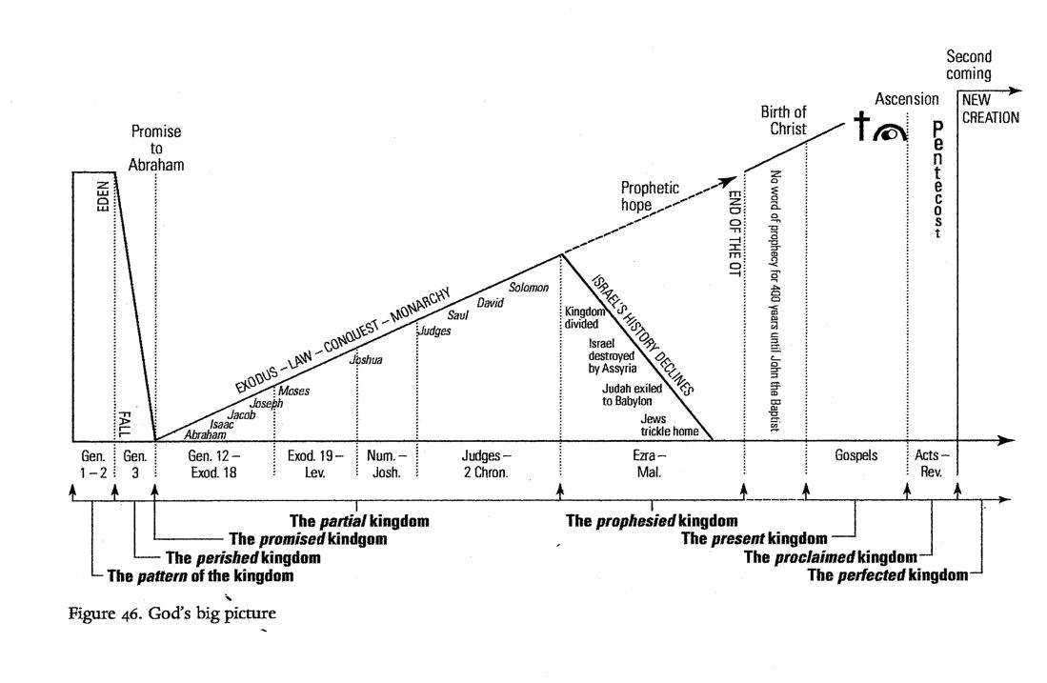

3-3, Who is John and what is his mission? (26b-27)

John was more than a prophet in the wilderness and he was in fact a forerunner of the messiah who prepared the way for Him.

How did Jesus connect John's ministry to his own? “This is the one about whom it is written: 'I will send my messenger ahead of you, who will prepare your way before you.” (27)

“I will send my messenger, who will prepare the way before me. Then suddenly the Lord you are seeking will come to his temple; the messenger of the covenant, whom you desire, will come,” says the Lord Almighty. (Malachi 3:1)

God would send a messenger right before he would send the Messiah in order that people’s hearts were prepared through his message.

That messenger was John. John pointed people to Jesus. This meant that Jesus is the Messiah. The whole point of John's ministry was to turn people to Jesus.

If they missed out on this, they would miss out on Jesus. But if they connected the Old Testament prophecy with John the Baptist, the only conclusion would be “Jesus.”

3-4, Why is John great? (27-28a)

He knew his mission in God’s work and he carried out his mission to the end as a martyr.

I tell you, among those born of women there is no one greater than John; yet the one who is least in the kingdom of God is greater than he.” (28a)

Jesus praised John the Baptist as the greatest man born of women. In this way, Jesus validated his ministry as one of the milestones in God's redemptive history.

John's ministry of repentance prepared people's hearts. John's ministry was necessary to help even the most hardened of sinners to realize their need to get right with God.

3-5, Why do you think the one who is least in the kingdom of God is greater than John? (28b)

John, though he was great, belonged to the age of the old covenant, which was mainly preparatory to Christ. The least new covenant saint has a higher privilege in Christ as a part of his bride (Eph 5:25-27, 32) than John the Baptist, who was only a friend of the bridegroom (John 3:29).

Husbands, love your wives, just as Christ loved the church and gave himself up for her ²⁶ to make her holy, cleansing her by the washing with water through the word, ²⁷ and to present her to himself as a radiant church, without stain or wrinkle or any other blemish, but holy and blameless.” (Eph 5:25-27)

This is a profound mystery—but I am talking about Christ and the church.” (Eph 5:32)
The bride belongs to the bridegroom. The friend who attends the bridegroom waits and listens for him, and is full of joy when he hears the bridegroom’s voice. That joy is mine, and it is now complete.” (Jn 3:29)

Also, we can say, “he who is the least” means “whoever humbles themselves like a child” would be regarded as the greatest in the kingdom of heaven as even greater than John the Baptist. (Mt 18:4)

Therefore, whoever takes the lowly position of this child is the greatest in the kingdom of heaven. (Mt 18:4)

4. Read verses 29-35. Why do all the people and the religious leaders respond differently? (29-30) To whom does Jesus compare the people of that generation? (31-32) How do they criticize both John’s and Jesus’ ministry? (33, 34) How is wisdom proved right? (35)

4-1, Read verses 29-35.

(All the people, even the tax collectors, when they heard Jesus’ words, acknowledged that God’s way was right, because they had been baptized by John. ³⁰ But the Pharisees and the experts in the law rejected God’s purpose for themselves, because they had not been baptized by John.) ³¹ Jesus went on to say, “To what, then, can I compare the people of this generation? What are they like? ³² They are like children sitting in the marketplace and calling out to each other: “‘We played the pipe for you, and you did not dance; we sang a dirge, and you did not cry.’ ³³ For John the Baptist came neither eating bread nor drinking wine, and you say, ‘He has a demon.’ ³⁴ The Son of Man came eating and drinking, and you say, ‘Here is a glutton and a drunkard, a friend of tax collectors and sinners.’ ³⁵ But wisdom is proved right by all her children.”

4-2, Why do all the people and the religious leaders respond differently? (29-30)

All the people, even the tax collectors, when they heard Jesus’ words, acknowledged that God’s way was right, because they had been baptized by John. ³⁰ But the Pharisees and the experts in the law rejected God’s purpose for themselves, because they had not been baptized by John.

All the people, who humbled themselves, had been baptized by John and accepted Jesus’s word, however, the religious leaders were proud and had not been baptized by John, so they rejected God’s purpose for themselves.

Likewise we see that there are only two different kinds of people: those who acknowledge that God's way is right and those who do not. God is sovereign and almighty. He always accomplishes his will in his own way.

4-3, To whom does Jesus compare the people of that generation? (31-32)

Jesus went on to say, “To what, then, can I compare the people of this generation? What are they like? ³² They are like children sitting in the marketplace and calling out to each other: “‘We played the pipe for you,

Jesus compared them to children sitting in the marketplace and calling out to each other.

4-4, How do they criticize both John’s and Jesus’ ministry? (33, 34)

For John the Baptist came neither eating bread nor drinking wine, and you say, ‘He has a demon.’ The Son of Man came eating and drinking, and you say, ‘Here is a glutton and a drunkard, a friend of tax collectors and sinners.’

Many people, in their childish pride, still refused to acknowledge that God's way was
right. They had in their own mind what they wanted and expected from the Messiah.

No matter what God did to change their mind, they refused. They used whatever excuse they could find in order not to repent.

4-5, How is wisdom proved right? (35)

“But wisdom is proved right by all her children.”

In contrast to the rejection by the foolish critics, spiritually wise persons could see that ministries of both John and Jesus were godly, despite their differences.

Those who have repented of their sins, received Jesus' death and resurrection for the forgiveness of their sins and have been born again, prove that God's wisdom in salvation is right.

The children of God who pass through life's trials with faith in Jesus, also prove that God's wisdom is right by the fruit of their lives.

In conclusion

God used John and Jesus differently for his redemptive work. Although John was great and a true prophet, he was a friend of the bridegroom, but he or she who tastes the grace of Jesus, has a great privilege as the bride of the lamb, Jesus by his blood, though he or she is humble and the least in his kingdom. May the Lord help us to be God’s humble children so that we may acknowledge that God’s way is right. “I pray that the eyes of your heart may be enlightened in order that you may know the hope to which he has called you, the riches of his glorious inheritance in his holy people.” (Eph 1:18)

One word: The one who is the least in the kingdom of God

