Whose Son is the Messiah?

Luke 20:41-47
Key Verse 42b, 43

“‘The Lord said to my Lord: “Sit at my right hand until I make your enemies a footstool for your feet.”’

Introduction

In the previous lessons, religious leaders came up with questions to trap Jesus. But today Jesus took initiative to question the teachers of the law in order to teach them who the Son of God is. Jesus must have thought that the teachers of the law were in charge of a very important task to teach the people with God’s words. When they had an unhealthy view about Jesus, the outcome of their teaching was devastating. Jesus had a shepherd heart for them. May the Lord help us not to repeat the same mistake as these religious leaders. Instead, may we grow as Bible teachers who have correct knowledge about Jesus in this confusing generation.

1. Read verses 41-42. What might have prompted Jesus to say this? (39) What question did Jesus ask them? (41) What did David say about Jesus in Psalm 110? (42) Who are ‘the Lord’ and ‘my Lord’? What does this conversation reveal about who Jesus is?

1-1, Read verses 41-42.

Then Jesus said to them, “Why is it said that the Messiah is the son of David? 42 David himself declares in the Book of Psalms: “‘The Lord said to my Lord: “Sit at my right hand

1-2, What might have prompted Jesus to say this? (39)

Some of the teachers of the law responded, “Well said, teacher!” 40 And no one dared to ask him any more questions.

- The Sadducees were silenced, and no one asked any more questions.
- But some of the teachers of the law, so impressed by Jesus’ Bible teaching, called out, “Well said, teacher!”
- But Jesus wasn’t going to forge a political alliance with the teachers of the law. Instead, Jesus points out a problem in their teaching regarding the Messiah.

1-3, What question did Jesus ask them? (41)

Then Jesus said to them, “Why is it said that the Messiah is the son of David?

- Teachers taught about the coming Messiah as the Son of David. They were looking forward to a descendant of David who would retake the throne and herald in a new age of Jewish dominance.

1-4, What did David say about Jesus in Psalm 110? (42)

David himself declares in the Book of Psalms: “‘The Lord said to my Lord: “Sit at my right hand

David himself, speaking by the Holy Spirit, declared: “‘The Lord said to my Lord: “Sit at my right hand (Mark 12:36a)
- This Old Testament verse is the most quoted verse in the New Testament.

1-5, Who are ‘the Lord’ and ‘my Lord’?

- Surely David wasn’t referring to himself as “my lord,” nor was God referring to himself, and so David and God must’ve been addressing someone else of great importance: the messiah!

- In English, the same word "Lord" appears twice. But in Hebrew these are two different words.
- The first "Lord" is translated from "Yahweh" and refers to the sacred name of God.
- The second "Lord" is translated from "Adonai" and refers to the one who is absolutely sovereign.
- In the Ten Commandments, the people of Israel were warned against abusing or misusing the sacred name of God, Yahweh.
- The Jewish people became very careful about guarding themselves, lest they be found guilty of blasphemy.
- To do so, they devised different titles which became substitutes for the name Yahweh.
- The supreme title of substitution was Adonai, meaning, the one who is sovereign over the kings of the world.

1-6, What does this conversation reveal about who Jesus is?

- What David wrote in Psalm 110:1 was: “Yahweh says to my Adonai.” God is having a conversation with someone whom David is addressing as Adonai.
- And Adonai is God’s title. It is that supreme title, the title reserved for God himself, which is bestowed upon Jesus Christ.
- In short, David was saying, “Jesus is God, the one who is absolutely sovereign over the kings of the world.”

2. Read verses 43-44. How does the Lord make His enemies a footstool for his feet? (43, Php 2:6-11) What can we learn from his declaration? What was the relationship between David and my ‘Lord’? (44)

2-1, Read verses 43-44.

until I make your enemies a footstool for your feet.”’ 44 David calls him ‘Lord.’ How then can he be his son?”

2-2, How does the Lord make His enemies a footstool for his feet? (43, Php 2:6-11)

until I make your enemies a footstool for your feet.”’

In your relationships with one another, have the same mindset as Christ Jesus: 6 Who, being in very nature God, did not consider equality with God something to be used to his own advantage; 7 rather, he made himself nothing by taking the very nature of a servant, being made in human likeness. 8 And being found in appearance as a man, he humbled himself by becoming obedient to death— even death on a cross! 9 Therefore God exalted him to the highest place and gave him the name that is above every name, 10 that at the name of Jesus every knee should bow, in heaven and on earth and under the earth, 11 and every tongue acknowledge that Jesus Christ is Lord, to the glory of God the Father.

2-3, What can we learn from his declaration?

- First of all, both God and Jesus struck a conversation.
- God the Father said to God the Son, “Sit at my right hand until I make your enemies a footstool for your feet”
- God the Father, God the Son, and God the Spirit have complete unity according to John 17:23. Still they have three entities, similar to our state.
- Our federal government has 3 parts: the Executive, (President and about 5,000,000 workers) Legislative (Senate and House of Representatives) and Judicial (Supreme Court and lower Courts).
- The President of the United States administers the Executive Branch of our government. He enforces the laws that the Legislative Branch (Congress) makes.
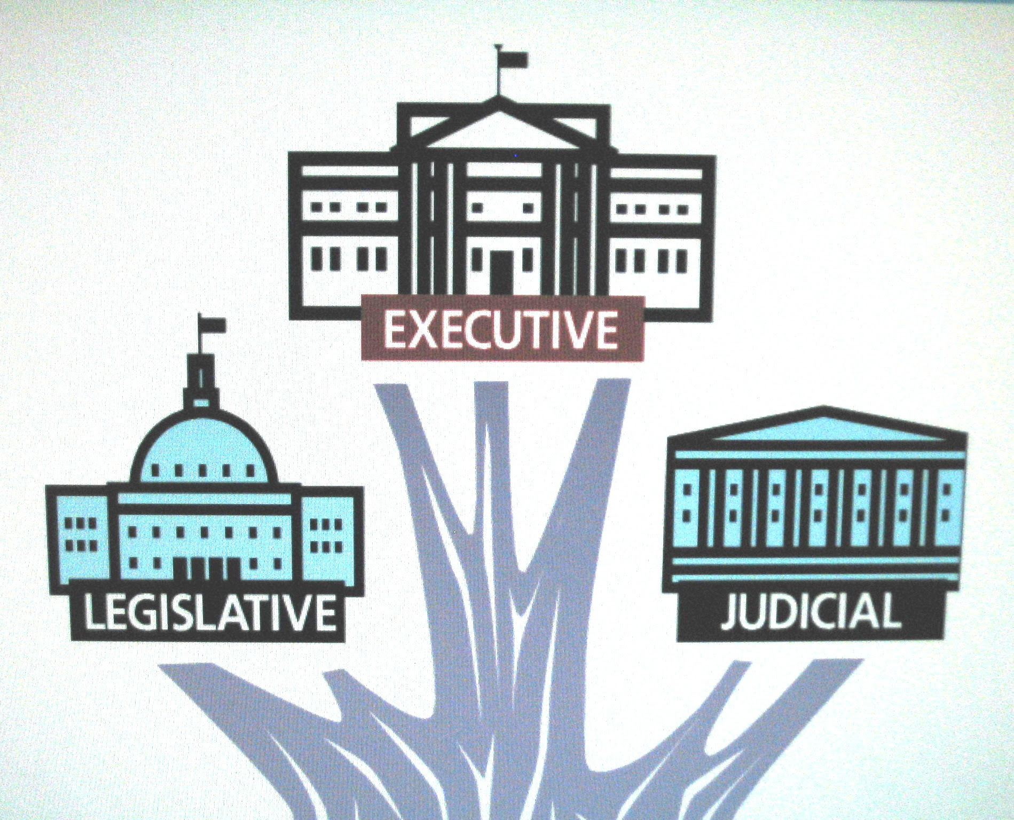

- God the Father is declaring His solemn laws and His words of promise. (Genesis 3:15)

- God the Spirit convicts us regarding sin, righteousness, and judgement. (John 16:5-16)

- God the Son, Jesus Christ is in charge of executive duties, performing critical deeds such as creation, administration, and judgment.

John 1:1- 3 reads,

In the beginning was the Word, and the Word was with God, and the Word was God. 2 He was with God in the beginning. 3 Through him all things were made; without him nothing was made that has been made.

Colossians 1:15-19 reads,

The Son is the image of the invisible God, the firstborn over all creation. 16 For in him all things were created: things in heaven and on earth, visible and invisible, whether thrones or powers or rulers or authorities; all things have been created through him and for him. 17 He is before all things, and in him all things hold together. 18 And he is the head of the body, the church; he is the beginning and the firstborn from among the dead, so that in everything he might have the supremacy. 19 For God was pleased to have all his fullness dwell in him,

John 5:22 reads,

Moreover, the Father judges no one, but has entrusted all judgment to the Son, 23 that all may honor the Son just as they honor the Father. Whoever does not honor the Son does not honor the Father, who sent him.

- Above all, what Jesus focused on was to lower Himself (becoming incarnate God) to reconcile us back to God.

Colossians 1:20-22 reads,

and through him to reconcile to himself all things, whether things on earth or things in heaven, by making peace through his blood, shed on the cross. 21 Once you were alienated from God and were enemies in your minds because of your evil behavior.22 But now he has reconciled you by Christ’s physical body through death to present you holy in his sight, without blemish and free from accusation

- Although Jesus is God, He humbled Himself like a servant of God. He did this to fulfill God’s will on the cross as the Lamb of God.
- Against all odds, Jesus chose to trust His Heavenly Father to the end.
- His mind must have been heavy due to the fact that He would be crucified soon according to God’s will.
- On the cross He exclaimed, “Why do you forsake me?” But there was no answer from above. He had to die lonely. He yielded Himself to the utter darkness by becoming sin and a curse.
- But that was not all. God raised Him from the dead and put all His enemies under His feet, making them His footstool.

1 Corinthians 5:20-28 reads,

But Christ has indeed been raised from the dead, the firstfruits of those who have fallen asleep. 21 For since death came through a man, the resurrection of the dead comes also through a man. 22 For as in Adam all die, so in Christ all will be made alive. 23 But each in turn: Christ, the firstfruits; then, when he comes, those who belong to him. 24 Then the end will come, when he hands over the kingdom to God the Father after he has destroyed all dominion, authority and power. 25 For he must reign until he has put all his enemies under his feet. 26 The last enemy to be destroyed is death. 27 For he “has put everything under his feet.” Now when it says that “everything” has been put under him, it is clear that this does not include God himself, who put everything under Christ. 28 When he has done this, then the Son himself will be made subject to him who put everything under him, so that God may be all in all.

2-4, What was the relationship between David and my ‘Lord’? (44)

David calls him ‘Lord.’ How then can he be his son?”

- Although David was Jesus’ grand grand ancestor physically, Jesus was before David.

Revelation 22:12-13 reads,

“Look, I am coming soon! My reward is with me, and I will give to each person according to what they have done. 13 I am the Alpha and the Omega, the First and the Last, the Beginning and the End.”

- Jesus is King of kings and Lord of lords. So David, a human king was a mere servant of Jesus Christ.

Revelation 19:11-16 reads,

I saw heaven standing open and there before me was a white horse, whose rider is called Faithful and True. With justice he judges and wages war. 12 His eyes are like blazing fire, and on his head are many crowns. He has a name written on him that no one knows but he himself. 13 He is dressed in a robe dipped in blood, and his name is the Word of God. 14 The armies of heaven were following him, riding on white horses and dressed in fine linen, white and clean. 15 Coming out of his mouth is a sharp sword with which to strike down the nations. “He will rule them with an iron scepter.” He treads the winepress of the fury of the wrath of God Almighty. 16 On his robe and on his thigh he has this name written: king of kings and lord of lords.

- David went through one battle after another. His life must have been hard due to continuous battles from every direction.
- The book of Psalm depicts how tough his life must have been!
- However he sanctified his hardships to know the Messiah deeper.
- It reminds us of what his son, Solomon said in 1 Kings 5:1-5.

When Hiram king of Tyre heard that Solomon had been anointed king to succeed his father David, he sent his envoys to Solomon, because he had always been on friendly terms with David. 2 Solomon sent back this message to Hiram:
3 “You know that because of the wars waged against my father David from all sides, he could not build a temple for the Name of the Lord his God until the Lord put his enemies under his feet. 4 But now the Lord my God has given me rest on every side, and there is no adversary or disaster. 5 I intend, therefore, to build a temple for the Name of the Lord my God, as the Lord told my father David, when he said, ‘Your son whom I will put on the throne in your place will build the temple for my Name.’

- Although David was a shepherd boy, he had personal faith in the Lord.
- From the beginning of his success against lions in the field or Goliath, he relied on the name of the Lord in facing his enemies.
- As a result, he was able to win victories no matter where he went.
- Likewise he must have received one word through God’s word of declaration.

“Sit at my right hand until I put your enemies a footstool for your feet”

- The first and foremost step that we might have is to have trust in our Lord and King, Jesus Christ just as David had done throughout his lifetime, thick or thin.
- All he had to do is to sit and rest assured in his God, admitting the fact that he is helpless and hopeless, asking for God’s mercy through many prayers.
- God is the living God as we learned in previous lessons.
- Likewise David believed God is living and working amidst any difficulty he faced.
- It was the one and only secret through which he claimed victories - one after another.
- Praise Jesus who became the ultimate victor who helps each of us to claim the same victory as His co-heirs.
- May the Lord help us to trust in our Lord and King so that we may not succumb to any problems and challenges.
- May the Lord help us to grow in our personal faith and fight our battle to the end for God’s glory.

3. Read verses 45-47. What was Jesus’ warning to His disciples about the teachers of the law? (45-47a) Why will they be punished most severely? (47b) How can we avoid becoming like them?

3-1, Read verses 45-47.

45 While all the people were listening, Jesus said to his disciples, 46 “Beware of the teachers of the law. They like to walk around in flowing robes and love to be greeted with respect in the marketplaces and have the most important seats in the synagogues and the places of honor at banquets. 47 They devour widows’ houses and for a show make lengthy prayers. These men will be punished most severely.”

3-2, What was Jesus’ warning to His disciples about the teachers of the law? (45-47a)

While all the people were listening, Jesus said to his disciples, 46 “Beware of the teachers of the law. They like to walk around in flowing robes and love to be greeted with respect in the marketplaces and have the most important seats in the synagogues and the places of honor at banquets. 47 They devour widows’ houses and for a show make lengthy prayers.

- When they had shallow knowledge about Jesus, their practical lives were terrible as described above.
- Rather than promoting the good of others, they became rotten leaders.
- Praise Jesus who helped them to open their spiritual eyes although he was about to enter Jerusalem for his death on the cross.
Isa 30:15 says,
This is what the Sovereign Lord, the Holy One of Israel, says: “In repentance and rest is your salvation, in quietness and trust is your strength, but you would have none of it.” May the Lord help us increase our faith to trust in Him more.

3-3, Why will they be punished most severely? (47b)

These men will be punished most severely.”

3-4, How can we avoid becoming like them?

- We can avoid becoming like them through following Jesus’ humble and sacrificial life on earth.
- He is like a prototype for those who follow him.

Mark 8:34-38 reads,

“Then he called the crowd to him along with his disciples and said: “Whoever wants to be my disciple must deny themselves and take up their cross and follow me. 35 For whoever wants to save their life will lose it, but whoever loses their life for me and for the gospel will save it. 36 What good is it for someone to gain the whole world, yet forfeit their soul? 37 Or what can anyone give in exchange for their soul? 38 If anyone is ashamed of me and my words in this adulterous and sinful generation, the Son of Man will be ashamed of them when he comes in his Father’s glory with the holy angels.”

- Jesus wanted to protect His disciples from the bad influences of the religious leaders. He wanted them to follow His in his footsteps after His death, resurrection, and ascension.
- May the Lord help us to avoid false teachings in our times and follow Jesus to the end. As we do this by serving the will of God for us, challenging campus mission with absolute trust and faith.

Matthews 28:18-20 reads,

Then Jesus came to them and said, “All authority in heaven and on earth has been given to me. 19 Therefore go and make disciples of all nations, baptizing them in the name of the Father and of the Son and of the Holy Spirit, 20 and teaching them to obey everything I have commanded you. And surely I am with you always, to the very end of the age.”

Mark 16:15-20 reads,

He said to them, “Go into all the world and preach the gospel to all creation. 16 Whoever believes and is baptized will be saved, but whoever does not believe will be condemned. 17 And these signs will accompany those who believe: In my name they will drive out demons; they will speak in new tongues;18 they will pick up snakes with their hands; and when they drink deadly poison, it will not hurt them at all; they will place their hands on sick people, and they will get well.” 19 After the Lord Jesus had spoken to them, he was taken up into heaven and he sat at the right hand of God. 20 Then the disciples went out and preached everywhere, and the Lord worked with them and confirmed his word by the signs that accompanied it.

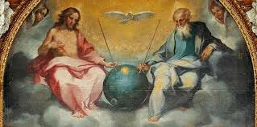

Conclusion

Today’s passage is a great comfort for us in that we are engaged in spiritual battle daily. But the Lord said to my Lord, “Sit at my right hand until I make your enemies a footstool at your feet.” We can rest assured with God’s word of promise in any challenging situation. May the Lord help us to claim Jesus’ victory in our mission life and in our remaining earthly lives. May we do this by repenting of all negative ideas and words so that we may follow Jesus’ footstep in serving God humbly. May we claim the ultimate victory in Him. Amen.

One word: Sit at my right hand!

