The Stone the Builders Rejected

Luke 20:9-19
Key Verse 13

“Then the owner of the vineyard said, ‘What shall I do? I will send my son, whom I love; perhaps they will respect him.’”

Introduction

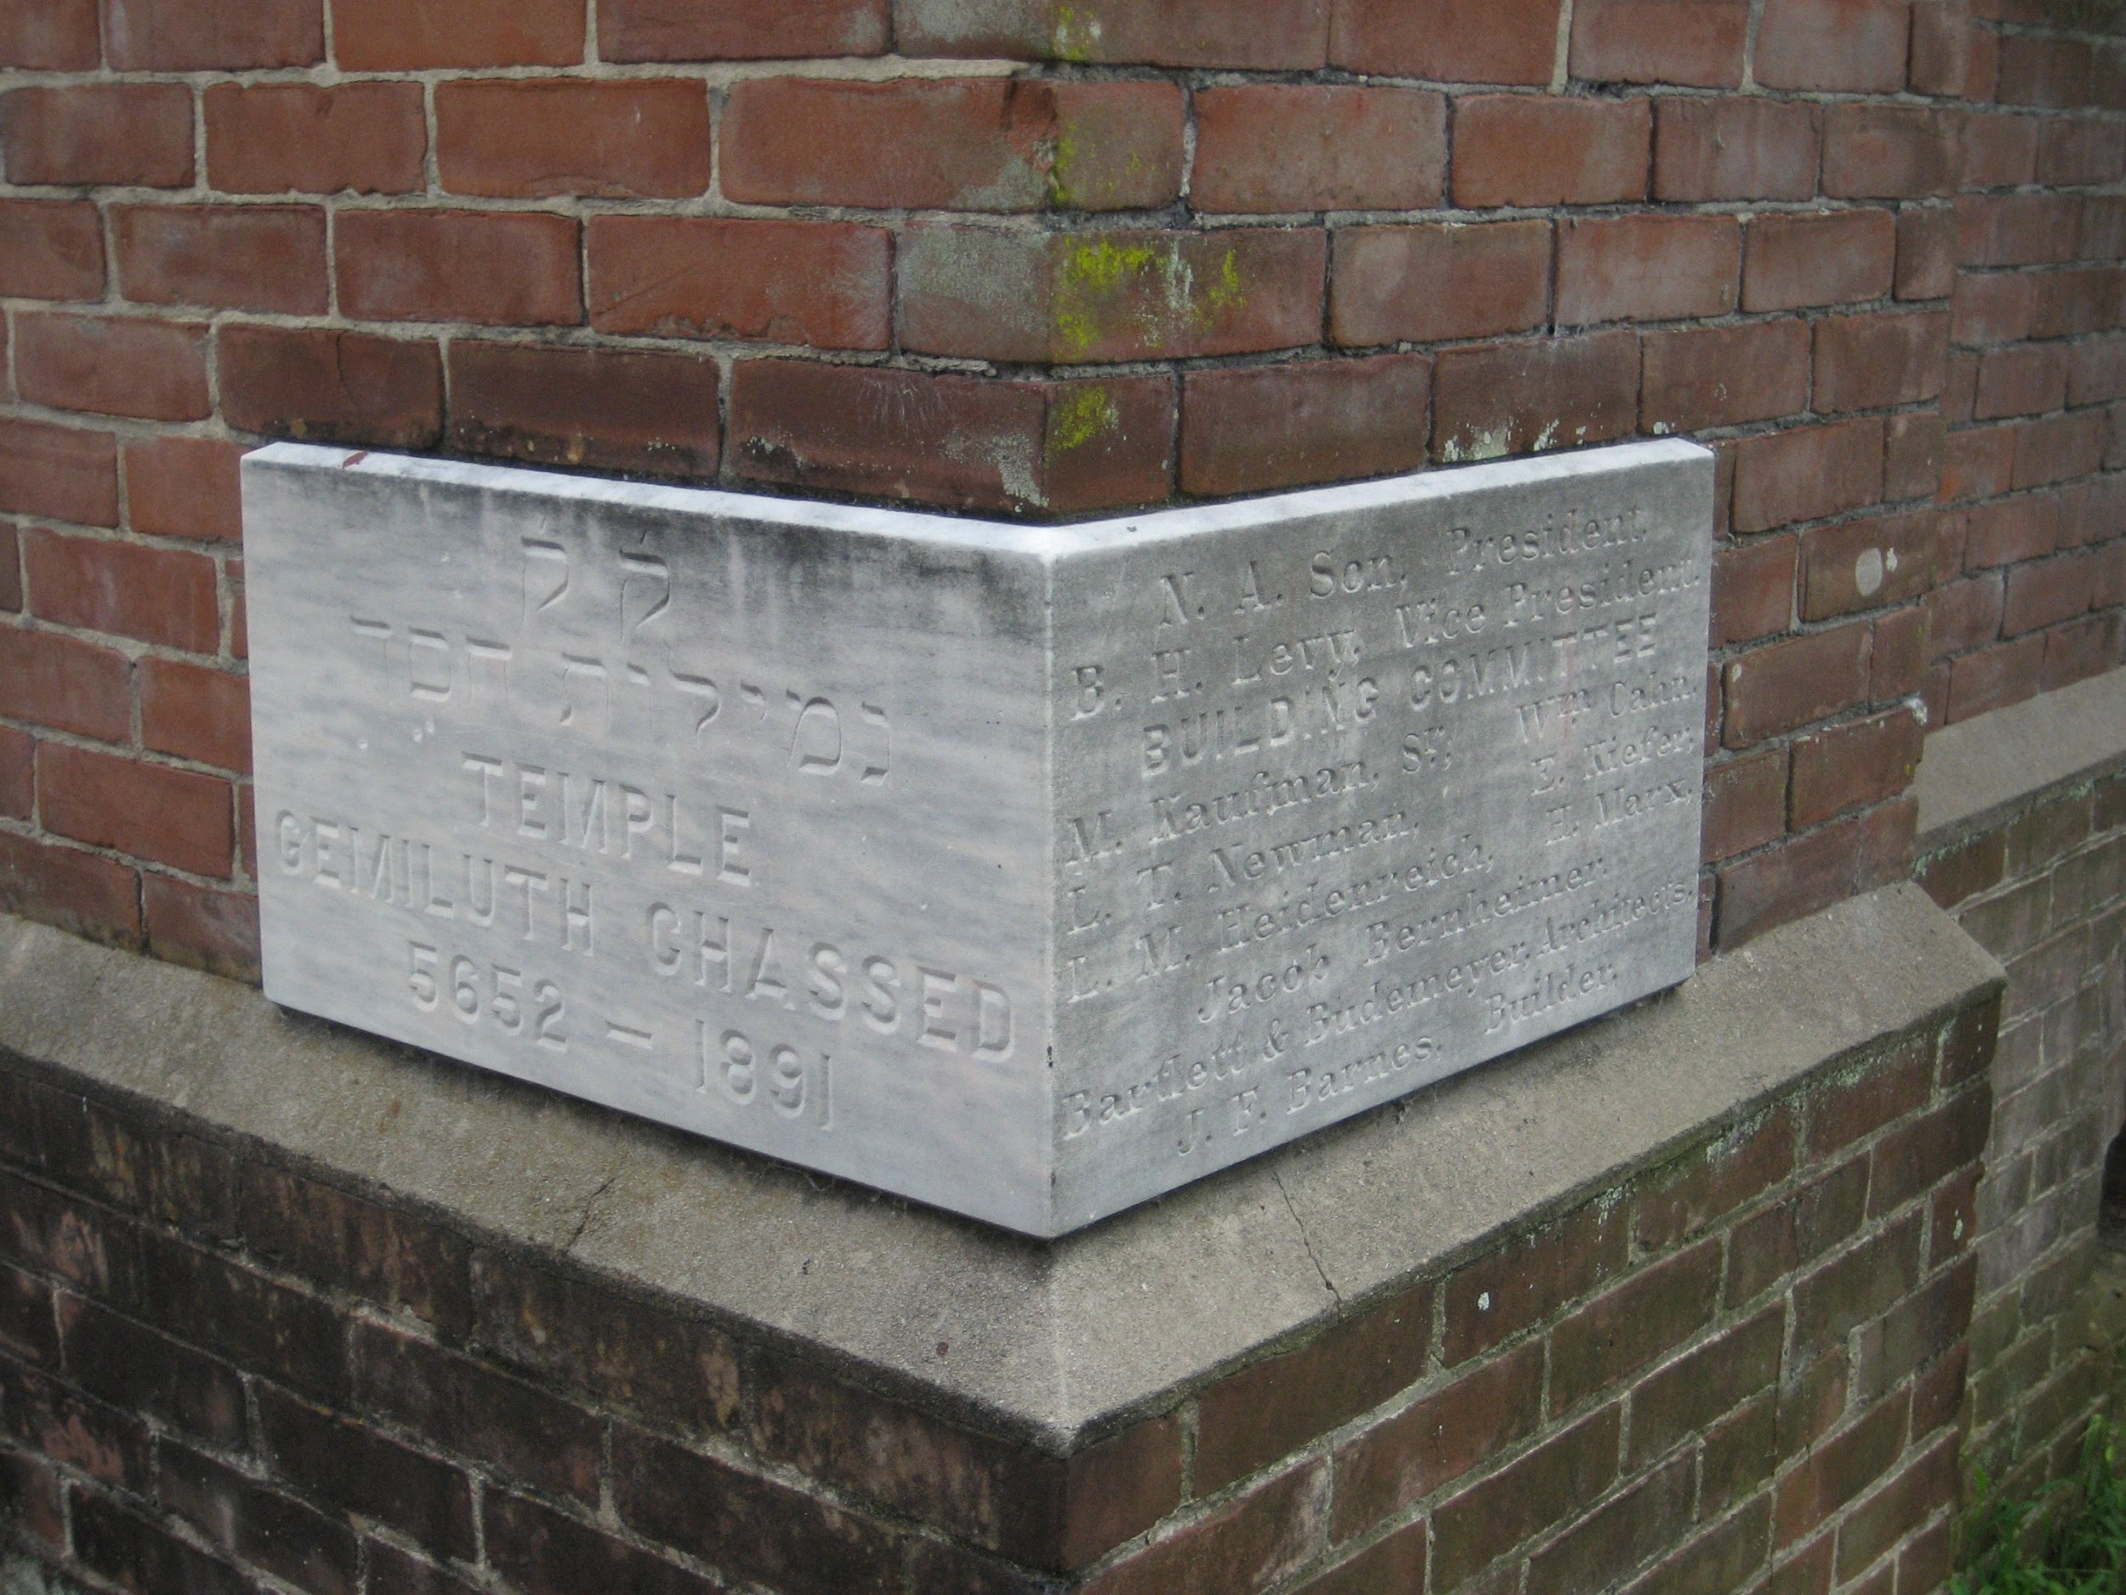
Today’s parable is about the owner of the vineyard and the tenants. In a nutshell, it is compared to a summary of God’s history since he created the garden of eden. In this parable, Jesus is compared with the stone the builders rejected. Imagine! A builder’s yard, full of stones ready for the task of building. Workers sort out slabs of marble and granite and arrange them into different sizes and shapes. Then they haul them up to their places on the wall. There is one stone that doesn’t belong in any of the other groups of materials. They separate it from the other pieces, expecting to throw it out when the job is done. But when they have almost finished, they discover that they need a stone of a particular shape for the very last piece. There is the stone they rejected earlier. It wouldn’t fit anywhere else, but it will fit here as pictured above. Likewise, Jesus is the cornerstone for God’s holy redemptive work. We would like to delve into God’s deepest love for each us by sending His one and only Son Jesus to die on the cross to save us from eternal condemnation. May the Lord help us to love and welcome Jesus in our hearts.

1. Read verse 9. To whom does “a man” refer to in this passage? Who do “some farmers” represent? What was the owner’s desire and expectation while he was away for a long time? (Isa 5:1-7)

1-1, Read verse 9.

He went on to tell the people this parable: “A man planted a vineyard, rented it to some farmers and went away for a long time.

1-2, To whom does “a man” refer to in this passage?

He went on to tell the people this parable: “A man planted a vineyard, rented it to some farmers and went away for a long time.”

1-3, Who do “some farmers” represent?

He went on to tell the people this parable: “A man planted a vineyard, rented it to some farmers and went away for a long time.

1-4, What was the owner’s desire and expectation while he was away for a long time? (Isa 5:1-7)

I will sing for the one I love a song about his vineyard: My loved one had a vineyard on a fertile hillside. 2 He dug it up and cleared it of stones and planted it with the choicest vines. He built a watchtower in it and cut out a winepress as well. Then he looked for a crop of good grapes, but it yielded only bad fruit. 3 “Now you dwellers in Jerusalem and people of Judah, judge between me and my vineyard. 4 What more could have been done for my vineyard than I have done for it? When I looked for good grapes, why did it yield only bad? 5 Now I will tell you what I am going to do to my vineyard: I will take away its hedge, and it will be destroyed; I will break down its wall, and it will be trampled. 6 I will make it a wasteland, neither pruned nor cultivated, and briers and thorns will grow there. will command the clouds not to rain on it.” 7 The vineyard of the Lord Almighty is the nation of Israel, and the people of Judah are the vines he delighted in. And he looked for justice, but saw bloodshed; for righteousness, but heard cries of distress.

- A man here or a landowner refers to God.
- The vineyard refers to his kingdom on earth. The farmers refer to the Israelites, but in a broader sense, to all mankind.
- The landowner took the time and effort to plant the vineyard just as God planted the garden of Eden in Genesis 2.
- According to Isaiah he planted this vineyard with the choicest of vines.
- Now what did God decide to do with this precious vineyard? He decided to rent it out to some farmers.
- In this way he had compassion on the farmers and gave them a job - to take care of his vineyard.
- After renting the vineyard out, he then went away for a long time. From this God first showed his trust in man.
- Trust is the most important part of any relationship.
- If I want to have a deep relationship with someone, the first thing I should work on is gaining their trust. When that trust is broken our relationship is broken.
- God put us in charge of the garden and his vineyard and went away for a long time to show us that he trusts us so that we can build a right relationship with him.

- Spiritually speaking God also expects us to bear fruit. He chose the Israelites to be his chosen people and treasured possession.
- Though the whole Earth was His, the Israelites were to be for him a kingdom of priests and a holy nation.
- What a privilege it was for the Israelites. He gave them his word and called them to be his witnesses so that all nations would be blessed through them.
- He gave them a land overflowing with milk and honey, a prosperous life, a mission to guard God’s glory.

- More fundamentally speaking, God has given each of us our very lives. No one created his own life; each person’s life is a gift from God.

John 1:3-5 reads,

“Through him all things were made; without him nothing was made that has been made. 4 In him was life, and that life was the light of all mankind. 5 The light shines in the darkness, and the darkness has not overcome it.”

- In addition, God has given each one talents and abilities, personality traits, strengths and weaknesses of character, and many other things.
- God did this for a purpose. It is essential for each of us to discover God’s purpose for our lives and to live for it, using the resources he has given to carry out that mission.
- And we should be thankful, recognizing all the grace God has given us freely by his love.
- Each person should be like a happy farmer who works hard each day with a thanks.
- Sometimes like the Israelites, we are prone to forgetting. Thus we must go through some training to be reminded of our Lord God.

Deuteronomy 8:3 reads,

“He humbled you, causing you to hunger and then feeding you with manna, which neither you nor your ancestors had known, to teach you that man does not live on bread alone but on every word that comes from the mouth of the LORD.”

2. Read verses 10-12. How did the tenants respond when the owner sent servants to collect some fruit from the harvest? (10) How did the tenants increase their hostility as the owner continued to send more servants? (11-12) What might have caused them to respond in such a way?

2-1, Read verses 10-12.

At harvest time he sent a servant to the tenants so they would give him some of the fruit of the vineyard. But the tenants beat him and sent him away empty-handed. 11 He sent another servant, but that one also they beat and treated shamefully and sent away empty-handed. 12 He sent still a third, and they wounded him and threw him out.

2-2, How did the tenants respond when the owner sent servants to collect some fruit from the harvest? (10)

At harvest time he sent a servant to the tenants so they would give him some of the fruit of the vineyard. But the tenants beat him and sent him away empty-handed.

- The owner of the vineyard desired and expected that the tenants would willingly give him some fruit out of their thanks and respect.
- It was a reasonable expectation. By giving the servant some fruit they could acknowledge that the vineyard was not theirs, but the owner's.
- They could maintain a proper relationship with the owner. Let us think for a moment what happens if we fail to pay the rent. Once we fail to pay our rent, the eviction process begins.

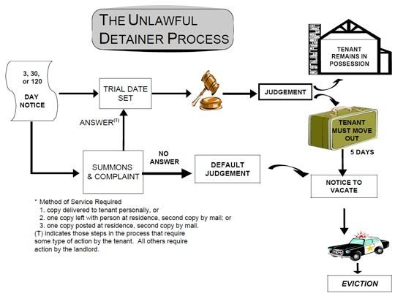

- If we have a mortgage on our house and fail to pay it for 3 months, the bank would begin the foreclosure process as follows.

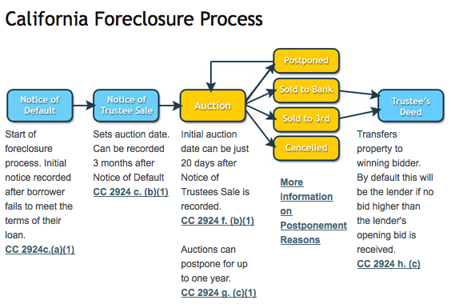

- God, however is not like such lenders we must pay. God doesn’t need our fruit. He doesn’t need it to make a living off of what we pay Him.
- Rather he uses this blessing to restore our relationship with Him and to remind us of how important it is to have a relationship with Him.

- God sent His prophets to the people so that they would produce the fruit of justice and righteousness, but instead they rejected the prophet’s message and worshiped idols.
- Because of their rejection and mistreatment of Jesus, the privilege to be his witnesses to all the nations is now for those of us who believe in Jesus as our personal Lord and Savior.
- God didn’t save us only for ourselves, but God wants to use us to bless all people in this world by sharing the love of Jesus.

2-3, How did the tenants increase their hostility as the owner continued to send more servants? (11-12)

11 He sent another servant, but that one also they beat and treated shamefully and sent away empty-handed. 12 He sent still a third, and they wounded him and threw him out.

- The first servant came and perhaps got a slap on the face or a kick on the behind. Then he was sent away with nothing.
- The second one came and got the same treatment, except he was also treated with shame. He was probably mocked, ridiculed, and spit on before he was sent away.
- The third one was physically wounded and thrown out like the Tuesday trash.
- God’s servants here refers to the prophets whom he sent to Israel to help them turn to God and produce the fruit of justice and righteousness.
- By sending his servants he desired to bless them by helping them maintain the proper relationship with their Creator.
- But because the tenants’ were blinded by sin, they couldn’t understand the owner’s intention.

2-4, What might have caused them to respond in such a way?

- Their problem was their greed, they wanted everything for themselves. As such their hearts were darkened and they progressed in their evilness to become robbers and even murderers.
- It reminds me of the relationship between parents and teenagers. The teens usually think they know what they want and misunderstand their parents intentions to help them by thinking of them as a big burden.
- They don’t realize how much their parents really love them and actually want what is best for them.
- Their actions hurt and wound many parents but we can only imagine God’s pain when his servants were rejected and wounded by those who misunderstood their intentions.
- God’s wisdom, love, and life purpose for us is far greater than that of our own parents.

3. Read verses 13-15a. What did the owner do? (13) What does this reveal about the heart of God? How did this parable come to pass in and through Jesus? (14-15)

3-1, Read verses 13-15a.

“Then the owner of the vineyard said, ‘What shall I do? I will send my son, whom I love; perhaps they will respect him.’ 14 “But when the tenants saw him, they talked the matter over. ‘This is the heir,’ they said. ‘Let’s kill him, and the inheritance will be ours.’ 15 So they threw him out of the vineyard and killed him.

3-2, What did the owner do? (13)

“Then the owner of the vineyard said, ‘What shall I do? I will send my son, whom I love; perhaps they will respect him.’

3-3, What does this reveal about the heart of God?

- Despite the ill treatment of all of his servants, the owner of the vineyard didn’t give up. He asked himself if there was anything else he could still do? He then decided that he would send his son, whom he loved.
- At first glance this may not sound very realistic. The tenants kept persisting and progressing in their sin by rejecting, beating, and wounding servant after servant.

1 Corinthians 13:1-3 reads,

“Love is patient, love is kind. It does not envy, it does not boast, it is not proud. 5 It does not dishonor others, it is not self-seeking, it is not easily angered, it keeps no record of wrongs. 6 Love does not delight in evil but rejoices with the truth. 7 It always protects, always trusts, always hopes, always perseveres.”

- God’s decision to send his son was an act of mercy that showed how much he loved the tenants despite their actions. His love was unconditional.
- He even knew what would happen to his son, but he sacrificed his son in hopes that the people might turn to him and experience that love themselves.
- Love heals and restores our soul. It is God’s desire for his love to do this for us.
- We pray for all people to learn of the sacrificial heart and love of God.

3-4, How did this parable come to pass in and through Jesus? (14-15)

“But when the tenants saw him, they talked the matter over. ‘This is the heir,’ they said. ‘Let’s kill him, and the inheritance will be ours.’ 15 So they threw him out of the vineyard and killed him. “What then will the owner of the vineyard do to them?

- The owner’s actions to send his son should have touched the tenant’s hearts but they treated him badly.
- They killed him and threw him out of the vineyard and killed him.
- They thought they could gain their inheritance by rejecting God and killing the heir, his son.
- Their refusal to give thanks to God by giving him some fruit from the vineyard caused their thinking to become futile and their foolish hearts were darkened.

Romans 1:21-23 reads,

“For although they knew God, they neither glorified him as God nor gave thanks to him, but their thinking became futile and their foolish hearts were darkened. 22 Although they claimed to be wise, they became fools 23 and exchanged the glory of the immortal God for images made to look like a mortal human being and birds and animals and reptiles.

4. Read verses 15b-19. What would the owner do about these rebellious tenants? (16a) How did the people respond? (16b) What did Jesus mean by quoting Psalm 118:22-23? (17-18) How can we become good tenants in God’s vineyard?

4-1, Read verses 15b-19.
“What then will the owner of the vineyard do to them? 16 He will come and kill those tenants and give the vineyard to others.” When the people heard this, they said, “God forbid!” 17 Jesus looked directly at them and asked, “Then what is the meaning of that which is written: “‘The stone the builders rejected has become the cornerstone’? 18 Everyone who falls on that stone will be broken to pieces; anyone on whom it falls will be crushed.” 19 The teachers of the law and the chief priests looked for a way to arrest him immediately, because they knew he had spoken this parable against them. But they were afraid of the people.

4-2, What would the owner do about these rebellious tenants? (16a)

16 He will come and kill those tenants and give the vineyard to others.”

- Because God is just he will eventually fulfill his justice. People who reject God and their duty to him never want to accept this outcome.
- They don’t think God could do this. They are blinded because they fail to recognize his authority.

4-3, How did the people respond? (16b)

When the people heard this, they said, “God forbid!”

- Upon hearing this word from God they should have fallen on their knees and repented but instead they just said “God forbid.”
- Just by saying these two words they thought they could stop Almighty God who created all things from carrying out this just punishment.
- We must pray for ourselves and for all people to bear fruit and help them to restore a proper relationship with their Creator.

4-4, What did Jesus mean by quoting Psalm 118:22-23? (17-18)

17 Jesus looked directly at them and asked, “Then what is the meaning of that which is written: “‘The stone the builders rejected has become the cornerstone’? 18 Everyone who falls on that stone will be broken to pieces; anyone on whom it falls will be crushed.”

- Jesus looked directly at those whose hearts were still hard and kept patiently teaching who he was.
- He quoted Psalm 118:22 to refer that he himself was the capstone which God exalted though the people did not acknowledge him.
- Jesus is often likened unto a stone or a rock in the Bible. He is the rock of provision that followed Israel in the desert

1 Corinthians 10:3-4 reads,

They all ate the same spiritual food 4 and drank the same spiritual drink; for they drank from the spiritual rock that accompanied them, and that rock was Christ.

1 Peter 2:8 reads,

“A stone that causes people to stumble and a rock that makes them fall.” They stumble because they disobey the message—which is also what they were destined for.

Daniel 2:45 reads,

This is the meaning of the vision of the rock cut out of a mountain, but not by human hands—a rock that broke the iron, the bronze, the clay, the silver and the gold to pieces.

- The cornerstone, "designated in antiquity the stone used at the building's corner to bear the weight or the stress of the two walls.
- It would have functioned somewhat like a 'keystone' or 'capstone' in an arch or other architectural form.
- It was the stone which was essential or crucial to the whole structure.

- Likewise Jesus is the foundation and the head of the church and the Father’s kingdom. Jesus fulfills salvation and he is also the judge.
- Whoever rejected him will be broken or crushed.

- After Jesus had finished speaking, the teachers of the law and the chief priests immediately looked for a way to arrest him, for they knew he had spoken this parable against them.
- They were the very tenants in this parable who killed the son, Jesus.
- Jesus himself told this parable to reveal what they would do to him a few days later. But it didn’t change his love for them.

4-5, How can we become good tenants in God’s vineyard?

- Let us think about how to be a good tenant.

1. Read Your Lease agreement carefully - Read the Bible carefully
2. Don’t Break the Lease - Put into practice what is written in the Bible
3. Pay your rent on time - Spending our time, money, and energy in maintaining our relationship with the Lord
4. Treat your rental like you would treat your own property - Take care of God’s resources for God’s interest
5. Get to know your neighbors - Love our coworkers and Bible students.

Conclusion

This parable shows that God deeply loves us and knows what’s best for us. When we make him the authority of our life we don’t lose anything but are blessed with more than we could possibly imagine. May each of us make Jesus the Lord of our life, that we would trust in his word and guidance always and experience his perfect love. May we love him back through our absolute obedience. In particular, may we not miss the world mission command of our Lord Jesus and put our priority on serving His interest despite some inconvenience.

One word: What shall I do?

