My House will be a House of Prayer

Luke 19:41-48
Key Verse 46

“It is written,” he said to them, “‘My house will be a house of prayer; but you have made it ‘a den of robbers.’”

Introduction

In this passage Jesus wept over Jerusalem because of God’s impending judgment. He drove out those who were selling at the temple. This passage shows Jesus’ great compassion towards sinners who reject Him and who will eventually face God’s judgment. In this passage we also see Jesus’ great zeal for God.

1. Read verses 41-44. Why did Jesus weep when he saw Jerusalem? (41-44) What did Jesus want people to understand? (42a) Why was it hidden from them? (42b) What would their enemies do to them? (43-44a) Why would these things happen to them? (44b)

1-1. Read verses 41-44.
As he approached Jerusalem and saw the city, he wept over it 42 and said, “If you, even you, had only known on this day what would bring you peace—but now it is hidden from your eyes. 43 The days will come upon you when your enemies will build an embankment against you and encircle you and hem you in on every side. 44 They will dash you to the ground, you and the children within your walls. They will not leave one stone on another, because you did not recognize the time of God’s coming to you.”

1-2. Why did Jesus weep when he saw Jerusalem? (41-44)
> Jesus knew what kind of people lived in Jerusalem and what they would do to him.
· Jesus knew God’s judgment upon Jerusalem because of their rejection of Him.
· Jesus was grieved, knowing the severe judgment they would face.
· Instead of getting angry about their rejection, Jesus had compassion on them. He felt pain when He thought about the future consequence of their rejecting Him.
· God is not willing that any should perish, but that all should come to repentance and be saved.
· When we see people rejecting Jesus, and know that future judgment awaits them, we feel pain and sadness.
· Instead of judging or getting angry at such people, we must see people with Jesus’ heart and mind.
· We should feel a deep sorrow towards those have yet to repent. We should see them with Jesus’ compassionate heart.
· Apostle Paul said, “ I have great sorrow and unceasing anguish in my heart.”(Rm 9:2) about those who didn’t repent.

1-3. What did Jesus want people to understand? (42a)
If you, even you, had only known on this day what would bring you peace.
· They didn’t know what would bring them peace - having faith in Jesus and repenting of their sins.
· God gave them such a great opportunity to know the way of salvation but they refused to accept it. Their guilt is great in the sight of God.
· People don’t have true peace because of their broken relationship with God caused by their sins. All sinners are under God’s wrath.
· People can’t have true peace until they are reconciled with God. Jesus reconciled God and sinners through his death on the cross. When people repent and believe in Jesus they can have true peace in Jesus.
· If people fail to accept Jesus, they are still under God’s wrath and judgment.

1-4. Why was it hidden from them? (42b)

but now it is hidden from your eyes.
· They didn’t want to listen to him and they didn’t want to repent.
· They were so privileged to have an opportunity to know. But they refused to accept the truth, due to their prejudice and pride.
· They are responsible for their ignorance because it comes from their love of darkness (John 3:19).
· God graciously offers help to us so we can know what we need to for our salvation. But if we fail to accept God’s help and instead reject it, we are responsible for not receiving the salvation God offered to us.

1-5. What would their enemies do to them? (43-44a)

when your enemies will build an embankment against you and encircle you and hem you in on every side. 44 They will dash you to the ground, you and the children within your walls. They will not leave one stone on another,

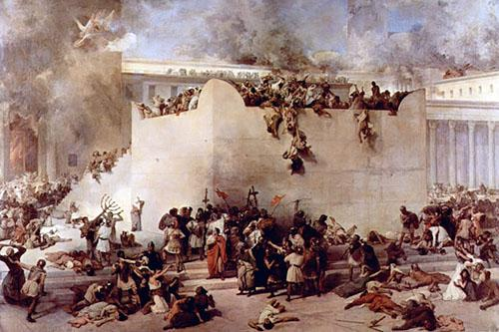
· Their enemies would attack Jerusalem and brutally kill them. Even their children would not be spared. This tragedy would take place within their own walls. Their buildings would be destroyed, not one stone being left on another.
· This would be God’s severe judgment upon the people of Jerusalem, for they rejected Him and would kill Him.
· Historically Jesus’ prediction was realized when the Roman army attacked Jerusalem in A.D. 63.
· God’s judgment on Jerusalem foreshadows his judgment on all people who don’t repent and reject Jesus by their unbelief.
· If people reject Jesus, they will be handed over to the enemies.

1-6. Why would these things happen to them? (44b)

because you did not recognize the time of God’s coming to you.”
· The time of God’s coming is the time of God’s salvation and God’s judgment.
· God sent his only Son Jesus to save them but they didn’t recognize him. Rather they rejected him and killed him.
· They didn’t recognize that God’s judgment was coming to them. There was judgment because of their spiritual ignorance.
· Still so many people don’t recognize the time of God’s coming to them. Because of their spiritual ignorance they will be judged severely and then perish.
· Jesus grieves for His people. They need help to avoid the tragedy of God’s impending judgement.

2. Read verses 45-46. What did Jesus do at the temple courts? (45) What was the purpose of the temple? (46a, Isa 56:7) How had people defiled God’s temple? (46b) What can we learn from Jesus? (Jn 2:16, 17)

2-1.Read verses 45-46.

“When Jesus entered the temple courts, he began to drive out those who were selling. 46 “It is written,” he said to them, “‘My house will be a house of prayer’; but you have made it ‘a den of robbers.’”

2-2. What did Jesus do at the temple courts? (45)

he began to drive out those who were selling.

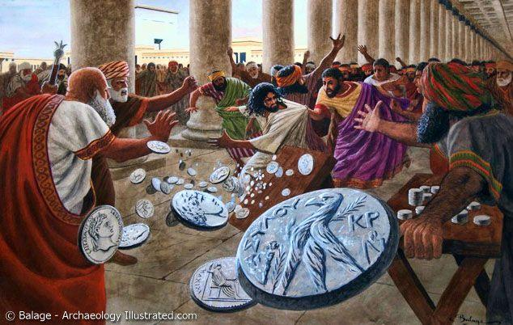

· People were doing business at the temple to make money. The religious leaders and merchants worked together to make money by cheating people. They turned God’s holy temple into a den of robbers.
· Jesus was filled with holy anger, seeing what had become of God’s temple. Jesus cleansed and purified the temple by driving out those who were doing their own business at the temple court.

2-3. What was the purpose of the temple? (46a, Isa 56:7)

“It is written,” he said to them, “‘My house will be a house of prayer’
· The temple is God’s house where God dwells. God’s temple is a holy place that should be honored at all times.
· Entering into the temple should be thought of as entering into God’s holy presence. Upon entering into the presence of God, people should do so with a trembling heart, with the fear of God, and with awesome respect & reverence.
· The temple is a house of prayer where his people can come and offer their prayers.
· The temple is the place where people should come to pray, not for other purposes.
· The temple is supposed to be filled with the prayers of His people.

2-4. How had people defiled God’s temple? (46b)

but you have made it ‘a den of robbers.
· They abused the temple by turning it into a market place. They were making money by tricking innocent people at the temple. They turned the temple into a den of robbers.
· They dishonored God. They were more interested in money than they were in God. They were committing a horrible sin before God.
· This event reveals the spiritual condition of Israel at that time. The religious leaders were totally corrupted. People didn’t honor God. Money became people’s idol and people were not interested in worshipping God.
· Materialism is dominating our generation. Living in such a corrupted environment, it would be easy for us to also seek money more than God.
· Our heart is the temple of God. It should be filled with prayer towards God.

2-5. What can we learn from Jesus? (Jn 2:16, 17)

To those who sold doves he said, “Get these out of here! Stop turning my Father’s house into a market!” 17 His disciples remembered that it is written: “Zeal for your house will consume me.”
· Jesus’ zeal for the temple is his zeal for God.
· Jesus knew that his actions would cause people to get angry. He knew that his life would even be at jeopardy. But he still fought against the evil they were doing because He had great zeal for God.
· We can fight for God’s name sake and truth when we are burning with the zeal for God.

3. Read verses 47-48. What did Jesus do at the temple every day? (47a) What were the religious leaders doing? (47b) Why weren’t they able to carry out their plans? (48)

3-1. Read verses 47-48.

Every day he was teaching at the temple. But the chief priests, the teachers of the law and the leaders among the people were trying to kill him. 48 Yet they could not find any way to do it, because all the people hung on his words.

3-2.What did Jesus do at the temple every day? (47a)

Every day he was teaching at the temple

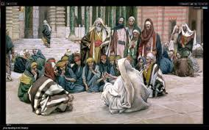
· Jesus restored the function of the temple by using it to teach the word of God. It shows that the temple should be the house of “teaching” God’s Word as well as praying.
· He committed himself to teaching to the last minutes until the time of his death.
· Every day teaching – Jesus devoted his life to teaching the word of God. Teaching the word of God was the major work of His ministry.
· He taught diligently because people could repent, know Him personally, and have faith in God when they heard and accepted the word of God.
· For our spiritual growth we need to hear, accept, and learn the Word of God. To help others, we also must pray and teach Word of God diligently.

3-3. What were the religious leaders doing? (47b)

But the chief priests, the teachers of the law and the leaders among the people were trying to kill him
· Instead of repenting of their sins, they hated Jesus all the more and even tried to kill him.

3-4. Why weren’t they able to carry out their plans? (48)

Yet they could not find any way to do it, because all the people hung on his words.
· People loved to hear the word of God from Jesus.

Conclusion

Jesus showed his great compassion toward people in Jerusalem who rejected Him by their unbelief and refusal to repent. Jesus wept when He saw the condition of people and that city. Even today, Jesus still has a broken heart for those who have yet to repent. Jesus also purified the temple with his great zeal for God. May God help us to have the same compassion toward those who don’t believe the gospel of Jesus and the same zeal for God that Jesus did.

One word: A house of prayer

