A Thankful Samaritan

Luke 17:11-19
Key Verse 16

“He threw himself at Jesus’ feet and thanked him--and he was a Samaritan.”

Introduction

On Jan. 29, 2014, when fisherman Jose Salvador Alvarenga washed ashore on a remote island deep in the Pacific Ocean, he was 6,700 miles from home, having survived 14 months lost at sea. It was a record of endurance never equaled by another castaway. Finally, after many adventures and often giving up hope after his one and only crewmate died, he was found and rescued miraculously. The first thing he did was to make radio contact with his family, for he valued his family more than anything else. From today’s passage, ten lepers shouted in a loud voice to get healed from Jesus. But one person came back in order to give thanks to Jesus. Nine lepers did not show up. Maybe they wanted to see their family first or had no reason to come back to Jesus after seeing the priests, for their goal was only to be set free from their chronic debilitating disease. It was natural for them to forget the grace of God when their deep need was met. Now they might have wanted to focus on what is practical or beneficial rather than bothering to come back and express thanks to Jesus or to live for the glory of God. May the Lord help us to remember what God has done for us and give thanks to Him so that we may maintain our eternal relationship with Him.

1. Read verses 11-13. Where was Jesus going and where was he now? (11) Who came to meet Jesus? (12) How did they ask for help from Jesus? (13) What can we learn from them?

1-1, Read verses 11-13.

Now on his way to Jerusalem, Jesus traveled along the border between Samaria and Galilee. 12 As he was going into a village, ten men who had leprosy[b] met him. They stood at a distance 13 and called out in a loud voice, “Jesus, Master, have pity on us!”

1-2, Where was Jesus going and where was he now? (11)

Now on his way to Jerusalem, Jesus traveled along the border between Samaria and Galilee.

- Jesus was on the way to Jerusalem where crucifixion awaited him. Jesus knew this and repeatedly foretold to his disciples of his future suffering, death, and resurrection.
- But no one understood what he was talking about. Jesus walked a lonely road, in obedience to God’s will.

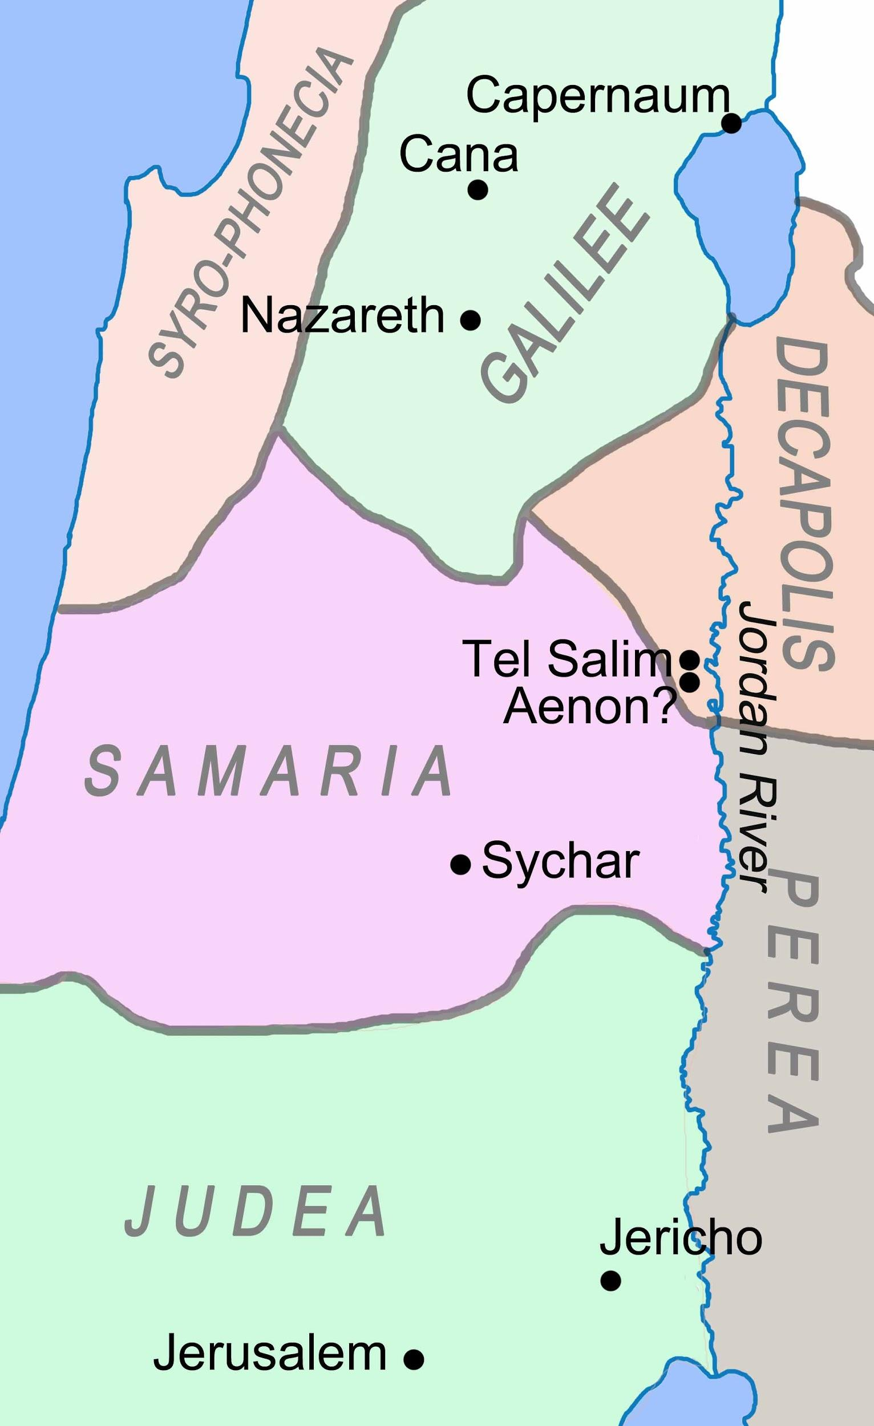
- Jesus traveled along the border between Samaria and Galilee. At that time, Jews despised Samaritans because of the historical background of this place.
- This offended the Samaritans, and made them resentful towards the Jews. So these two different groups of people did not associate with one another.
- Jesus had broken through this prejudice when he witnessed to a Samaritan woman in John 4.

Luke 9:51-53 reads,

“As the time approached for him to be taken up to heaven, Jesus resolutely set out for Jerusalem. 52 And he sent messengers on ahead, who went into a Samaritan village to get things ready for him; 53 but the people there did not welcome him, because he was heading for Jerusalem.”

- Jesus, who was fully human and fully a Jew, could have taken offense as James and John asked Jesus to call down fire from heaven to destroy the Samaritan village.
- Unlike James and John, Jesus had a plan to spread the gospel throughout Samaria.
- Jesus had no prejudice. For instance, one day Jesus had to go through the land of Samaria to serve a Samaritan woman.
- Regardless of social status or prejudice, Jesus pointed out that the name of the game is to show one’s gratitude properly.

- The gospel also obliterates human barriers, for it is universal good news: all have sinned, and are justified freely by God's grace.
- That was why Jesus was on the way to Jerusalem to liberate men from sinful prejudices so that we might love one another, regardless of nationality or ethnicity.

1-3, Who came to meet Jesus? (12)

12 As he was going into a village, ten men who had leprosy met him. They stood at a distance

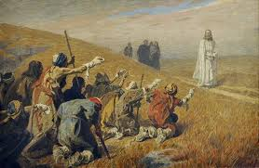
- As Jesus entered a village, ten men with leprosy met him. Both Jews and Samaritans were among them according to verse 16.
- They traveled together and sought help together. To them, the barriers between Jew and Samaritan were irrelevant.
- They were despised by both, for they carried a contagious, disfiguring and fatal disease.
- Lepers were not allowed among healthy people, but stayed in strict quarantine.
- Lepers could associate only with other lepers. They were isolated and lonely. They remained anonymous even among themselves.

- These lepers seemed condemned to a hopeless existence. However, one day, these men heard that Jesus had compassion on men with leprosy and had the power to heal them.
- Jesus was coming through their territory. It might have been impossible for them to leave the territory.
- But Jesus took initiative to come to the place where they lived in the borderline between Samaria and Galilee.

1-4, How did they ask for a help from Jesus? (13)

and called out in a loud voice, “Jesus, Master, have pity on us!”

- With new hope rising in them, they banded together and went to Jesus. They stood at a distance and called out in a loud voice, “Jesus, Master, have pity on us!”
- They came to Jesus just as they were and pleaded for mercy. Their cry revealed their desperate need and faith in Jesus.
- This cry must have come from their hope, only in Jesus.

1-5, What can we learn from them?

- Again they came to Jesus together and they prayed together, even though they were a mixed group of Jews and Samaritans.
- Bonded by their misery, their national and other prejudices vanished and they came together in prayer.
- A common misfortune had broken down their racial and national barriers.
- In the common tragedy of their leprosy they had forgotten they were Jews and Samaritans and remembered only they were men in desperate need.
- In UBF, we have something in common in that we are forgiven sinners and we came together and we prayed together without any human barriers.
- We give thanks to Jesus who called us to become His family members.

2. Read verses 14. What did Jesus do for the ten leprous men? Why were they told to show themselves to the priests? (Lev 13:2,17, 45-46; Mt 8:4) How might Jesus’ command to them have been difficult to obey? What happened when the men obeyed Jesus’ word?

2-1, Read verses 14.

When he saw them, he said, “Go, show yourselves to the priests.” And as they went, they were cleansed.

2-2, What did Jesus do for the ten leprous men?

When he saw them, he said, “Go, show yourselves to the priests.”

- People’s hearts might have been cold towards these men. But Jesus did not ignore their cry. Jesus saw them with a compassionate heart. Jesus did not pass them by.
- Jesus was willing to help. In the midst of his own painful and lonely struggle, Jesus’ compassion never dries up or runs out.
- Jesus is always ready to show compassion to helpless sinners in our time of need.

Exodus 34:6-7b reads,

“And he passed in front of Moses, proclaiming, ‘The Lord, the Lord, the compassionate and gracious God, slow to anger, abounding in love and faithfulness, maintaining love to thousands, and forgiving wickedness, rebellion and sin.’”

2-3, Why were they told to show themselves to the priests? (Lev 13:2, 17, 45-46; Mt 8:4)

- It was because Jesus came to fulfill the law.
- Jesus could have commanded them to be healed and let them go to their own families.
- But Jesus commanded them to go and show themselves to the priests in accordance with what the Scripture indicated.
- According to the law, people with skin diseases had to be examined by the priest, and if found clean, could be pronounced healthy/fit for community life among God’s people.

Leviticus 13:2, 17, 45-46 reads,

2 “When anyone has a swelling or a rash or a shiny spot on their skin that may be a defiling skin disease, they must be brought to Aaron the priest or to one of his sons who is a priest.

17 The priest is to examine them, and if the sores have turned white, the priest shall pronounce the affected person clean; then they will be clean.

45 “Anyone with such a defiling disease must wear torn clothes, let their hair be unkempt, cover the lower part of their face and cry out, ‘Unclean! Unclean!’ 46 As long as they have the disease they remain unclean. They must live alone; they must live outside the camp.

Matthew 8:4 reads,

Then Jesus said to him, “See that you don’t tell anyone. But go, show yourself to the priest and offer the gift Moses commanded, as a testimony to them.”

2-4, How might Jesus’ command to them have been difficult to obey?

- It must have been hard for them to obey Jesus’ command, for the priests might not welcome them.
- Jesus could have simply said, “I am willing, Be clean!” Rather He told them to go and show themselves to the priests.

- Jesus’ words challenged the men to believe that they were healed before it happened and to act in obedience to Jesus’ words.
- Jesus was teaching them to live by faith and to obey the word of God by faith.

2-5, What happened when the men obeyed Jesus’ word?

And as they went, they were cleansed.

- Jesus’ word has power in it. It is the very Word of God who created the heavens and the earth.
- Sensing his spiritual authority, the men obeyed him at once by turning to leave. Miraculously, their leprosy was healed. Their flesh was restored.
- In the Bible, leprosy is symbolic of the power of sin. As leprosy ruins one’s body, sin utterly ruins one's life by making him sick unto death spiritually, emotionally, and intellectually.
- There is no human cure for sin. Only Jesus can save us from sin and heal us from its consequences.

1 John 1:9 says,

“If we confess our sins, he is faithful and just and will forgive us our sins and purify us from all unrighteousness.”

- Jesus can cleanse any sinner completely and give him a new life.
- Let’s come to Jesus, our compassionate Healer. Why does Jesus heal us? Jesus heals us so that we may obey the word of God and become useful to God.

Luke 1:74,75 says,

“...to rescue us from the hand of our enemies, and to enable us to serve him without fear in holiness and righteousness before him all our days.”

- In Jesus, we can live the most joyful, fruitful, and happy life. We can serve God all our days and then enter into everlasting glory.
- What a wonderful Savior Jesus is! (https://www.youtube.com/watch?v=LlxPyWF7Xaw)

3. Read verses 15-16. What did one man do after he saw he was healed? (15) How did he thank Jesus? (16) What can we learn from him?

3-1, Read verses 15-16.

One of them, when he saw he was healed, came back, praising God in a loud voice. 16 He threw himself at Jesus’ feet and thanked him—and he was a Samaritan.

3-2, What did one man do after he saw he was healed? (15)

One of them, when he saw he was healed, came back, praising God in a loud voice.
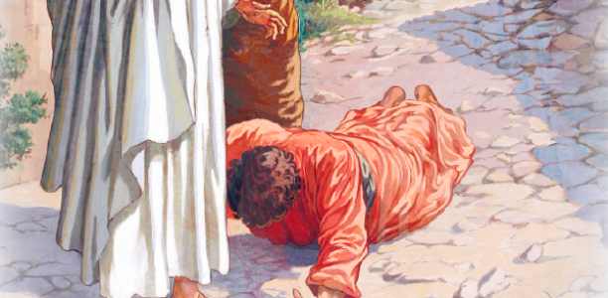
- It is significant that this man praised God as his first response. The man saw God through Jesus. He knew that his healing had come from God.
- Before meeting the priests, he couldn’t but come back in order to praise God.
- He sensed that the great God of the universe knew his sufferings as a leper, and was concerned for him. He felt that God loved him very personally.
- When he realized God’s love for him, waves of praise and thanks began to burst forth from his heart. He had no regard for what people thought.
- He was overwhelmed by God’s presence and praised God with all his strength in a loud voice: “Praise God!”
- This foreigner did a fabulous job in terms of praising God. In fact the meaning of “Judah” is “praise God.” So nine Jewish lepers were supposed to praise God.
- But the Samaritan leper did instead. What is the name of the game? It is to praise God.
- We should acknowledge God’s presence as one of God’s created beings.
- We received the grace of forgiveness, healing, new vision and clear spiritual direction.
- It was God, who is unseen--who is Spirit--who worked within us. God’s Spirit filled those who spoke the Word of God to us. God’s Spirit touched our hearts through their message.
- God’s Spirit ministered to us and gave his spiritual blessings to us. So we must first praise God for his work.

3-3, How did he thank Jesus? (16)

He threw himself at Jesus’ feet and thanked him—and he was a Samaritan.

- The healed man did not stop with praising God. He also thanked Jesus.
- He first threw himself at Jesus’ feet. He was offering himself to Jesus. At that moment, he wanted to give everything to Jesus.
- He recognized that his new life was not just his; his life belonged to Jesus.
- He was ready to obey Jesus no matter what Jesus said. If Jesus told him to go as a missionary, he would go, trusting Jesus’ power and love.
- In a spirit of surrender, he said again and again, “Thank you! Thank you, Jesus!”
- His words of thanks expressed an offering of his life to Jesus. He teaches us how to praise God and thank Jesus.

3-4, What can we learn from him?

- We easily see the total depravity of human beings.
- For instance, in the book of Judges, the phrase, “The Israelites once again did evil in the eyes of the Lord,” is repeated many times.
- No sooner had they lived in peace by God’s grace than they rejected God again.
- Likewise nobody can thank God naturally. Each person must learn how to thank God.
- It requires a lot of struggling through prayer and sincere Bible study.
- Those who are truly humble are able to give thanks in all circumstances.

James 4:6 reads,

“God opposes the proud but shows favor to the humble”

- The Chinese have a proverb: “When eating bamboo sprouts, remember the man who planted them.”
- Likewise when we eat a steak, we remember the American farmer—and the God who gave the farmer rain for the grain and the livestock.
- Everything we have is a gift from God. “Every good and perfect gift is from above” (James 1:17)

4. Read verses 17-19. How did Jesus express his disappointment by comparing the other nine men with one thankful foreigner? (17, 18) What blessing did this thankful Samaritan receive? (19) What does this event teach about the importance of being thankful?

4-1, Read verses 17-19.

Jesus asked, “Were not all ten cleansed? Where are the other nine? 18 Has no one returned to give praise to God except this foreigner?” 19 Then he said to him, “Rise and go; your faith has made you well.”

4-2, How did Jesus express his disappointment by comparing the other nine men with one thankful foreigner? (17, 18)

Jesus asked, “Were not all ten cleansed? Where are the other nine? 18 Has no one returned to give praise to God except this foreigner?”

- As much as the man’s thanks pleased Jesus, it also exposed the fault of the other nine.
- They, too, were cleansed by Jesus.
- But they did not return to praise God and thank Jesus. This was a tragic mistake.

4-3, What blessing did this thankful Samaritan receive? (19)

Then he said to him, “Rise and go; your faith has made you well.”
- He received the true certificate or a clean bill of health from the High Priest, Jesus Christ.
- Jesus is the best Physician.
- Maybe the other nine went straight to the priests.
- But this Samaritan had to give thanks to Jesus, for he must have known where his true healing came from.
- Thanksgiving is the first and foremost step in having personal faith in God.
- Jesus accepted his reverent submission and became his Lord. Then, the Lord Jesus told him to rise and go.
- Jesus credited his faith for his healing. It meant he was right with God. Now he could go forth as a man with dignity, recognized by the king, healthy and fit to serve in God’s world.
- His future was promising; he could be a truly great man and blessing to the world.
- Here we learn the secret to bearing God’s blessings. It is to praise and thank God.

4-4, What does this event teach about the importance of being thankful?

- Those who fail to praise and thank God become dark and foolish. Eventually they fall into idolatry and becomes slaves of sin.
- This is why Jesus told another man whom he had healed after 38 years of paralysis, “Stop sinning, or something worse may happen to you” (Jn 5:14).
- We must learn to praise and thank God for his blessings. In fact, we should praise and thank God always.
- So St. Paul wrote, “Be joyful always; pray continually; give thanks in all circumstances, for this is God's will for you in Christ Jesus” (1 Th 5:16-18).
- Even in difficult circumstances, we have many reasons to thank God. God is our Creator who gave us our very lives.
- God is our Provider who sustains us with all necessary things each day, including food, water, and air.
- God is our Redeemer who gave his one and only Son Jesus Christ as a ransom sacrifice for our sins.
- He saved us from eternal condemnation. God pours out his blessings on us everyday in many ways that we are not even aware of.
- God is worthy of all our praise and thanks. Let’s praise and thank God with all our hearts and lives.

Romans 1:21 says,

“For although they knew God, they neither glorified him as God nor gave thanks to him, but their thinking became futile and their foolish hearts were darkened.”

- However, when we want to praise and thank God, we find that it is not always easy. Our sneaky sinful nature binds us in self-centeredness and ingratitude.
- This is manifest in several ways. Sinful people usually see what they do not have--and feel sorry about that--instead of seeing what they have, and giving thanks.
- Sinful people usually remember one wrong done by others, while ignoring the many good things done for them by God and others.
- Moreover, life in this world can be hard. Sometimes we feel too tired or worn out to be thankful. Sometimes it just seems inconvenient to give thanks to God.
- There are many exciting and interesting things to do first. But in the course of pursuing them, we can miss the chance to thank God.
- To express our thanksgiving to God we must struggle against our sinful nature, fighting a spiritual battle in prayer.

Ephesians 5:20 reads,

“Always giving thanks to God the Father for everything, in the name of our Lord Jesus Christ.”

Conclusion

Only one(10%) came back to give thanks; and he was the unlikely one - a Samaritan or a foreigner. And, though he was the only one, at least he was very loud about his thanks. It is easy to be loud in asking for help like the other nine lepers. John F. Kennedy said, “As we express our gratitude, we must never forget that the highest appreciation is not to utter words but to live by them.” I believe the Grateful Samaritan learned that the highest appreciation he could show to Jesus was to live daily for him. Jesus changed the life of a Samaritan woman who told many what He had done for him. As a result, the lives of many people in Sychar of Samaria changed because of her testimony. Also Jesus healed a man of demon possession in the region of the Gerasenes and said, "Go home to your own people and tell them how much the Lord has done for you and how he has had mercy on you."

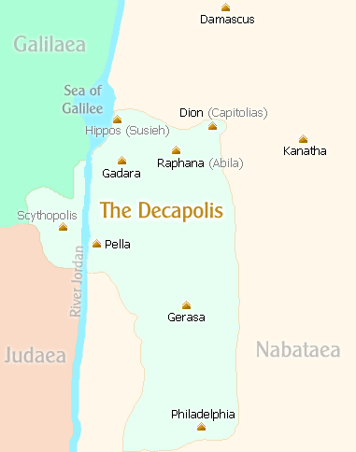
So the man went away and began to tell to the people in the Decapolis(Scythopolis, Pella, Dion, Gerasa, Philadelphia, Gadara, Raphana, Kanatha, Hippos and Damascus) how much Jesus had done for him. And all the people were amazed. Perhaps the same could happen in the Samaria in and through the Grateful Samaritan. The same thing could happen in us! May the Lord help us to be a thankful person like the grateful Samaritan no matter where we go and witness about Jesus.

One word: Give thanks!

