I WILL HAND ALL OF THEM OVER TO ISRAEL

Joshua 11:1-12:24
Key Verse 11:6

The Lord said to Joshua, “Do not be afraid of them, because by this time tomorrow I will hand all of them, slain, over to Israel. You are to hamstring their horses and burn their chariots.”

Introduction

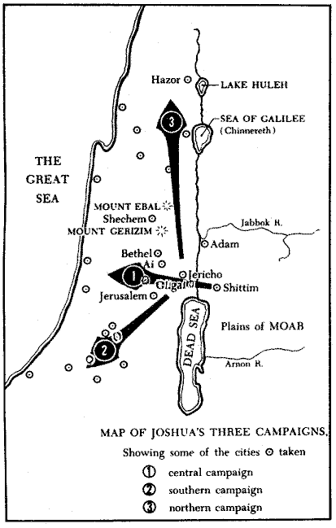
After Joshua and Israel claimed the victories in central and southern campaigns, now at this chapter they moved to north. It can be compared to our life’s journey. We are in constant battle against our enemies until we enter into the heaven. Not everyone finishes this journey with final victory. Some gives up on the way. Others fall into sin, not being able to obtain God’s blessing. Today we are going to learn how Joshua claimed his final victory in the Promised Land. May the Lord help us to learn of how to claim our final victory by faith and obedience in His words of promise. Amen.

1. Read 11:1-5. What did Jabin king of Hazor hear and how did he react? (1-3) How is the united army against Israel described? (4-5)

1-1, Read 11:1-5.

When Jabin king of Hazor heard of this, he sent word to Jobab king of Madon, to the kings of Shimron and Akshaph, 2 and to the northern kings who were in the mountains, in the Arabah south of Kinnereth, in the western foothills and in Naphoth Dor on the west; 3 to the Canaanites in the east and west; to the Amorites, Hittites, Perizzites and Jebusites in the hill country; and to the Hivites below Hermon in the region of Mizpah. 4 They came out with all their troops and a large number of horses and chariots—a huge army, as numerous as the sand on the seashore. 5 All these kings joined forces and made camp together at the Waters of Merom to fight against Israel.

1-2, What did Jabin king of Hazor hear and how did he react? (1-3)

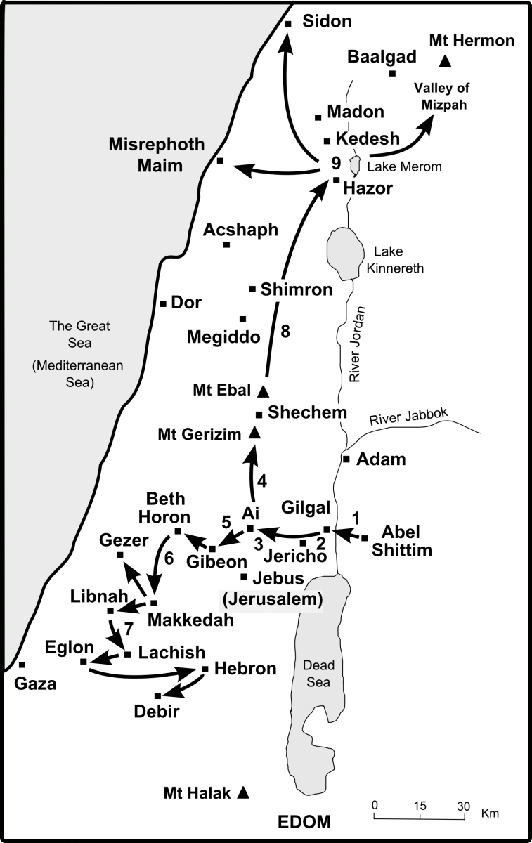
When Jabin king of Hazor heard of this, he sent word to Jobab king of Madon, to the kings of Shimron and Akshaph, 2 and to the northern kings who were in the mountains, in the Arabah south of Kinnereth, in the western foothills and in Naphoth Dor on the west; 3 to the Canaanites in the east and west; to the Amorites, Hittites, Perizzites and Jebusites in the hill country; and to the Hivites below Hermon in the region of Mizpah.

- The Canaanites in the northern area heard how the Israelites won great victories. They must have been shocked. They also knew that Joshua’s next target would be the cities of the northern region.
- Jabin king of Hazor heard of Israel’s victories in the south, he decided to take action before it would be too late.
- So he called all kings in the Northern area and spoke to them to fight against Israel. He must be a competent king who could mobilize the entire armies of the Northern area. His strategy was simple, gather all the forces and spare no resource.

1-3, How is the united army against Israel described? (4-5)

4 They came out with all their troops and a large number of horses and chariots—a huge army, as numerous as the sand on the seashore. 5 All these kings joined forces and made camp together at the Waters of Merom to fight against Israel.

- Enemy soldiers comprised of troops from many different places—mountains, foothills, hill country, east and west.
- They came with a large number of horses and chariots. Their soldiers were well equipped. Unlike the southern kings that Israel conquered previously, there were thousands of cavaliers and chariots.
- The enemy seemed well equipped and God’s people appeared outnumbered. The Israeli army looked so small in comparison to the Canaanites who were like sand on the seashore.
- The Canaanites came trusting in the number of their soldiers and in their superior military technologies. But Israel had none of them. They had just God alone.

- This is how the enemy, devil, stands against us. He tries to devour us with visible and threatening things in life. Their purpose is to make us fearful so that we can give up to trust in God.
- If we are overwhelmed by this kind of situation, we become the slaves of fear, vulnerable to enemies’ attack.
- When Goliath campaigned against Israel, Israeli soldiers were all fearful that no one dared to stand against Goliath. However David trusted in God and fought against Goliath in the name of almighty God.
- In order to be winners of spiritual warfare, we need to know how to engage in battle. We can’t beat the enemy if stand against him with the same way our enemy approaches. Spiritual warfare is not the fighting with sword and spear but it is all about our trust in the name of almighty God.

2. Read 11:6-15. What did God tell Joshua to do? (6) How did Joshua and his whole army fight? (7-10) How did Joshua obey Moses? (11-15; Ex 23:20-23; Deut 7:1-2)

2-1, Read 11:6-15.

The Lord said to Joshua, “Do not be afraid of them, because by this time tomorrow I will hand all of them, slain, over to Israel. You are to hamstring their horses and burn their chariots.” 7 So Joshua and his whole army came against them suddenly at the Waters of Merom and attacked them, 8 and the Lord gave them into the hand of Israel. They defeated them and pursued them all the way to Greater Sidon, to Misrephoth Maim, and to the Valley of Mizpah on the east, until no survivors were left. 9 Joshua did to them as the Lord had directed: He hamstrung their horses and burned their chariots.
10 At that time Joshua turned back and captured Hazor and put its king to the sword. (Hazor had been the head of all these kingdoms.) 11 Everyone in it they put to the sword. They totally destroyed[a] them,not sparing anyone that breathed, and he burned Hazor itself. 12 Joshua took all these royal cities and their kings and put them to the sword. He totally destroyed them, as Moses the servant of the Lord had commanded. 13 Yet Israel did not burn any of the cities built on their mounds—except Hazor, which Joshua burned. 14 The Israelites carried off for themselves all the plunder and livestock of these cities, but all the people they put to the sword until they completely destroyed them, not sparing anyone that breathed. 15 As the Lord commanded his servant Moses, so Moses commanded Joshua, and Joshua did it; he left nothing undone of all that the Lord commanded Moses.

2-2, What did God tell Joshua to do? (6)

6 The Lord said to Joshua, “Do not be afraid of them, because by this time tomorrow I will hand all of them, slain, over to Israel. You are to hamstring their horses and burn their chariots.”

- Now it became the pattern of the book of Joshua that God encourages Joshua whenever he faces challenges and trials. We all need encouragement.
- How weak and vulnerable we are! Even if we receive God’s grace and mercy today, we may become nervous and fearful tomorrow when we face trouble.
- That is our reality. God knows our weakness that we are prone to be fearful to face great challenge although we know God, believe in him and experience his mighty power.
- Even Joshua needed God’s encouragement in each campaign. Encouragement is great source of life that makes our spirit strong.
- We are all struggling with different issues and troubles in life. Let us listen to God, his words of encouragement, “Do not be afraid,” so that we may not give up but continue trusting in God.
- God promises that He Himself will hand the enemies over to Israel, slain. All these things will happen within 24 hours.
- Our God is the faithful God. Whenever He gives a word of promise, He is faithful to keep His words. He is the LORD of host, the LORD of the armies of heaven and the true leader of Israel’s armies.

- “You are to hamstring their horses and burn their chariots.” On the surface this direction seems unnecessary and impractical.
- Israel can benefit from the horses and use the chariots for future military activities, but God told Israel to hamstring the horses and burn the chariots.

2-3, How did Joshua and his whole army fight? (7-10)

7 So Joshua and his whole army came against them suddenly at the Waters of Merom and attacked them, 8 and the Lord gave them into the hand of Israel. They defeated them and pursued them all the way to Greater Sidon, to Misrephoth Maim, and to the Valley of Mizpah on the east, until no survivors were left. 9 Joshua did to them as the Lord had directed: He hamstrung their horses and burned their chariots. 10 At that time Joshua turned back and captured Hazor and put its king to the sword. (Hazor had been the head of all these kingdoms.)

- After receiving God’s words of encouragement, Joshua and the whole army came against them suddenly at the waters of Merom and attacked them, and the LORD gave them into the hands of Israel.
- They defeated them and pursued them all the way to Greater Sidon, to Misrephoth Maim, and to the Valley of Mizpah on the east, until no survivors were left.
- The key point here is that the LORD gave them into the hands of Israel. God delivered their enemies into their hands and made it possible for Israel to defeat and pursue them.

- Joshua was a man of absolute obedience. He took God’s words to heart and followed the battle strategy quickly and completely.
- Joshua led Israel to resounding victories against overwhelming number of soldiers because they believed God’s promise of victory and obeyed his instructions.

- Trust and obedience are the keys of victory in this battle. As we have read the passage, there are repeated phrase that shows Joshua’s absolute obedience to God and to God’s servant Moses.
- The LORD had commanded Moses and Joshua completed what was supposed to fulfill. Especially Joshua did to them as the LORD had directed. He hamstrung their horses and burned their chariots.
- There were thousands of horses and chariots to take care of, but Joshua and his men obeyed God’s words without fail.

- What could be the reason why God told Joshua to hamstring the horses and burn the enemy chariots? It was God’s desire for Joshua and Israel to rely on God alone not taking benefit of their enemies’ advanced resources.
- God wanted to get rid of even a hint of physical resources that the Israelites may rely on. In our society, money has power. Money provides safety, comfort, pleasure and promising future partly.
- We may hamstring our dependence on materials. God is our fortress, shield and great reward. We may continue to fight the good fight by depending God alone.

2-4, How did Joshua obey Moses? (11-15; Ex 23:20-23; Deut 7:1-2)

11 Everyone in it they put to the sword. They totally destroyed them,not sparing anyone that breathed, and he burned Hazor itself. 12 Joshua took all these royal cities and their kings and put them to the sword. He totally destroyed them, as Moses the servant of the Lord had commanded. 13 Yet Israel did not burn any of the cities built on their mounds—except Hazor, which Joshua burned. 14 The Israelites carried off for themselves all the plunder and livestock of these cities, but all the people they put to the sword until they completely destroyed them, not sparing anyone that breathed. 15 As the Lord commanded his servant Moses, so Moses commanded Joshua, and Joshua did it; he left nothing undone of all that the Lord commanded Moses.

“See, I am sending an angel ahead of you to guard you along the way and to bring you to the place I have prepared. 21 Pay attention to him and listen to what he says. Do not rebel against him; he will not forgive your rebellion, since my Name is in him. 22 If you listen carefully to what he says and do all that I say, I will be an enemy to your enemies and will oppose those who oppose you. 23 My angel will go ahead of you and bring you into the land of the Amorites, Hittites, Perizzites, Canaanites, Hivites and Jebusites, and I will wipe them out. (Exo. 23)

When the Lord your God brings you into the land you are entering to possess and drives out before you many nations—the Hittites, Girgashites, Amorites, Canaanites, Perizzites, Hivites and Jebusites, seven nations larger and stronger than you— 2 and when the Lord your God has delivered them over to you and you have defeated them, then you must destroy them totally. Make no treaty with them, and show them no mercy. (Deuteronomy 7)

- Joshua’s motivation in the conquest was not to take revenge for the opposition against Israel; rather it was to fulfill the LORD’s commands.
- God in His sovereign wisdom forbids any form of associations with the Canaanites because He knows what the outcome will be.
- This is why Christians do not marry unbelievers, because they will turn you away from the LORD to serve other gods and the LORD’s anger will burn against you.
- Joshua took God’s commandments seriously absolutely. Fulfilling the LORD’s commandments was more important than his own personal desires.
- He did everything exactly as Moses the servant of the LORD had commanded him although Moses was dead.
- Joshua continued to obey the word of the LORD through God’s servant Moses. Joshua left nothing undone of all that the LORD commanded Moses.
- Joshua reminds us of Jesus. Jesus is the most obedient person that ever lived. He learned obedience from what he suffered (Heb 5:8).
- Jesus prayed, “Father if you are willing take this cup from me; yet not my will but yours be done (Luke 22:42).” May God teach us the humble obedience and commitment to God that Jesus and Joshua had.

3. Read 11:16-23. How did Joshua continue the conquest of Canaan in following Moses’ direction? (16-22) When did the land have rest from war? (23)

3-1, Read 11:16-23.

So Joshua took this entire land: the hill country, all the Negev, the whole region of Goshen, the western foothills, the Arabah and the mountains of Israel with their foothills, 17 from Mount Halak, which rises toward Seir, to Baal Gad in the Valley of Lebanon below Mount Hermon. He captured all their kings and put them to death. 18 Joshua waged war against all these kings for a long time. 19 Except for the Hivites living in Gibeon, not one city made a treaty of peace with the Israelites, who took them all in battle. 20 For it was the Lord himself who hardened their hearts to wage war against Israel, so that he might destroy them totally, exterminating them without mercy, as the Lord had commanded Moses. 21 At that time Joshua went and destroyed the Anakites from the hill country: from Hebron, Debir and Anab, from all the hill country of Judah, and from all the hill country of Israel. Joshua totally destroyed them and their towns. 22 No Anakites were left in Israelite territory; only in Gaza, Gath and Ashdod did any survive.
23 So Joshua took the entire land, just as the Lord had directed Moses, and he gave it as an inheritance to Israel according to their tribal divisions. Then the land had rest from war.

3-2, How did Joshua continue the conquest of Canaan in following Moses’ direction? (16-22)

So Joshua took this entire land: the hill country, all the Negev, the whole region of Goshen, the western foothills, the Arabah and the mountains of Israel with their foothills, 17 from Mount Halak, which rises toward Seir, to Baal Gad in the Valley of Lebanon below Mount Hermon. He captured all their kings and put them to death. 18 Joshua waged war against all these kings for a long time. 19 Except for the Hivites living in Gibeon, not one city made a treaty of peace with the Israelites, who took them all in battle. 20 For it was the Lord himself who hardened their hearts to wage war against Israel, so that he might destroy them totally, exterminating them without mercy, as the Lord had commanded Moses.

- So Joshua took the entire land. Joshua waged war against all these kings for a long time. Except the Hivites living in Gibeon, not one city made a treaty of peace with the Israelites, who took them all in battle.
- When we think about it, it is very surprising. They knew their fate was destruction and yet except the Hivites who lived in Gibeon none of the Canaanite cities sued for peace.
- They were not peacemakers, they were not humble and they were not ready to come to the LORD’s side. Then like Pharaoh the LORD hardened their heart to wage war against Israel, so that he might destroy them totally.

21 At that time Joshua went and destroyed the Anakites from the hill country: from Hebron, Debir and Anab, from all the hill country of Judah, and from all the hill country of Israel. Joshua totally destroyed them and their towns. 22 No Anakites were left in Israelite territory; only in Gaza, Gath and Ashdod did any survive.

- The Anakites were a race of giants who are closely related to the Nephilims. In numbers 13:32, “The land we explored devours those living in it. All the people we saw there are of great size. We saw the Nephilim there (the descendant of Anak come from the Nephilim). We seemed like grasshoppers in our own eyes, and we looked the same to them.”
- Out of 12 spies only Joshua and Caleb gave a good report that honored God but the people were already discouraged by the report of the 10 and they revolted against God and against his servant Moses.
- Because of this the people wandered in the desert for 38 years. Now by faith, they could face the same giants their fathers tried to avoid 40 years earlier.
- At that time Joshua went and destroyed the Anakites from the hill country: from Hebron, Debir and Anab, from all the hill country of Judah and from all the hill country of Israel.
- Joshua totally destroyed them and their towns. No Anakite were left in Israelite territory; only in Gaza, Gath and Ashdod did any survive (These are Philistine cities). Joshua and Israel grew in faith until they were courageous enough to drive out and totally destroy giants from the land.

3-3, When did the land have rest from war? (23)

23 So Joshua took the entire land, just as the Lord had directed Moses, and he gave it as an inheritance to Israel according to their tribal divisions. Then the land had rest from war.

- After Joshua had taken the entire land, he gave it as an inheritance to Israel according to their tribal divisions. Then the land had rest from war.

Heb 4:9-11 reads,
“There remains, then, a Sabbath-rest for the people of God; for anyone who enters God’s rest also rests from their works, just as God did from his. Let us, therefore, make every effort to enter that rest, so that no one will perish by following the example of disobedience.”

- May the Lord help us to continue fighting the good fight with faith and obedience until we may enter the kingdom of God finally to have rest. On earthly journey, we are supposed to engage in fierce battle without compromise for God’s glory!

4. Read 12:1-24. Who were the kings the Israelites defeated on the east and west sides of the Jordan? What is the meaning of this description?

4-1, Read 12:1-24.

These are the kings of the land whom the Israelites had defeated and whose territory they took over east of the Jordan, from the Arnon Gorge to Mount Hermon, including all the eastern side of the Arabah: 2 Sihon king of the Amorites, who reigned in Heshbon.
He ruled from Aroer on the rim of the Arnon Gorge—from the middle of the gorge—to the Jabbok River, which is the border of the Ammonites. This included half of Gilead. 3 He also ruled over the eastern Arabah from the Sea of Galilee[a] to the Sea of the Arabah (that is, the Dead Sea), to Beth Jeshimoth, and then southward below the slopes of Pisgah. 4 And the territory of Og king of Bashan, one of the last of the Rephaites, who reigned in Ashtaroth and Edrei. 5 He ruled over Mount Hermon, Salekah, all of Bashan to the border of the people of Geshur and Maakah, and half of Gilead to the border of Sihon king of Heshbon. 6 Moses, the servant of the Lord, and the Israelites conquered them. And Moses the servant of the Lordgave their land to the Reubenites, the Gadites and the half-tribe of Manasseh to be their possession.
7 Here is a list of the kings of the land that Joshua and the Israelites conquered on the west side of the Jordan, from Baal Gad in the Valley of Lebanon to Mount Halak, which rises toward Seir. Joshua gave their lands as an inheritance to the tribes of Israel according to their tribal divisions. 8 The lands included the hill country, the western foothills, the Arabah, the mountain slopes, the wilderness and the Negev.These were the lands of the Hittites, Amorites, Canaanites, Perizzites, Hivites and Jebusites. These were the kings:
9 the king of Jericho | one
the king of Ai (near Bethel) | one
10 the king of Jerusalem | one
the king of Hebron | one
11 the king of Jarmuth | one
the king of Lachish | one
12 the king of Eglon | one
the king of Gezer | one
13 the king of Debir | one
the king of Geder | one
14 the king of Hormah | one
the king of Arad | one
15 the king of Libnah | one
the king of Adullam | one
16 the king of Makkedah | one
the king of Bethel | one
17 the king of Tappuah | one
the king of Hepher | one
18 the king of Aphek | one
the king of Lasharon | one
19 the king of Madon | one
the king of Hazor | one
20 the king of Shimron Meron | one
the king of Akshaph | one
21 the king of Taanach | one
the king of Megiddo | one
22 the king of Kedesh | one
the king of Jokneam in Carmel | one
23 the king of Dor (in Naphoth Dor) | one
the king of Goyim in Gilgal | one
24 the king of Tirzah | One
thirty-one kings in all.

4-2, Who were the kings the Israelites defeated on the east and west sides of the Jordan?
4-3, What is the meaning of this description?

- The outcome of victory is written in chapter 12. Joshua’s army conquered land both east and west of the Jordan river; from Mount Hermon in the north to beyond the Negev to Mount Halak in the south.
- Thirty-one kings and their cities had been defeated. The Israelites had overpowered the Hittites, the Amorites, the Canaanites, the Perizzites, the Hivites, and the Jebusites.

Conclusion

In this passage we learn that God gives victory to those who trust in God’s promise and obey His commandments. When Joshua accepted God’s promises, and Israel responded by faith in God with absolute obedience, God gave them the entire land of Canaan as their inheritance and the land had rest from war. The outcome of the war was victory and rest. This is the picture of our life in heaven when we finish our life journey. May the Lord help us to deny ourselves, take up our cross and follow Jesus who is the author of faith to fight a good fight will have eternal rest in our eternal home in heaven.

One word: Soldiers, Advance!

