GOD IN HEAVEN ABOVE AND ON THE EARTH BELOW

Joshua 2:1-24
Key Verse 11
"When we heard of it, our hearts melted and everyone's courage failed because of you, for the Lord your God is God in heaven above and on the earth below."

Introduction
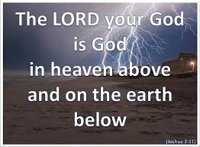
In this passage we can see how the first battle of the war of conquest started, the battle of Jericho. Joshua sent two spies to the Jericho to look over the land. When the king of the land looked for them, a prostitute named Rahab hid the spies to save them. She believed God as the God in heaven above and on earth below. By faith she stood with God’s people and served His will and saved her and her family. Her help on the basis of her faith became a critical part for the first battle. Through this passage we can learn what kind of person God uses for His salvation work and war to expand his kingdom.

1. Read verse 1-7. What did Joshua do with the two spies? (1a) Where did they go? (1b) What did the king of Jericho do when he was told about this event? (2-3) How did Rahab help the spies? (4-7)

1-1. Read verse 1-7.
Then Joshua son of Nun secretly sent two spies from Shittim. “Go, look over the land,” he said, “especially Jericho.” So they went and entered the house of a prostitute named Rahab and stayed there.² The king of Jericho was told, “Look, some of the Israelites have come here tonight to spy out the land.” ³ So the king of Jericho sent this message to Rahab: “Bring out the men who came to you and entered your house, because they have come to spy out the whole land.”⁴ But the woman had taken the two men and hidden them. She said, “Yes, the men came to me, but I did not know where they had come from. ⁵ At dusk, when it was time to close the city gate, they left. I don’t know which way they went. Go after them quickly. You may catch up with them.” ⁶ (But she had taken them up to the roof and hidden them under the stalks of flax she had laid out on the roof.) ⁷ So the men set out in pursuit of the spies on the road that leads to the fords of the Jordan, and as soon as the pursuers had gone out, the gate was shut.

1-2. What did Joshua do with the two spies? (1a)

Then Joshua son of Nun secretly sent two spies from Shittim. “Go, look over the land,” he said, “especially Jericho.”
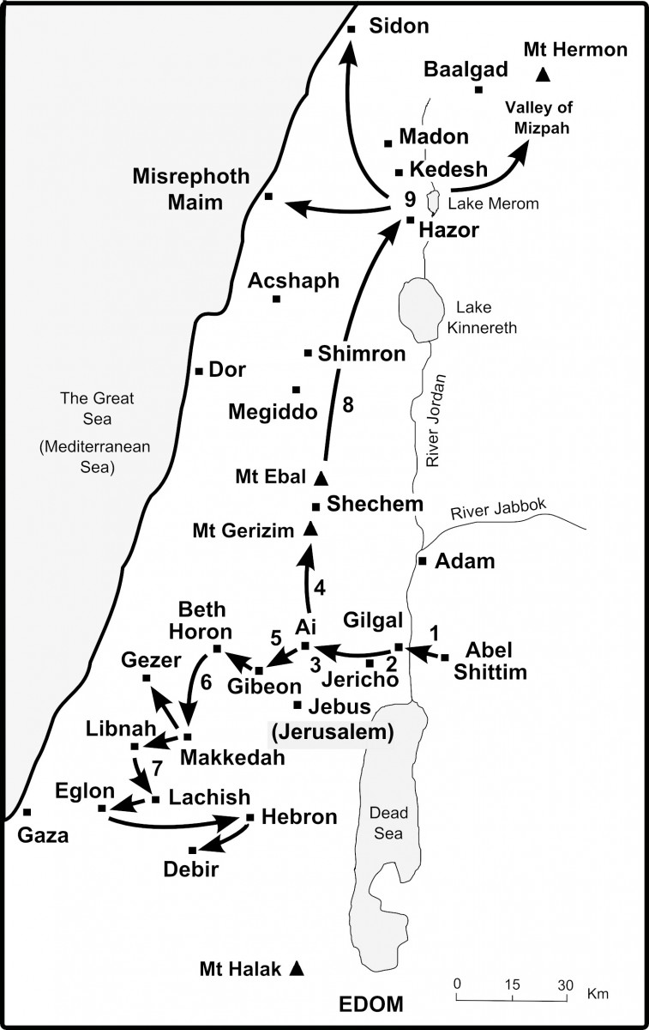
· Joshua secretly sent two spies from Shittim to look over the land especially Jericho.
· Even though Joshua was going to fight the war of conquest by faith he still made efforts to prepare the war by sending spies to look over the land. We do things by faith in God but we should do our best to do our part.
· If the war was for conquest, it is so important to know the enemy and the condition of the land because when we get enough information, we can prepare the war in the best way. Strategies and tactics for a war are determined and based on the information about the enemy and the land.
- To win campus students and our children we need to make efforts to know them through prayer and other ways.
· “Especially Jericho”- It was important to conquer the Jericho; 1) Jericho was located by an important ford of the Jordan River. The city had to be destroyed for the Israelite to go any farther on their journey of conquest. 2) The battle of the Jericho was the first battle that Israelite would fight for the war. First battle for following wars is important all the time because if they win the first battle they can have the confidence about the rest of the battles.

1-3. Where did they go? (1b)
So they went and entered the house of a prostitute named Rahab and stayed there.

· The spies went to the house of a prostitute named Rahab.
- It might be because it was the good place where they could hide their identity more easily than other places especially as strangers. Also it might be the good place where they could get a lot of information about the situation of the city and people. Also her house was a good place where the spies could look over the city because her house was on the high place of the wall.
- Rahab was a Canaanite woman and a prostitute. She is found in Jesus’ genealogy (Mt 1:5-6) Salmon the father of Boaz, whose mother was Rahab, Boaz the father of Obed, whose mother was Ruth, Obed the father of Jesse,⁶ and Jesse the father of King David.

1-4. What did the king of Jericho do when he was told about this event? (2-3)
The king of Jericho was told, “Look, some of the Israelites have come here tonight to spy out the land.” ³ So the king of Jericho sent this message to Rahab: “Bring out the men who came to you and entered your house, because they have come to spy out the whole land.”
· People in the city noticed that the two spies had come to the city and made report to the king. They might be able to notice the spies’ spying action because they were very alert about the Israelites’ invasion.
- Now the spies were in great danger to be captured and killed.
· The king ordered Rahab to bring out the spies from her house. The king had very detail information about the spies’ hiding place. He already knew where the spies were hiding.
· There were many good reasons for her to bring out the spies to the king
- The two men were spies of their enemy who were trying to invade their kingdom. She was supposed to be loyal to her country.
- It was king’s order. She would be killed by disobeying king’s order.
- It was hard to say that she didn’t know where the spies were because the king already had had the detail information that they had need in her house.

1-5. How did Rahab help the spies? (4-7)
But the woman had taken the two men and hidden them. She said, “Yes, the men came to me, but I did not know where they had come from. ⁵ At dusk, when it was time to close the city gate, they left. I don’t know which way they went. Go after them quickly. You may catch up with them.” ⁶ (But she had taken them up to the roof and hidden them under the stalks of flax she had laid out on the roof.) ⁷ So the men set out in pursuit of the spies on the road that leads to the fords of the Jordan, and as soon as the pursuers had gone out, the gate was shut.
· Rahab hid the spies under the stalks of flax and gave wrong information to the king’s men to go wrong way to find the spies.
- She saved and helped the spies even though they were his people’s enemy.
- She risked her life to help the spies. It was a dangerous thing to do. If the king had known what she had done, she would not have survived.
- Rahab’s help for the spies was a critical thing for the battle of Jericho. If Rahab followed the king’s order, Israelite would have been very discouraged hearing the failure of spying.

2. Read verses 8-13. How did Rahab describe what had happened to her people? (8-11a) What did Rahab believe about God? (11b) What favor did she ask of the spies? (12-13)

2-1. Read verses 8-13.
⁸ Before the spies lay down for the night, she went up on the roof ⁹ and said to them, “I know that the Lord has given you this land and that a great fear of you has fallen on us, so that all who live in this country are melting in fear because of you. ¹⁰ We have heard how the Lord dried up the water of the Red Sea^{[a]} for you when you came out of Egypt, and what you did to Sihon and Og, the two kings of the Amorites east of the Jordan, whom you completely destroyed.^{[b]} ¹¹ When we heard of it, our hearts melted in fear and everyone’s courage failed because of you, for the Lord your God is God in heaven above and on the earth below.¹² “Now then, please swear to me by the Lord that you will show kindness to my family, because I have shown kindness to you. Give me a sure sign ¹³ that you will spare the lives of my father and mother, my brothers and sisters, and all who belong to them—and that you will save us from death.”

2-2. How did Rahab describe what had happened to her people? (8-11a)
⁸ Before the spies lay down for the night, she went up on the roof ⁹ and said to them, “I know that the Lord has given you this land and that a great fear of you has fallen on us, so that all who live in this country are melting in fear because of you. ¹⁰ We have heard how the Lord dried up the water of the Red Sea^{[a]} for you when you came out of Egypt, and what you did to Sihon and Og, the two kings of the Amorites east of the Jordan, whom you completely destroyed.^{[b]} ¹¹ When we heard of it, our hearts melted in fear and everyone’s courage failed because of you,
· The people in the land had heard what God had done for Israelite; God dried up the water of the Red Sea, and what Israelite had done to two kings of Amorites.
- The story of God’s mighty work spread everywhere and it reached even Jericho.
· When the people in the country heard what God had done, a great fear of Israelite fallen on them and all people in the country were melting in fear because of Israelite and everyone’s courage failed
· A great fear of Israelite fallen on the people in the country. When they heard what God had done they were so shocked and became fearful because what God had done was so great and powerful.
- They got fear of Israelite because of God’s great work for them. Israelite was not strong people. They used be slave people whom people ignored and despised. But because of God and his mighty work, people became very fearful toward Israelite. They were nothing in the world but because of God they became powerful people whom others feared.
- In this world we could be despised and ignored but when God does great work and reveal his glory through us people in the world get the fear of us. Because of God we can become most powerful people in the world.
· The people in Jericho lost their heart and desire to fight- when people in the city heard about what God had done their hearts melted in fear and everyone’s courage failed because of Israelite. They couldn’t fight Israelite because of their fear. They were like a mouse before a cat. When a mouse faces a big cat it even cannot move before the cat. They already lost the battle.

2-3. What did Rahab believe about God? (11b)
for the Lord your God is God in heaven above and on the earth below.
· Rahab believed God of Israelite is the God in heaven above and on the earth below.
- She believed God of Israelite who had been with them and fought for them.
· God in heaven above and on the earth below.
- It means the God who is in the highest above all things in heaven and on earth.
- It means the God who rules over everything in heaven and on earth with his mighty power and sovereignty.
- It means the God who is only true God in heaven and on earth.
· Rahab realized that the God of Israelite was true God hearing what God had done for his people.
- Canaanites had their own gods, the idols. Rahab must have believed their gods. But hearing what God had done for his people, she realized that he is the true God who is in heaven above and on the earth.
- She was wise enough to learn about God from what she heard about God and His deeds. Other people in the country didn’t figure out who God is. They might think that God was one of gods, hoping that their god may protect them from this mighty god. They just became fearful hearing about what God had done.
- It happens that people don’t understand anything about God even though they hear about God.
- Rahab was a prostitute. But even though she had lived very lowly life, she got faith in God hearing what God had done and saved her and her family. She was a blessed woman before God even though people despised her.
· Rahab stood on God’s side by helping His people.
- Once she realized that God is the true God in heaven and on earth, she decided to serve God and his people. She expressed her faith by practical action of faith.
- She decided to serve God instead of serving her people or king who were against God. We should take care of people and our nation but when they don’t follow God or against God we can’t support them.
- It was not easy for her to do thing against her own people, but she knew that it was right to serve the will of God who is God in heaven and on earth. Serving God’s will should be the first priority above everything.
· “I know that the Lord has given you this land -Rahab knew that God already decided to give the land. She knew what God’s will was. So she wanted to obey God’s will instead of fighting against it.
- She knew that fighting against God is death but nothing else. It is right to serve God’s will more than anything else.
- The people in Jericho were supposed to surrender to God’s will to live but they fought against God’s will and all perished together with the city.

2-4. What favor did she ask of the spies? (12-13)
“Now then, please swear to me by the Lord that you will show kindness to my family, because I have shown kindness to you. Give me a sure sign ¹³ that you will spare the lives of my father and mother, my brothers and sisters, and all who belong to them—and that you will save us from death.”

· Rahab asked the spies to spare the lives of her family members when they would destroy the city as the reward for her kindness to them and asked them for sign for assurance.
- She wanted to save her family. She wanted to save her and her family from God’s judgment.
- She loved her family members. Even though she was a prostitute she loved her family members and wanted to save them from the death. We need to pray for our family members for their salvation.
- Her request was fair. God never ignores what we do to serve his will. God always rewards what we do to serve his will.

3. Read verses 14-24. What agreement did Rahab and the spies make? (14) How did she help them to escape? (15-16) What agreement did they make regarding the scarlet cord? (17-21) What did they report to Joshua? (22-24)

3-1. Read verses 14-24.
¹⁴ “Our lives for your lives!” the men assured her. “If you don’t tell what we are doing, we will treat you kindly and faithfully when the Lord gives us the land.”¹⁵ So she let them down by a rope through the window, for the house she lived in was part of the city wall. ¹⁶ She said to them, “Go to the hills so the pursuers will not find you. Hide yourselves there three days until they return, and then go on your way.”¹⁷ Now the men had said to her, “This oath you made us swear will not be binding on us ¹⁸ unless, when we enter the land, you have tied this scarlet cord in the window through which you let us down, and unless you have brought your father and mother, your brothers and all your family into your house. ¹⁹ If any of them go outside your house into the street, their blood will be on their own heads; we will not be responsible. As for those who are in the house with you, their blood will be on our head if a hand is laid on them. ²⁰ But if you tell what we are doing, we will be released from the oath you made us swear.”²¹ “Agreed,” she replied. “Let it be as you say.”So she sent them away, and they departed. And she tied the scarlet cord in the window.²² When they left, they went into the hills and stayed there three days, until the pursuers had searched all along the road and returned without finding them. ²³ Then the two men started back. They went down out of the hills, forded the river and came to Joshua son of Nun and told him everything that had happened to them. ²⁴ They said to Joshua, “The Lord has surely given the whole land into our hands; all the people are melting in fear because of us.”

3-2. What agreement did Rahab and the spies make? (14)
“Our lives for your lives!” the men assured her. “If you don’t tell what we are doing, we will treat you kindly and faithfully when the Lord gives us the land.”
· “Our lives for your lives!” : the spies said that their lives and Rahab’s family lives were bound now and assured that they would save her lives even sacrificing their lives.
· They promised her that they would treat her kindly and faithfully. When we are faithful to God, God is also faithful to us.

3-3. How did she help them to escape? (15-16)
So she let them down by a rope through the window, for the house she lived in was part of the city wall. ¹⁶ She said to them, “Go to the hills so the pursuers will not find you. Hide yourselves there three days until they return, and then go on your way.”

· She let the spies down by a rope through the window and gave them instruction how to hide themselves.
· She was very bold and brave: It was not easy to do such dangerous escaping action. But she was very bold and brave and took action because of her faith in God. When she believed that helping the spies was God’s will. She then took action boldly and bravely.
· She was very wise and clever : She was able to give them instruction how to escape. She knew how to handle the situation in the best way. She was not just good at decorating herself or cooking men but knew how to manage things well.

3-4. What agreement did they make regarding the scarlet cord? (17-21)
Now the men had said to her, “This oath you made us swear will not be binding on us ¹⁸ unless, when we enter the land, you have tied this scarlet cord in the window through which you let us down, and unless you have brought your father and mother, your brothers and all your family into your house. ¹⁹ If any of them go outside your house into the street, their blood will be on their own heads; we will not be responsible. As for those who are in the house with you, their blood will be on our head if a hand is laid on them. ²⁰ But if you tell what we are doing, we will be released from the oath you made us swear.”²¹ “Agreed,” she replied. “Let it be as you say.”So she sent them away, and they departed. And she tied the scarlet cord in the window.

· They made an agreement that the scarlet cord would be the mark of the house where Rahab’s family members would stay and Israelite would save them in the house when they would destroy the city.
· She tied the scarlet cord in the window- The scarlet cord was the sign of their agreement.
- The scarlet cord reminds us of the blood of the lamb that Israelite applied on the frame of the door of house when God killed all the firstborns in Egypt.
- It also reminds us the blood of Jesus which is the blood of God’s covenant. God saves us from the death when we have faith in the blood of Jesus.

3-5. What did they report to Joshua? (22-24)
²² When they left, they went into the hills and stayed there three days, until the pursuers had searched all along the road and returned without finding them. ²³ Then the two men started back. They went down out of the hills, forded the river and came to Joshua son of Nun and told him everything that had happened to them. ²⁴ They said to Joshua, “The Lord has surely given the whole land into our hands; all the people are melting in fear because of us.”

· The two spies made report to Joshua telling him everything that had happened to them.
· “The Lord has surely given the whole land into our hands; all the people are melting in fear because of us”.
- They were assured that God would give them the land through the spying journey especially through Rahab’s testimony.
- It was great help for Israelite to engage the war with full assurance. Israelite might be sure whether they would win the victory or not for the battle but now they got full assurance of the victory. Rahab’s help was so critical for their battle.
- God gave them the assurance through one woman of faith. Her faith took huge part of the first battle.
- We need to have assurance for our battle for the Lord. Jesus promised that he would be with us. Our battle to expand his kingdom especially on campus is guaranteed for the victory. We need to go to the battle with full assurance no matter what situation is.
- If we engage in the battle for God’s kingdom with assurance in the Lord we can enjoy the victory of the battle. May God help us to go to the battle on the campus with the assurance and experience great victory.

Conclusion
Rahab was a lowly woman as prostitute but she believed in God as God in heaven above and on earth below. By faith she served God’s will and stood with God’s people. Because of her faith she saved her and her family member’s life and contributed to the war of conquest greatly. She became heroine in the history of the war of conquest and belonged to the genealogy of Christ. May God give us many women of faith like Rahab who can help God’s people to win the victory for the war for him.
One word, “God in heaven above and on earth below”

