GIVE ME THIS HILL COUNTRY

Joshua 13:1-15:63
Key Verse: 14:12

Now give me this hill country that the Lord promised me that day. You yourself heard then that the Anakites were there and their cities were large and fortified, but, the Lord helping me, I will drive them out just as he said.”

Introduction
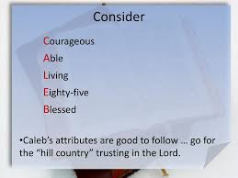
Chapters 1-12 records the conquest of Canaan while chapters 13-24 narrates the distribution of the conquered land. But the division of the land is significant because as God had promised Israel finally becomes a nation that consists of its’ own people and land. For the land distribution, the tribe of Levi is excluded because they are God-designated priestly tribe. They are to scatter throughout Israel and live in small towns and the cities of refuge, serving God’s people as God’s servants. That being said, chapter 13-15 describe the part of the division of the land. We are going to skim through the passage understanding the meaning of the division of the land. During the division of the land, one man stands out from the rest. He is Caleb. The main focus of this message could be on Caleb whose faith, patience, courage and influence.

1. Read 13:1-33. What did the LORD promise Joshua and what last task was given to him? (1-7) Describe the division of the land east of the Jordan, given to the tribe of Reuben, to the tribe of Gad, and to the half-tribe of Manasseh. (8-33)

1-1, Read 13:1-33.

When Joshua had grown old, the Lord said to him, “You are now very old, and there are still very large areas of land to be taken over. 2 “This is the land that remains: all the regions of the Philistines and Geshurites, 3 from the Shihor River on the east of Egypt to the territory of Ekron on the north, all of it counted as Canaanite though held by the five Philistine rulers in Gaza, Ashdod, Ashkelon, Gath and Ekron; the territory of the Avvites 4 on the south; all the land of the Canaanites, from Arah of the Sidonians as far as Aphek and the border of the Amorites; 5 the area of Byblos; and all Lebanon to the east, from Baal Gad below Mount Hermon to Lebo Hamath. 6 “As for all the inhabitants of the mountain regions from Lebanon to Misrephoth Maim, that is, all the Sidonians, I myself will drive them out before the Israelites. Be sure to allocate this land to Israel for an inheritance, as I have instructed you, 7 and divide it as an inheritance among the nine tribes and half of the tribe of Manasseh.” 8 The other half of Manasseh,[a] the Reubenites and the Gadites had received the inheritance that Moses had given them east of the Jordan, as he, the servant of the Lord, had assigned it to them. 9 It extended from Aroer on the rim of the Arnon Gorge, and from the town in the middle of the gorge, and included the whole plateau of Medeba as far as Dibon, 10 and all the towns of Sihon king of the Amorites, who ruled in Heshbon, out to the border of the Ammonites. 11 It also included Gilead, the territory of the people of Geshur and Maakah, all of Mount Hermon and all Bashan as far as Salekah—12 that is, the whole kingdom of Og in Bashan, who had reigned in Ashtaroth and Edrei. (He was the last of the Rephaites.) Moses had defeated them and taken over their land. 13 But the Israelites did not drive out the people of Geshur and Maakah, so they continue to live among the Israelites to this day. 14 But to the tribe of Levi he gave no inheritance, since the food offerings presented to the Lord, the God of Israel, are their inheritance, as he promised them. 15 This is what Moses had given to the tribe of Reuben, according to its clans:
16 The territory from Aroer on the rim of the Arnon Gorge, and from the town in the middle of the gorge, and the whole plateau past Medeba 17 to Heshbon and all its towns on the plateau, including Dibon, Bamoth Baal, Beth Baal Meon, 18 Jahaz, Kedemoth, Mephaath, 19 Kiriathaim, Sibmah, Zereth Shahar on the hill in the valley, 20 Beth Peor, the slopes of Pisgah, and Beth Jeshimoth— 21 all the towns on the plateau and the entire realm of Sihon king of the Amorites, who ruled at Heshbon. Moses had defeated him and the Midianite chiefs, Evi, Rekem, Zur, Hur and Reba—princes allied with Sihon—who lived in that country. 22 In addition to those slain in battle, the Israelites had put to the sword Balaam son of Beor, who practiced divination. 23 The boundary of the Reubenites was the bank of the Jordan. These towns and their villages were the inheritance of the Reubenites, according to their clans.
24 This is what Moses had given to the tribe of Gad, according to its clans:
25 The territory of Jazer, all the towns of Gilead and half the Ammonite country as far as Aroer, near Rabbah; 26 and from Heshbon to Ramath Mizpah and Betonim, and from Mahanaim to the territory of Debir; 27 and in the valley, Beth Haram, Beth Nimrah, Sukkoth and Zaphon with the rest of the realm of Sihon king of Heshbon (the east side of the Jordan, the territory up to the end of the Sea of Galilee[b]). 28 These towns and their villages were the inheritance of the Gadites, according to their clans.
29 This is what Moses had given to the half-tribe of Manasseh, that is, to half the family of the descendants of Manasseh, according to its clans:
30 The territory extending from Mahanaim and including all of Bashan, the entire realm of Og king of Bashan—all the settlements of Jair in Bashan, sixty towns, 31 half of Gilead, and Ashtaroth and Edrei (the royal cities of Og in Bashan). This was for the descendants of Makir son of Manasseh—for half of the sons of Makir, according to their clans.
32 This is the inheritance Moses had given when he was in the plains of Moab across the Jordan east of Jericho. 33 But to the tribe of Levi, Moses had given no inheritance; the Lord, the God of Israel, is their inheritance, as he promised them.

1-2, What did the LORD promise Joshua and what last task was given to him? (1-7)

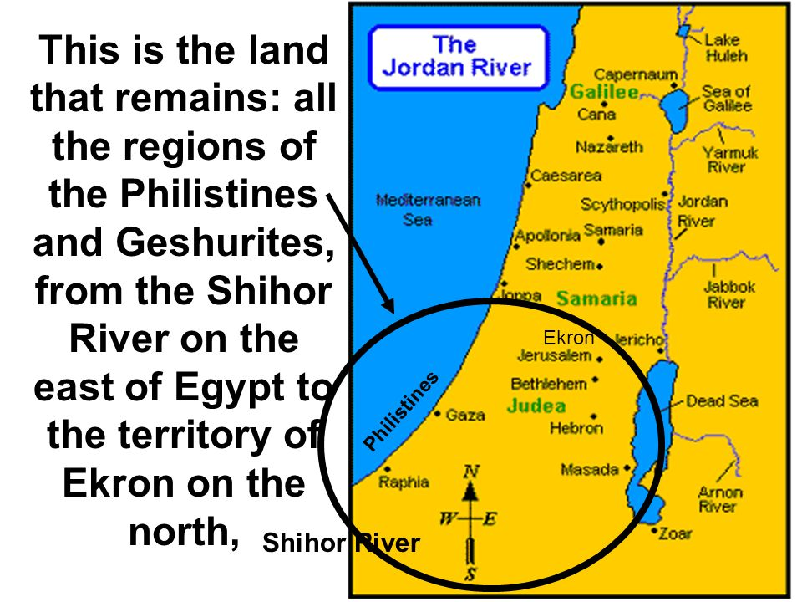
When Joshua had grown old, the Lord said to him, “You are now very old, and there are still very large areas of land to be taken over.

2 “This is the land that remains: all the regions of the Philistines and Geshurites, 3 from the Shihor River on the east of Egypt to the territory of Ekron on the north, all of it counted as Canaanite though held by the five Philistine rulers in Gaza, Ashdod, Ashkelon, Gath and Ekron; the territory of the Avvites
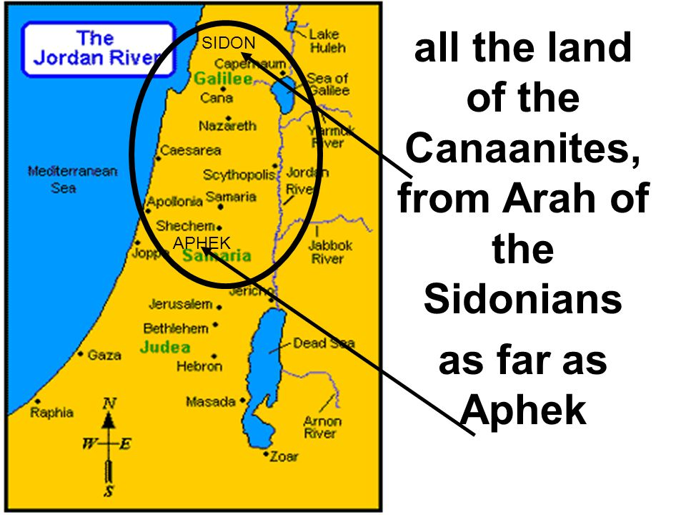
4 on the south; all the land of the Canaanites, from Arah of the Sidonians as far as Aphek and the border of the Amorites; 5 the area of Byblos; and all Lebanon to the east, from Baal Gad below Mount Hermon to Lebo Hamath.
6 “As for all the inhabitants of the mountain regions from Lebanon to Misrephoth Maim, that is, all the Sidonians, I myself will drive them out before the Israelites. Be sure to allocate this land to Israel for an inheritance, as I have instructed you, 7 and divide it as an inheritance among the nine tribes and half of the tribe of Manasseh.”

- The major war to conquer the Promised Land was over. It took several years. Now Joshua was very old. It was time for him to retire.
- But God did not say to Joshua, “Joshua, you are now very old. So why don’t you retire and install another leader?”
- Instead, he reminded Joshua of the land that remained not conquered. In God’s work, there is no retirement until they finish their life journey on earth.
- The unconquered area in the south was basically the regions that the Philistines, Geshurites and Avites held; in the north, the regions that the Canaanites and Sidonians ruled (4-6)
- But God promised that he would drive out these Canaanites and commanded Joshua to divide the land.
- So from that time on, each tribe should take responsibility to eliminate the remaining enemy within its territory.
- God is so wise. He wanted each tribe to have faith in God like Joshua and conquer the enemy within its boundary by faith.
- By receiving the land, each tribe was responsible for its allotted land and for using it in a way that pleased God.

1-3, Describe the division of the land east of the Jordan, given to the tribe of Reuben, to the tribe of Gad, and to the half-tribe of Manasseh. (8-33)

The other half of Manasseh, the Reubenites and the Gadites had received the inheritance that Moses had given them east of the Jordan, as he, the servant of the Lord, had assigned it to them.
9 It extended from Aroer on the rim of the Arnon Gorge, and from the town in the middle of the gorge, and included the whole plateau of Medeba as far as Dibon, 10 and all the towns of Sihon king of the Amorites, who ruled in Heshbon, out to the border of the Ammonites. 11 It also included Gilead, the
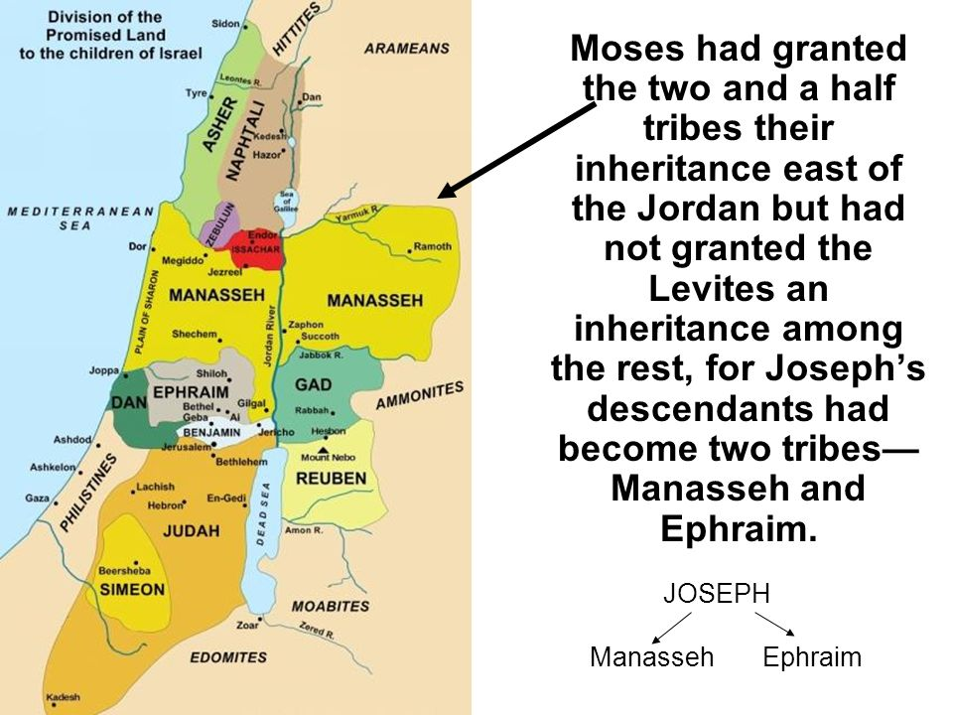
territory of the people of Geshur and Maakah, all of Mount Hermon and all Bashan as far as Salekah—12 that is, the whole kingdom of Og in Bashan, who had reigned in Ashtaroth and Edrei. (He was the last of the Rephaites.) Moses had defeated them and taken over their land. 13 But the Israelites did not drive out the people of Geshur and Maakah, so they continue to live among the Israelites to this day.
14 But to the tribe of Levi he gave no inheritance, since the food offerings presented to the Lord, the God of Israel, are their inheritance, as he promised them.
15 This is what Moses had given to the tribe of Reuben, according to its clans:
16 The territory from Aroer on the rim of the Arnon Gorge, and from the town in the middle of the gorge, and the whole plateau past Medeba 17 to Heshbon and all its towns on the plateau, including Dibon, Bamoth Baal, Beth Baal Meon, 18 Jahaz, Kedemoth, Mephaath, 19 Kiriathaim, Sibmah, Zereth Shahar on the hill in the valley, 20 Beth Peor, the slopes of Pisgah, and Beth Jeshimoth— 21 all the towns on the plateau and the entire realm of Sihon king of the Amorites, who ruled at Heshbon. Moses had defeated him and the Midianite chiefs, Evi, Rekem, Zur, Hur and Reba—princes allied with Sihon—who lived in that country. 22 In addition to those slain in battle, the Israelites had put to the sword Balaam son of Beor, who practiced divination. 23 The boundary of the Reubenites was the bank of the Jordan. These towns and their villages were the inheritance of the Reubenites, according to their clans.
24 This is what Moses had given to the tribe of Gad, according to its clans:
25 The territory of Jazer, all the towns of Gilead and half the Ammonite country as far as Aroer, near Rabbah; 26 and from Heshbon to Ramath Mizpah and Betonim, and from Mahanaim to the territory of Debir; 27 and in the valley, Beth Haram, Beth Nimrah, Sukkoth and Zaphon with the rest of the realm of Sihon king of Heshbon (the east side of the Jordan, the territory up to the end of the Sea of Galilee[b]). 28 These towns and their villages were the inheritance of the Gadites, according to their clans.
29 This is what Moses had given to the half-tribe of Manasseh, that is, to half the family of the descendants of Manasseh, according to its clans:
30 The territory extending from Mahanaim and including all of Bashan, the entire realm of Og king of Bashan—all the settlements of Jair in Bashan, sixty towns, 31 half of Gilead, and Ashtaroth and Edrei (the royal cities of Og in Bashan). This was for the descendants of Makir son of Manasseh—for half of the sons of Makir, according to their clans.
32 This is the inheritance Moses had given when he was in the plains of Moab across the Jordan east of Jericho. 33 But to the tribe of Levi, Moses had given no inheritance; the Lord, the God of Israel, is their inheritance, as he promised them.

- The territories east side of the Jordan given to two and a half tribes—the tribes of Reuben, Gad and half of Manasseh.
- Before crossing the Jordan River and entering the Promised Land, Moses fought Sihon king of Heshbon and Og king of Bashan and took their lands and given to the two and a half tribes. And Joshua confirmed their territories again.

2. Read 14:1-15. How was the land west of the Jordan divided? (1-5) Notice the allotment for Caleb. What can we learn from him? (6-12) How did Joshua bless Caleb? (13-15)

2-1, Read 14:1-15.

Now these are the areas the Israelites received as an inheritance in the land of Canaan, which Eleazar the priest, Joshua son of Nun and the heads of the tribal clans of Israel allotted to them. 2 Their inheritances were assigned by lot to the nine and a half tribes, as the Lord had commanded through Moses. 3 Moses had granted the two and a half tribes their inheritance east of the Jordan but had not granted the Levites an inheritance among the rest, 4 for Joseph’s descendants had become two tribes—Manasseh and Ephraim. The Levites received no share of the land but only towns to live in, with pasturelands for their flocks and herds. 5 So the Israelites divided the land, just as the Lord had commanded Moses.
6 Now the people of Judah approached Joshua at Gilgal, and Caleb son of Jephunneh the Kenizzite said to him, “You know what the Lord said to Moses the man of God at Kadesh Barnea about you and me. 7 I was forty years old when Moses the servant of the Lord sent me from Kadesh Barnea to explore the land. And I brought him back a report according to my convictions, 8 but my fellow Israelites who went up with me made the hearts of the people melt in fear. I, however, followed the Lord my God wholeheartedly. 9 So on that day Moses swore to me, ‘The land on which your feet have walked will be your inheritance and that of your children forever, because you have followed the Lord my God wholeheartedly.’ 10 “Now then, just as the Lord promised, he has kept me alive for forty-five years since the time he said this to Moses, while Israel moved about in the wilderness. So here I am today, eighty-five years old! 11 I am still as strong today as the day Moses sent me out; I’m just as vigorous to go out to battle now as I was then. 12 Now give me this hill country that the Lord promised me that day. You yourself heard then that the Anakites were there and their cities were large and fortified, but, the Lord helping me, I will drive them out just as he said.” 13 Then Joshua blessed Caleb son of Jephunneh and gave him Hebron as his inheritance. 14 So Hebron has belonged to Caleb son of Jephunneh the Kenizzite ever since, because he followed the Lord, the God of Israel, wholeheartedly. 15 (Hebron used to be called Kiriath Arba after Arba, who was the greatest man among the Anakites.) Then the land had rest from war.

2-2, How was the land west of the Jordan divided? (1-5)

Now these are the areas the Israelites received as an inheritance in the land of Canaan, which Eleazar the priest, Joshua son of Nun and the heads of the tribal clans of Israel allotted to them. 2 Their inheritances were assigned by lot to the nine and a half tribes, as the Lord had commanded through Moses. 3 Moses had granted the two and a half tribes their inheritance east of the Jordan but had not granted the Levites an inheritance among the rest, 4 for Joseph’s descendants had become two tribes—Manasseh and Ephraim. The Levites received no share of the land but only towns to live in, with pasturelands for their flocks and herds. 5 So the Israelites divided the land, just as the Lord had commanded Moses.

- Eleazar the priest, Joshua and the heads of the tribal clans allotted the land fairly and transparently.
- God was the one who chose the portion of the land given to each tribe. The division of the land west of the Jordan was done by lot for the nine and a half tribes.
- The significance of the division of the land would prevent people and tribes from personal and tribal dispute and arguments over the property.
- The division of the land also clearly shows that the Israelites received the land from God, not by their own strength and effort.
- Of course, the people of Israel engaged in the battle. But if God didn’t fight for them, how could they defeat the city of Jericho and allied enemies.
- With their own strength, they would be defeated by the Canaanites like the first battle of Ai. But God fought their enemies and gave each tribe land appropriately.
- So they should give thanks to God for granting them the land where they could serve God freely as God’s chosen people.
- By and large, everything we have is God’s gift. God is the Creator and the Lord of all. We are just stewards of our possessions and life before God the giver.
- As God’s steward living before our Lord God, we must become responsible for the area and people around us.
- The Israelites received the land but they could not take care of it. Later, they became the people of diaspora without a country. May we be responsible stewards for our life, family, mission and church.

2-3, Notice the allotment for Caleb.
2-4, What can we learn from him? (6-12)

Allotment for Caleb
6 Now the people of Judah approached Joshua at Gilgal, and Caleb son of Jephunneh the Kenizzite said to him, “You know what the Lord said to Moses the man of God at Kadesh Barnea about you and me. 7 I was forty years old when Moses the servant of the Lord sent me from Kadesh Barnea to explore the land. And I brought him back a report according to my convictions, 8 but my fellow Israelites who went up with me made the hearts of the people melt in fear. I, however, followed the Lord my God wholeheartedly. 9 So on that day Moses swore to me, ‘The land on which your feet have walked will be your inheritance and that of your children forever, because you have followed the Lord my God wholeheartedly.’ 10 “Now then, just as the Lord promised, he has kept me alive for forty-five years since the time he said this to Moses, while Israel moved about in the wilderness. So here I am today, eighty-five years old! 11 I am still as strong today as the day Moses sent me out; I’m just as vigorous to go out to battle now as I was then.

- Caleb was the leader from the tribe of Judah whom Moses sent from Kadesh Barnea to spy out the land of Canaan together with Joshua and 10 other leaders.
- At that time he was 40 years old. But in this passage, he was 85 years old after 40 years of wilderness life plus 5 years of the conquest war in Canaan.
- It was time to divide the land according to God’s promises. Caleb was now a very old man. However, he was different from other old people.

- Before receiving the land, Caleb and the people of Judah came to Joshua at Gilgal and reminded Joshua of God’s word of promise to Caleb at Kadesh Barnea.
- Then based on God’s promise, Caleb claimed the land which he would take from the strongest enemies Anakites(10-12).
- Caleb’s character was, “wholeheartedly serve God!” Americans love dogs, for they are wholeheartedly serving their owner. Caleb means dog!
- Caleb didn’t follow the unbelieving opinion of the majority people. He followed God and did what God wanted him to do. May God help all of us to follow God wholeheartedly.
- Even when his hair turned white, and even when Moses who gave him God’s promise died, he never let go of this promise. Rather it was burning continually in his heart. He had an undying vision that came from God’s promise.

- Those who hold on to God’s promise should patiently wait until God fulfills it, and never let go of it. Abraham waited 25 years. Moses waited 40 years. Caleb waited 45 years.
- We all receive God’s promise. Is God’s promise to you still burning in your heart? We must have faith and patience while waiting for God’s promise to be fulfilled.
- Let us sing, “Standing, standing, I’m standing on the promises of God.”
https://www.youtube.com/watch?v=tTwmS7uyqOo
- God’s promise is also ours to claim. Until we take hold of God’s promise, God’s promise is just written words in the Bible. When we take it, then it is ours. If we take it, we should claim. And if you don’t claim it, you will not get the prize.

12 Now give me this hill country that the Lord promised me that day. You yourself heard then that the Anakites were there and their cities were large and fortified, but, the Lord helping me, I will drive them out just as he said.”

- What Caleb claimed was the hill country Hebron that God had promised to give him. But the land he claimed was not a fertile pasture, but a rugged hill country where the fierce looking Anakites were ready to fight.
- To an 85 years old man, it might be very difficult to drive them out. To ordinary people’s eyes, this old man really looked like old grasshopper before the Anakites.
- But Caleb believed that God would be with him and help him to drive out the enemies and conquer the Promised Land.
- He was more than sure to win the victory because God had promised him and would help him for the battle.
- He believed that age was just a number. He believed that God who gave him the promise will help him to drive them out. This old man’s faith was as same as his faith 45 years ago.

2-5, How did Joshua bless Caleb? (13-15)

13 Then Joshua blessed Caleb son of Jephunneh and gave him Hebron as his inheritance. 14 So Hebron has belonged to Caleb son of Jephunneh the Kenizzite ever since, because he followed the Lord, the God of Israel, wholeheartedly. 15 (Hebron used to be called Kiriath Arba after Arba, who was the greatest man among the Anakites.) Then the land had rest from war.

- So Joshua must have been greatly moved by Caleb. He blessed Caleb and gave him Hebron as his inheritance. And Caleb drove out the Anakites from Hebron and it belonged to Caleb.
- Its original name was Kiriath Arba—Arba’s city. Arba proudly named the city after his name.After taking it, however, Caleb didn’t name it as Kiriath Caleb, but Hebron meaning, “the Hebrew place.”

3. Read 15:1-63. For the allotment of Judah, what are their southern, eastern, northern, and western boundaries? (1-12) When Hebron was given to Caleb, what did he do? (13-19) Describe the towns Judah received (20-63)

3-1, Read 15:1-63.

The allotment for the tribe of Judah, according to its clans, extended down to the territory of Edom,to the Desert of Zin in the extreme south.
2 Their southern boundary started from the bay at the southern end of the Dead Sea, 3 crossed south of Scorpion Pass, continued on to Zin and went over to the south of Kadesh Barnea. Then it ran past Hezron up to Addar and curved around to Karka. 4 It then passed along to Azmon and joined the Wadi of Egypt, ending at the Mediterranean Sea. This is their[a] southern boundary.
5 The eastern boundary is the Dead Sea as far as the mouth of the Jordan.
The northern boundary started from the bay of the sea at the mouth of the Jordan, 6 went up to Beth Hoglah and continued north of Beth Arabah to the Stone of Bohan son of Reuben. 7 The boundary then went up to Debir from the Valley of Achor and turned north to Gilgal, which faces the Pass of Adummim south of the gorge. It continued along to the waters of En Shemesh and came out at En Rogel. 8 Then it ran up the Valley of Ben Hinnom along the southern slope of the Jebusite city (that is, Jerusalem). From there it climbed to the top of the hill west of the Hinnom Valley at the northern end of the Valley of Rephaim. 9 From the hilltop the boundary headed toward the spring of the waters of Nephtoah, came out at the towns of Mount Ephron and went down toward Baalah (that is, Kiriath Jearim). 10 Then it curved westward from Baalah to Mount Seir, ran along the northern slope of Mount Jearim (that is, Kesalon), continued down to Beth Shemesh and crossed to Timnah. 11 It went to the northern slope of Ekron, turned toward Shikkeron, passed along to Mount Baalah and reached Jabneel.The boundary ended at the sea.
12 The western boundary is the coastline of the Mediterranean Sea.
These are the boundaries around the people of Judah by their clans.
13 In accordance with the Lord’s command to him, Joshua gave to Caleb son of Jephunneh a portion in Judah—Kiriath Arba, that is, Hebron. (Arba was the forefather of Anak.) 14 From Hebron Caleb drove out the three Anakites—Sheshai, Ahiman and Talmai, the sons of Anak. 15 From there he marched against the people living in Debir (formerly called Kiriath Sepher). 16 And Caleb said, “I will give my daughter Aksah in marriage to the man who attacks and captures Kiriath Sepher.” 17 Othniel son of Kenaz, Caleb’s brother, took it; so Caleb gave his daughter Aksah to him in marriage.
18 One day when she came to Othniel, she urged him[b] to ask her father for a field. When she got off her donkey, Caleb asked her, “What can I do for you?”
19 She replied, “Do me a special favor. Since you have given me land in the Negev, give me also springs of water.” So Caleb gave her the upper and lower springs.
20 This is the inheritance of the tribe of Judah, according to its clans:
21 The southernmost towns of the tribe of Judah in the Negev toward the boundary of Edom were:
Kabzeel, Eder, Jagur, 22 Kinah, Dimonah, Adadah, 23 Kedesh, Hazor, Ithnan, 24 Ziph, Telem, Bealoth,25 Hazor Hadattah, Kerioth Hezron (that is, Hazor), 26 Amam, Shema, Moladah, 27 Hazar Gaddah, Heshmon, Beth Pelet, 28 Hazar Shual, Beersheba, Biziothiah, 29 Baalah, Iyim, Ezem, 30 Eltolad, Kesil, Hormah, 31 Ziklag, Madmannah, Sansannah, 32 Lebaoth, Shilhim, Ain and Rimmon—a total of twenty-nine towns and their villages.
33 In the western foothills:
Eshtaol, Zorah, Ashnah, 34 Zanoah, En Gannim, Tappuah, Enam, 35 Jarmuth, Adullam, Sokoh, Azekah,36 Shaaraim, Adithaim and Gederah (or Gederothaim)[c]—fourteen towns and their villages.
37 Zenan, Hadashah, Migdal Gad, 38 Dilean, Mizpah, Joktheel, 39 Lachish, Bozkath, Eglon, 40 Kabbon, Lahmas, Kitlish, 41 Gederoth, Beth Dagon, Naamah and Makkedah—sixteen towns and their villages.
42 Libnah, Ether, Ashan, 43 Iphtah, Ashnah, Nezib, 44 Keilah, Akzib and Mareshah—nine towns and their villages.
45 Ekron, with its surrounding settlements and villages; 46 west of Ekron, all that were in the vicinity of Ashdod, together with their villages; 47 Ashdod, its surrounding settlements and villages; and Gaza, its settlements and villages, as far as the Wadi of Egypt and the coastline of the Mediterranean Sea.
48 In the hill country:
Shamir, Jattir, Sokoh, 49 Dannah, Kiriath Sannah (that is, Debir), 50 Anab, Eshtemoh, Anim, 51 Goshen,Holon and Giloh—eleven towns and their villages.
52 Arab, Dumah, Eshan, 53 Janim, Beth Tappuah, Aphekah, 54 Humtah, Kiriath Arba (that is, Hebron) and Zior—nine towns and their villages.
55 Maon, Carmel, Ziph, Juttah, 56 Jezreel, Jokdeam, Zanoah, 57 Kain, Gibeah and Timnah—ten towns and their villages.
58 Halhul, Beth Zur, Gedor, 59 Maarath, Beth Anoth and Eltekon—six towns and their villages.[d]
60 Kiriath Baal (that is, Kiriath Jearim) and Rabbah—two towns and their villages.
61 In the wilderness:
Beth Arabah, Middin, Sekakah, 62 Nibshan, the City of Salt and En Gedi—six towns and their villages.
63 Judah could not dislodge the Jebusites, who were living in Jerusalem; to this day the Jebusites live there with the people of Judah.

3-2, For the allotment of Judah, what are their southern, eastern, northern, and western boundaries? (1-12)

The allotment for the tribe of Judah, according to its clans, extended down to the territory of Edom,to the Desert of Zin in the extreme south. 2 Their southern boundary started from the bay at the southern end of the Dead Sea, 3 crossed south of Scorpion Pass, continued on to Zin and went over to the south of Kadesh Barnea. Then it ran past Hezron up to Addar and curved around to Karka. 4 It then passed along to Azmon and joined the Wadi of Egypt, ending at the Mediterranean Sea. This is their[a] southern boundary.
5 The eastern boundary is the Dead Sea as far as the mouth of the Jordan.
The northern boundary started from the bay of the sea at the mouth of the Jordan, 6 went up to Beth Hoglah and continued north of Beth Arabah to the Stone of Bohan son of Reuben. 7 The boundary then went up to Debir from the Valley of Achor and turned north to Gilgal, which faces the Pass of Adummim south of the gorge. It continued along to the waters of En Shemesh and came out at En Rogel. 8 Then it ran up the Valley of Ben Hinnom along the southern slope of the Jebusite city (that is, Jerusalem). From there it climbed to the top of the hill west of the Hinnom Valley at the northern end of the Valley of Rephaim. 9 From the hilltop the boundary headed toward the spring of the waters of Nephtoah, came out at the towns of Mount Ephron and went down toward Baalah (that is, Kiriath Jearim). 10 Then it curved westward from Baalah to Mount Seir, ran along the northern slope of Mount Jearim (that is, Kesalon), continued down to Beth Shemesh and crossed to Timnah. 11 It went to the northern slope of Ekron, turned toward Shikkeron, passed along to Mount Baalah and reached Jabneel.The boundary ended at the sea.
12 The western boundary is the coastline of the Mediterranean Sea.
These are the boundaries around the people of Judah by their clans.

3-3, When Hebron was given to Caleb, what did he do? (13-19)

13 In accordance with the Lord’s command to him, Joshua gave to Caleb son of Jephunneh a portion in Judah—Kiriath Arba, that is, Hebron. (Arba was the forefather of Anak.) 14 From Hebron Caleb drove out the three Anakites—Sheshai, Ahiman and Talmai, the sons of Anak. 15 From there he marched against the people living in Debir (formerly called Kiriath Sepher). 16 And Caleb said, “I will give my daughter Aksah in marriage to the man who attacks and captures Kiriath Sepher.” 17 Othniel son of Kenaz, Caleb’s brother, took it; so Caleb gave his daughter Aksah to him in marriage. 18 One day when she came to Othniel, she urged him[b] to ask her father for a field. When she got off her donkey, Caleb asked her, “What can I do for you?”
19 She replied, “Do me a special favor. Since you have given me land in the Negev, give me also springs of water.” So Caleb gave her the upper and lower springs.

- Caleb was not only a man of great faith but also a man of encouragement to help others to serve the Lord.
- His daughter learned her father’s spirit and live by faith and claim the land.

3-4, Describe the towns Judah received (20-63)

20 This is the inheritance of the tribe of Judah, according to its clans: 21 The southernmost towns of the tribe of Judah in the Negev toward the boundary of Edom were:
Kabzeel, Eder, Jagur, 22 Kinah, Dimonah, Adadah, 23 Kedesh, Hazor, Ithnan, 24 Ziph, Telem, Bealoth,25 Hazor Hadattah, Kerioth Hezron (that is, Hazor), 26 Amam, Shema, Moladah, 27 Hazar Gaddah, Heshmon, Beth Pelet, 28 Hazar Shual, Beersheba, Biziothiah, 29 Baalah, Iyim, Ezem, 30 Eltolad, Kesil, Hormah, 31 Ziklag, Madmannah, Sansannah, 32 Lebaoth, Shilhim, Ain and Rimmon—a total of twenty-nine towns and their villages.
33 In the western foothills:
Eshtaol, Zorah, Ashnah, 34 Zanoah, En Gannim, Tappuah, Enam, 35 Jarmuth, Adullam, Sokoh, Azekah,36 Shaaraim, Adithaim and Gederah (or Gederothaim)[c]—fourteen towns and their villages.
37 Zenan, Hadashah, Migdal Gad, 38 Dilean, Mizpah, Joktheel, 39 Lachish, Bozkath, Eglon, 40 Kabbon, Lahmas, Kitlish, 41 Gederoth, Beth Dagon, Naamah and Makkedah—sixteen towns and their villages.
42 Libnah, Ether, Ashan, 43 Iphtah, Ashnah, Nezib, 44 Keilah, Akzib and Mareshah—nine towns and their villages.
45 Ekron, with its surrounding settlements and villages; 46 west of Ekron, all that were in the vicinity of Ashdod, together with their villages; 47 Ashdod, its surrounding settlements and villages; and Gaza, its settlements and villages, as far as the Wadi of Egypt and the coastline of the Mediterranean Sea.
48 In the hill country:
Shamir, Jattir, Sokoh, 49 Dannah, Kiriath Sannah (that is, Debir), 50 Anab, Eshtemoh, Anim, 51 Goshen,Holon and Giloh—eleven towns and their villages.
52 Arab, Dumah, Eshan, 53 Janim, Beth Tappuah, Aphekah, 54 Humtah, Kiriath Arba (that is, Hebron) and Zior—nine towns and their villages.
55 Maon, Carmel, Ziph, Juttah, 56 Jezreel, Jokdeam, Zanoah, 57 Kain, Gibeah and Timnah—ten towns and their villages.
58 Halhul, Beth Zur, Gedor, 59 Maarath, Beth Anoth and Eltekon—six towns and their villages.[d]
60 Kiriath Baal (that is, Kiriath Jearim) and Rabbah—two towns and their villages.
61 In the wilderness: Beth Arabah, Middin, Sekakah, 62 Nibshan, the City of Salt and En Gedi—six towns and their villages. 63 Judah could not dislodge the Jebusites, who were living in Jerusalem; to this day the Jebusites live there with the people of Judah.

Conclusion

The hill country Hebron for us could be our difficult school study, our workplace, our family or our church. But most importantly, It is also our mission field that God gave us as our inheritance. We have privilege to claim it and responsibility to drive out our enemies, sin and Satan. We must make it as God-dwelling place. We face secular humanism, materialism and hedonism everywhere. They are like the Anakites. May God give us faith and courage to serve campuses like Caleb’s spirit through 1:1 bible study and discipleship ministry. Amen!

One word: Wholeheartedly!

