Looking Ahead to His Reward

Hebrews 11:23-31
Key verse 26

“He regarded disgrace for the sake of Christ as of greater value than
the treasures of Egypt, because he was looking ahead to his reward.”

Introduction

Through today’s passage we will see God’s promises come true through Moses’ parents, Moses, and the Israelites as a community of faith. Those who lost their personal faith died in the desert. But some, like Moses, Caleb, Joshua, and the new generation who humbly learned to follow God, were allowed to experience God’s victory. Even a foreign woman, Rahab tasted God’s great victory and was able to take part in God’s redemptive history by faith. May the name of Jesus be praised!

- Read verses 23-26. How did Moses’ parents display their faith? (23) What does Moses’ refusal to be known as the son of Pharaoh’s daughter mean? (24) What kind of life did he choose to live by faith? (25) What prompted Moses to make such a decision? (26)

1-1, Read verses 23-26.

By faith Moses’ parents hid him for three months after he was born, because they saw he was no ordinary child, and they were not afraid of the king’s edict. 24 By faith Moses, when he had grown up, refused to be known as the son of Pharaoh’s daughter. 25 He chose to be mistreated along with the people of God rather than to enjoy the fleeting pleasures of sin.26 He regarded disgrace for the sake of Christ as of greater value than the treasures of Egypt, because he was looking ahead to his reward.

1-2, How did Moses’ parents display their faith? (23)

By faith Moses’ parents hid him for three months after he was born, because they saw he was no ordinary child, and they were not afraid of the king’s edict.
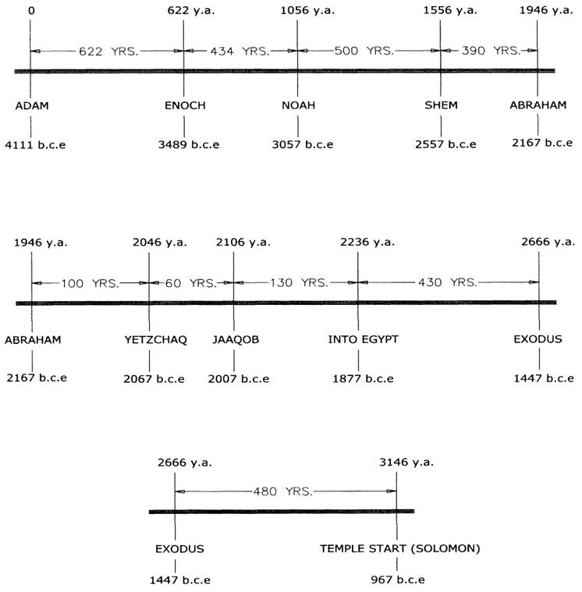
- Moses seemed to be born in the wrong place at the wrong time as the wrong gender. At that time baby girls were favored over boys. He face the threat of death as soon as he was born like our Lord Jesus Christ.
- Exodus 1:8-22 tells us the background of Moses' birth. Moses was born when the Egyptian Empire was in political transition.
- The new king of Egypt, who forgot about what Joseph had done, began to persecute the Israelites. He feared the Israelites were becoming a threat to their national security.
- Pharaoh oppressed the Israelites by forced labor, hoping that this would keep them from becoming too numerous. But his plan failed. The more the Israelites were oppressed, the more they multiplied and spread.
- Finally, Pharaoh, king of Egypt, issued an edict that every baby boy born to Hebrew parents had to be thrown into the river and drowned.
- If all the Israelite boys were killed, there would be no men to create a nation.
- The girls could be put into forced labor. Moses was born into a Hebrew slave family in Egypt. In short, he was born into a fatalistic situation.
- But God turned this tragic situation into an opportunity to raise up one of the greatest leaders all time in our human history.
- One cannot speak about Moses’ faith without first taking note of the faith of his parents. Moses’ life began with the faith of his parents because he was too young to know what was going on.

“By faith Moses’ parents hid him for three months because they saw he was no ordinary child.”
- The author emphasized the faith of Moses’ parents. They hid the baby Moses by faith, not fearing the king’s edict.
- Other parents saw no other choice and threw their babies into the river, following the king’s edict.
- But Moses parents were different. They hid him. It was because they saw that he was no ordinary child. It means that as soon as Moses’ parent saw the baby Moses, they believed that God has some special plan for him.
- When they saw the child with eyes of faith, they could see that he was no ordinary child; they were convinced that God was with him.
- Moses' parents did not have foreknowledge of how God intended to raise Moses as the deliverer of the Israelites after 430 years of Egyptian slavery.
- But they believed that God was with the baby Moses. They were people of faith. The baby Moses was saved because of his parent’s faith.
- It seems to be a small matter in human eyes. But it was a turning point in God’s history.
- Through this small event God began to raise up a leader of the Exodus. It was the beginning of a new history for the people of God.

- Pharaoh’s edict was a matter of life and death at that time. People were afraid of the king’s edict. But Moses' parents were different.
- They were not afraid of the king's edict. Because Moses' parents feared God, they didn’t fear visible human beings, even the king.
- By faith they hid their beautiful baby for three months, trusting God rather than fearing Pharaoh.
- When baby Moses began to cry after three months, his parents placed him in a basket and the baby Moses drifted out into the Nile River.
- Through this act of faith, they entrusted the baby Moses into God’s hands. They did their part and God continued to work and do His part, working together with Moses’ parents.
- In answering their prayers, God intervened in Moses' life. Moses was in the right place, at the right time, and was the right person by God’s sovereign will.
- Pharaoh's daughter went down to the River Nile to bathe. She saw the basket among the reeds. When she opened it, she saw the baby. Thank God!
- She ended up giving him to a Hebrew nurse, who was Moses' real mother.
- Pharaoh's daughter named him Moses, saying, "I drew him out of the water." When Moses' parents believed in God Almighty, God was with them and with their son Moses.

- Today, we live in the age of no commitment. Many parents do not make a long term commitment for their children and see their children as an economic burden, trouble maker, or even as a threat.
- There is currently a crises in the country of Korea where newborn babies are unwanted. Because of this, Korea’s population keeps decreasing. May the Lord raise up believers like Moses’ parents and raise their children boldly as God’s servants like Moses.
- A parent’s faith is critical in order to impress faith upon a child’s soul.
- A parent’s faith plays an important role in children developing personal faith. We have to see our children with eyes of faith and believe that God is with them. We must believe they will be the powerful and influential spiritual leaders like Moses.
- We need to protect them from the evil influence of the world and nurture them with spiritual milk until they grow up in faith. Then after they grow up, we must entrust them into God’s hands as Moses’ parents did.
- We do our part and God will do his part, to take care of our children with his mighty hands.

1-3, What does Moses’ refusal to be known as the son of Pharaoh’s daughter mean? (24)

By faith Moses, when he had grown up, refused to be known as the son of Pharaoh’s daughter.
- What was the basis of his decision? It was “by faith.”
- Moses had a double identity-an Egyptian prince and a Hebrew man. He had to choose one.
- Moses had grown up and it grieved him to see his people being mistreated. (Exo 2:11) On one occasion he saw an Egyptian beating a Hebrew.
- He came to the Hebrew’s defense and killed the Egyptian with his martial arts skills. But Pharaoh found out and sought Moses’ life. Moses fled and spent the next 40 years in Midian.
- If Moses remained in the palace, he might have been a possible successor of the Egyptian Emperor because he was a favorite of the Pharaoh.

“By faith he refused to be known as the son of the Pharaoh’s daughter.”
- Moses knew that he would lose his position as the Prince of Egypt by his actions. Moses made a choice to separate himself from the ways of the Egyptians.
- He understood that the life in Egypt was not what God wanted for him. Moses lived in Egypt for 40 years and yet, like Joseph, he knew that it was not home.
- The power, prestige, and glory of the Egypt were upon him. But by faith he gave up his glorious prince position. He gave it all up.

1-4, What kind of life did he choose to live by faith? (25)

He chose to be mistreated along with the people of God rather than to enjoy the fleeting pleasures of sin.

- He knew that the treasures of Egypt were like the fleeting pleasures of sin. In the palace people could enjoy parties, eat gourmet food, wear fine clothes, and enjoy many other forms of pleasure and entertainment.
- The palace life was luxurious, comfortable, and fun. But these comforts and pleasures are fleeting and temporary. When the initial thrill is over, there’s no meaning and feelings of futility and guilt follow.
- The palace life bears the fruit of sin which is ultimately death. Moses knew and understood this well.

Psalm 90:10 and 12 record his words,

“Our days may come to seventy years, or eighty, if our strength endures; yet the best of them are but trouble and sorrow, for they quickly pass, and we fly away…Teach us to number our days that we may gain a heart of wisdom”

1 Peter 1:24-25 reads also,

“All people are like grass, and all their glory is like the flowers of the field; the grass withers and the flowers fall, but the word of the Lord endures forever”

- When we suffer as one of the people of God, we find meaning and purpose and bear good fruit which lasts forever. This is what Moses truly valued.
- With this value system, he could go the way of suffering with confidence.

“He chose to be mistreated along with the people of God rather than to enjoy the pleasure of sin for a short time.” (Old NIV version)
- Mistreatment followed Moses after he made the decision to identify as one of God’s people. His decision was very costly because it invited immediate oppression.
- It’s human nature to avoid suffering as much as possible and to enjoy an easy-going life.
- But Moses made a clear choice to obey God by accepting his mission to be mistreated along with the people of God.
- He thought about God’s people who were groaning under the yoke of Egypt rather than seeking his own personal pleasures and the glory of the world.
- When Moses chose to be mistreated along with his people, he gave up pleasure and comfort and chose suffering instead.
- Humanly speaking, it was a hard choice. But Moses chose to suffer with his people instead of being the prince of Egypt because he loved God.

- Like Moses, by faith we must refuse to be associated with the pleasures of this world. This world is not our eternal home.
- When we decide to follow God’s word, we will be mistreated by the world like Moses.
- The pleasures of this world are temporary and it cannot be compared to the eternal relationship we have with our God.
- Therefore, we must refuse to follow the pleasures of sin. Rather, we should remember how God called us out of our bondage to slavery in Egypt and separate ourselves from a sinful way of life and follow the will of God.
- When we read about Moses in the Bible, we learn that he made the right choice. Because of his choice, he did not become a mummy in Egypt.
- Instead, he was used by God and he could be a blessing to all of his spiritual descendants. The Christian life requires a choice before God.
- We made our personal decision of faith before God to serve young college campus students in America to obey Jesus’ command.
- God did not call us to have a better life in this world, but He called us to become Bible teachers and disciple makers for Jesus.

1-5, What prompted Moses to make his decision? (26)

26 He regarded disgrace for the sake of Christ as of greater value than the treasures of Egypt, because he was looking ahead to his reward.

- Moses had another reason for choosing to suffer with his people.
- When Moses suffered, he suffered with Christ. Jesus Christ became our eternal high priest who went into heaven after offering his blood once for all.
- Now he is sitting at the right hand of God in glory. At the mount of transfiguration Moses was one of the servants talking with Jesus in honor.
- The author encouraged us to go through persecution and suffering to identify with Christ’ disgrace as Moses received disgrace for the sake of Christ.
- Likewise we must receive disgrace for the sake of Christ when we face all kinds of mistreatment simply because we love Christ.
Hebrews 11:6c says,
“He rewards those who earnestly seek him.”
- Moses sought God's reward. For this, he could forsake the treasures of Egypt. He was sure of God's reward.
- These days there are many people who have no true sense of reward. Some people say, “I don’t need reward. I just live.”
- But in reality all people look forward to receiving their reward. This is the reason people are willing to suffer and work hard when they go to work or sacrifice their time and money to get an education.
- In the spiritual world the same is true. We are not seeking the temporary reward the world gives but seeking God’s eternal reward which is kept in heaven for all who live by faith.
- Apostle Paul valued Jesus more than anything in the world. He suffered for Christ to know the power of resurrection.

He said in Philippians 3:8,
“What is more, I consider everything a loss compared to the surpassing greatness of knowing Christ Jesus my Lord, for whose sake I have lost all things. I consider them rubbish, that I may gain Christ.”
- Paul gave up everything for the sake of Christ because he found great value in Jesus.
- What do you value most in your life? What did you give up for the sake of Christ? Let’s seek to have Jesus rather than seeking wealth or fame that this world offers.
- When we live for Jesus, we will be happy and satisfied.

Matthew 16:26 says,
“What good will it be for a man if he gains the whole world, yet forfeits his soul? Or what can a man give in exchange for his soul?”

- Read verses 27-29. What enabled Moses to leave Egypt along with his people? (27) What was the significance of keeping the Passover? (28) When passing through the Red Sea, what happened to the Israelites in contrast to the Egyptians? (29) How can we apply this to our own lives?

2-1, Read verses 27-29.

27 By faith he left Egypt, not fearing the king’s anger; he persevered because he saw him who is invisible. 28 By faith he kept the Passover and the application of blood, so that the destroyer of the firstborn would not touch the firstborn of Israel. 29 By faith the people passed through the Red Sea as on dry land; but when the Egyptians tried to do so, they were drowned.

2-2, What enabled Moses to leave Egypt along with his people? (27)

By faith he left Egypt, not fearing the king’s anger; he persevered because he saw him who is invisible.

- We can think about this verse in two stages(Moses’ fugitive life and Moses’ life of leadership, leading the Israelites 40 years later) although it doesn’t specify.

- First, Moses became a political fugitive to the mighty Pharaoh. Suddenly Moses’ position was changed from a mighty prince of Egypt to a criminal.
- The king’s anger was burning against Moses because of his choice. But to Moses, his choice was clear. He made up his mind to live for God.
- Then God gave him spiritual eyes to see that God is Almighty. He decided to follow the king of heaven not the king of this world.

"He persevered because he saw him who is invisible."

- This tells more clearly the reason why Moses was not afraid of the king's anger and persevered through all hardships.
- It was because Moses could see God who is invisible with eyes of faith. It’s unimaginable how much he persevered in the wilderness.
- He spent the next forty years in the wilderness to receive humble training as God’s servant. He was tending dumb sheep day in and day out.
- He repeated the same things over and over. Through wilderness training, God built Moses’ character to become a humble and compassionate shepherd.
- Moses maintained a close relationship with God though he was in the desert. He had quiet time with the Lord away from the noise and distraction of the world.
- This close walk with God sustained Moses through all of his difficult days.

- Second, this verse may indicate that he led Israel during the time in Exodus 3.
- God sent Moses to confront Pharaoh and deliver his people from Egyptian bondage. Moses needed faith in God to do this.
- Humanly speaking, Pharaoh was the mightiest man on earth and Moses was a mere fugitive and criminal.
- Moses seemed to be no match for Pharaoh; it was like throwing an egg at a rock and expecting the rock to break.
- When Pharaoh got angry, he wanted to kill Moses. But by faith Moses persevered; it was because he saw him who is invisible—the King of kings.

2-3, What was the significance of keeping the Passover? (28)

By faith he kept the Passover and the application of blood, so that the destroyer of the firstborn would not touch the firstborn of Israel.
- Exodus was possible when the blood of the Passover lambs was shed. It was not easy for Moses to keep the Passover.
- How could the blood of a lamb on a doorframe save them from the Destroyer? But by faith Moses kept the Passover and the Israelites were saved.
- The Passover lamb foreshadows the coming of Jesus as the Lamb of God. By his blood, Jesus delivers us from the power of sin and Satan

2-4, When passing through the red sea how were the Israelites different from the Egyptians? (29)

By faith the people passed through the Red Sea as on dry land; but when the Egyptians tried to do so, they were drowned.

- The event of crossing the Red Sea is described in Exodus 14. It was orchestrated by God for the purpose of planting faith in the hearts of his people and to display his glory to the Egyptians (14:4, 31).
- When Pharaoh realized that the departure of the Israelite slaves would drastically change Egypt’s economy and lifestyle, he decided to pursue them with his chariots and horsemen.
- Upon seeing the army of Egypt approaching them, the Israelites were terrified. When fear filled their hearts they forgot everything God had done, and complained bitterly to Moses: “Leave us alone! Let us serve the Egyptians! It would have been better for us to serve the Egyptians than to die in the desert.”
- Though they were physically free from Egypt, they were still bound by a slave’s mentality. At this moment, Moses planted faith in God, saying, “Do not be afraid. Stand firm and you will see the deliverance the LORD will bring today…The LORD will fight for you; you need only to be still” (Ex 14:13- 14).
- Then the LORD said to Moses, “Tell the Israelites to move on. Raise your staff and stretch your hand over the sea to divide the water so that the Israelites can go through the sea on dry ground.”
- “Move on!” That was God’s command. Now they were in a dilemma: should they move on, or go back and return to slavery? When they looked at the walls of water on the right and left, it must have been scary.
- Would the water stay separated long enough for over a million people to pass through? They felt that they were risking their lives and families.
- Yet at this critical moment they listened to God’s word and obeyed his direction, and they moved on by faith. They simply trusted God and his servant Moses.
- They had one mind and one spirit and moved together as one body. Then they could pass through the Red Sea as on dry land. Praise God!
- Upon seeing this, the Egyptians thought, “Aha! Anything those Israelites can do, we can do better. We have chariots!”
- So they boldly tried to cross by their own effort. What was the result? God released the water and it swept them all away. They all drowned.

2-5, How can we apply it to our lives?

- Faith may seem like nothing. But having faith is a matter of life and death. God sees our hearts. We cannot deceive God.
- When we really trust God and have faith in our hearts, God knows this and is pleased by it and does something for us.
- When we depend on something else, such as military power, money and our own wisdom and experience, we cannot please God.
- The consequence of not pleasing God is serious. To God what matters is our faith. We can please God only by faith.

- Read verses 30-31. How did the army destroy the walls of Jericho? (30a; Jos 6:12-20) How can we apply this to our life of faith? (30b) How is Rahab’s faith marked? (31; Jos 2:1, 9-14; 6:22-25; Mt 1:5)

3-1, Read verses 30-31.

30 By faith the walls of Jericho fell, after the army had marched around them for seven days. 31 By faith the prostitute Rahab, because she welcomed the spies, was not killed with those who were disobedient.

3-2, How did the army destroy the walls of Jericho? (30a; Jos 6:12-20)

30 By faith the walls of Jericho fell,

- Another key event was the conquest of Jericho, which took place forty years after the people passed through the Red Sea.
- During that forty year period, all the Israelites who were 20 years old or over fell in the desert. It was due to their distrust of God and grumbling against God and his servant Moses.
- God regarded their unbelief as a very serious sin. So he swore with an oath that they would never enter his rest, with the exception of Caleb and Joshua, who trusted God (Nu 14:28-30).
- Now, the Exodus generation was gone and a new generation, under the leadership of Joshua, was at the border of the Promised Land.
- Jericho was the first major city that needed to be conquered. But the problem was that Jericho was surrounded by a great earthen rampart with a stone retaining wall which was 15 feet high.
- On top of that wall were two more tiers of mudbrick walls, about six feet wide, that extended over 45 feet high.
- The people of Jericho had shut themselves up behind these walls due to their fear. They were hunkered down to defend themselves.
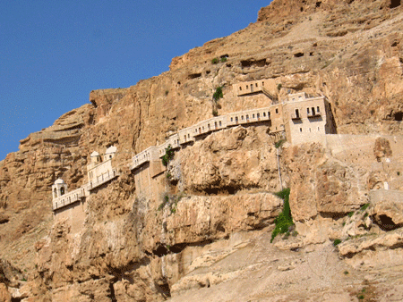
- At this moment, God instructed the army to march around the city once a day for six days, following the ark of the covenant, carried by priests.
- On the seventh day they were to march around it seven times with the priests blowing their trumpets. After hearing a long blast on the trumpets the army was to give a loud shout. Then the wall of the city would collapse and they could go straight in.
- According to human reason, this was an odd way to fight a battle. They seemed vulnerable to enemy attacks. They could have been fearful and doubted God’s plan.
- But they simply trusted God. They followed the ark of God, which symbolized his presence and his word.
- Every day they marched around with prayerful hearts. Then God was pleased with their faith and he made the walls of Jericho fall. This is the victory of faith.

3-3, How can we apply this to our life of faith? (30b)

after the army had marched around them for seven days.

- From these two events(Passover and Jericho) we learn the importance of the faith of God’s community.
- The author intentionally focused on the people and the army, not just their leaders.
- This tells us that God works not just through one person’s faith, but through the faith of his people as a community.
- God wants us as his church to strive together as one for the faith of the gospel.

Philippians 1:27 reads,
Whatever happens, conduct yourselves in a manner worthy of the gospel of Christ. Then, whether I come and see you or only hear about you in my absence, I will know that you stand firm in the one Spirit, striving together as one for the faith of the gospel
- The enemies of the gospel are strong. When we look at the world, anti-Christian elements are rapidly increasing. Our struggle is not against flesh and blood, but against the spiritual forces of evil in the heavenly realms (Eph 6:12).
- Satan’s power is behind media and organizations that promote sinful lifestyles while seeking to destroy Christian values. Satan works through those who trust in money to turn people against God.
- We cannot fight against this with our own wisdom and the democratic system. We need God’s help. So we should not fight with human means.
- Rather we need to put on the full armor of God and take up the sword of the Spirit—which is the word of God.
- And we need to pray in the Spirit on all occasions with all kinds of prayers and requests (Eph 6:17-18).
- Sometimes we feel that our Bible study ministry and prayer is insignificant. But these are the spiritual weapons that God uses with his divine power.
- Paul says, “…they have divine power to demolish strongholds” (2Co 10:4b).
- Let’s continue to study and teach the God’s word diligently and to pray. God can use us to demolish the spiritual forces of evil in our time. In conquering

3-4, How is Rahab’s faith marked? (31; Jos 2:1, 9-14; 6:22-25; Mt 1:5)

31 By faith the prostitute Rahab, because she welcomed the spies, was not killed with those who were disobedient.

- Rahab’s role was crucial. She was one of the Canaanites, who were an idol worshiping people, and a prostitute.
- Humanly speaking, the Israelite spies were her enemies. But she welcomed them and defended them, at the risk of her own life.
- It was because she saw the one true God at work through them and she believed he would keep his promises to them.
- So she stood on God’s side, instead of with her own people who were corrupted and facing God’s judgment.
- God honored her faith and saved her as well as her household. Furthermore, God included her in the genealogy of the Messiah Jesus Christ (Mt 1:5).
- This shows us very clearly that what matters to God is only faith.

Conclusion

Today we have learned how important it is to have faith as parents. God also blessed Moses’ faith of decision. May the Lord help us to see the importance of the faith of the community as the Israelites passed through the red sea and conquered the Jericho. In America Christians are becoming a minority. Being disciples, shepherds, or missionaries appeared to be unpopular from worldly point of view. But we are more than conquerors and history makers to please the Lord Almighty God. May the Lord value the life of faith the most and continue to claim the victory in our lives. Amen.

One word: Moses chose to be mistreated with the people of God!

