IS IT BECAUSE THERE IS NO GOD IN ISRAEL?

2 Kings 1:1-18
Key verse 3

But the angel of the Lord said to Elijah the Tishbite, “Go up and meet the messengers of the king of Samaria and ask them, ‘Is it because there is no God in Israel that you are going off to consult Baal-Zebub, the god of Ekron?’

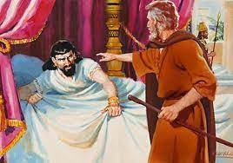
Introduction
The books of 1 Kings and 2 Kings are known to be one book. Human kings, especially in Israel, thought that they were kings and they could do whatever they wanted to do at their disposal. But God only is the true King and they were under God’s absolute absolute authority and power because God is the king of heaven and the earth. God is the perfect king. That's why they should have opened the Scriptures to know God first. But they did not. After the death of Ahab, wicked kings continue to rule in Israel. This passage is about his son, Ahaziah and his unbelieving practice before the Lord. But God and His servant, Elijah could not be mocked. May the Lord help us to believe that God lives no matter what happens in our unbelieving atmosphere and we may continue to commit ourselves to the living God!

1. Read verses 1-4. What happened to Ahaziah? (1-2a) Where did he seek help? (2b) What warning did God give Ahaziah’s messengers through Elijah? (3,4)

1-1, Read verses 1-4.
After Ahab’s death, Moab rebelled against Israel. 2 Now Ahaziah had fallen through the lattice of his upper room in Samaria and injured himself. So he sent messengers, saying to them, “Go and consult Baal-Zebub, the god of Ekron, to see if I will recover from this injury.”
3 But the angel of the Lord said to Elijah the Tishbite, “Go up and meet the messengers of the king of Samaria and ask them, ‘Is it because there is no God in Israel that you are going off to consult Baal-Zebub, the god of Ekron?’ 4 Therefore this is what the Lord says: ‘You will not leave the bed you are lying on. You will certainly die!’” So Elijah went.

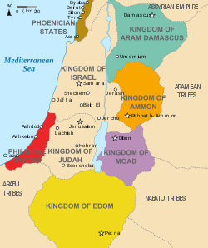
1-2, What happened to Ahaziah? (1-2a)
After Ahab’s death, Moab rebelled against Israel. 2 Now Ahaziah had fallen through the lattice of his upper room in Samaria and injured himself.

- Ahab died. Although his time was the vilest time in Israel, it was a time of political stability as well as economic prosperity.
- After his death, Moab found a chance to be independent. The rebellion of Moab indicates as a sign of the decline of Israel’s military power
- Ahaziah fell. It was a kind of unanticipated crisis as a matter of getting worse.

1-3, Where did he seek help? (2b)
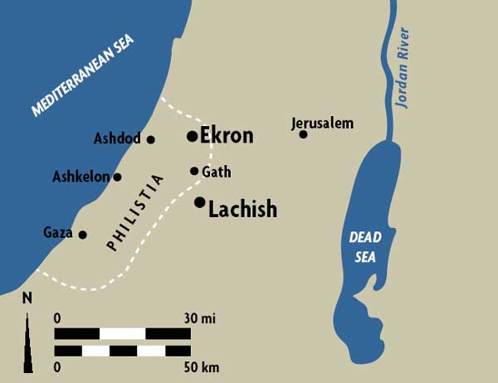
So he sent messengers, saying to them, “Go and consult Baal-Zebub, the god of Ekron, to see if I will recover from this injury.”

- Ahazian was a true worshipper of the god of Ekron, for he turned to this god at the time of trouble.
- Baal-Zebub was a god of flies. Ekron was one of five famous cities in the Philistine.

1-4, What warning did God give Ahaziah’s messengers through Elijah? (3,4)
3 But the angel of the Lord said to Elijah the Tishbite, “Go up and meet the messengers of the king of Samaria and ask them, ‘Is it because there is no God in Israel that you are going off to consult Baal-Zebub, the god of Ekron?’ 4 Therefore this is what the Lord says: ‘You will not leave the bed you are lying on. You will certainly die!’” So Elijah went.
- King Ahaziah believed that God lived. But he lived as if there was no God in Israel. He was a practical atheist.
- Ahaziah did not seek help from the true God; therefore he will get no help. Instead this will be an occasion for God to send a message of judgment to him.
- But this was a mercy to Ahaziah. His death was imminent, and he still had time to repent and prepare to meet God.

2. Read verses 5-8. How did Ahaziah receive God’s warning? (5-6) How did he come to know that the man who gave him warning was Elijah? (7-8) What should he have done after receiving God’s warning?

2-1, Read verses 5-8.
When the messengers returned to the king, he asked them, “Why have you come back?”
6 “A man came to meet us,” they replied. “And he said to us, ‘Go back to the king who sent you and tell him, “This is what the Lord says: Is it because there is no God in Israel that you are sending messengers to consult Baal-Zebub, the god of Ekron? Therefore you will not leave the bed you are lying on. You will certainly die!”’”
7 The king asked them, “What kind of man was it who came to meet you and told you this?”
8 They replied, “He had a garment of hair[a] and had a leather belt around his waist.” The king said, “That was Elijah the Tishbite.”

2-2, How did Ahaziah receive God’s warning? (5-6)
When the messengers returned to the king, he asked them, “Why have you come back?” 6 “A man came to meet us,” they replied. “And he said to us, ‘Go back to the king who sent you and tell him, “This is what the Lord says: Is it because there is no God in Israel that you are sending messengers to consult Baal-Zebub, the god of Ekron? Therefore you will not leave the bed you are lying on. You will certainly die!”’”
- Though they were sent to seek a word from the pagan priests of Baal-Zebub, they returned to the king with the word of God without going to Ekron.
- It was irresistible for them to obey the prophet of God, Elijah and they couldn’t but obey.

2-3, How did he come to know that the man who gave him warning was Elijah? (7-8)
7 The king asked them, “What kind of man was it who came to meet you and told you this?” 8 They replied, “He had a garment of hair and had a leather belt around his waist.”The king said, “That was Elijah the Tishbite.”
- Ahaziah clearly suspected it was the Prophet Elijah who spoke this word. His suspicion was confirmed when the man was described as a hairy man wearing a leather belt around his waist.

2-4, What should he have done after receiving God’s warning?
- He should have repented of his sin of idol worship and seeking help from the pagan god without asking the living God in Israel.
Is it because there is no God in Israel?
- It was a kind of wake up call spiritually. God is our provider and our protector. He is our very great reward and the shield.
- Idols rob God of his glory by pretending to provide for us what God really provides. Idols rob God of his worship by stealing people’s hearts and souls.
- People turn to idols and love them, and they make offerings to idols to get what they want. Idols are really just reflections of the sinful desires of men.
- Do we live as if there is no God in Israel? Who do you run to when you are burdened or distressed? Do you consult God, or run to your own idols?
- Jesus keeps calling to us, “Come to me, all you who are weary and burdened, and I will give you rest (Matt 11:28).”

3. Read verses 9-18. How did Elijah respond to the first two companies of soldiers sent by the king to arrest him? (9-12) What was the attitude of the captain of the third company? (13-14)? What happened to the king? (15-18)

3-1, Read verses 9-18.
Then he sent to Elijah a captain with his company of fifty men. The captain went up to Elijah, who was sitting on the top of a hill, and said to him, “Man of God, the king says, ‘Come down!’”
10 Elijah answered the captain, “If I am a man of God, may fire come down from heaven and consume you and your fifty men!” Then fire fell from heaven and consumed the captain and his men.
11 At this the king sent to Elijah another captain with his fifty men. The captain said to him, “Man of God, this is what the king says, ‘Come down at once!’”
12 “If I am a man of God,” Elijah replied, “may fire come down from heaven and consume you and your fifty men!” Then the fire of God fell from heaven and consumed him and his fifty men.
13 So the king sent a third captain with his fifty men. This third captain went up and fell on his knees before Elijah. “Man of God,” he begged, “please have respect for my life and the lives of these fifty men, your servants! 14 See, fire has fallen from heaven and consumed the first two captains and all their men. But now have respect for my life!”
15 The angel of the Lord said to Elijah, “Go down with him; do not be afraid of him.” So Elijah got up and went down with him to the king.
16 He told the king, “This is what the Lord says: Is it because there is no God in Israel for you to consult that you have sent messengers to consult Baal-Zebub, the god of Ekron? Because you have done this, you will never leave the bed you are lying on. You will certainly die!” 17 So he died, according to the word of the Lord that Elijah had spoken.
Because Ahaziah had no son, Joram[b] succeeded him as king in the second year of Jehoram son of Jehoshaphat king of Judah. 18 As for all the other events of Ahaziah’s reign, and what he did, are they not written in the book of the annals of the kings of Israel?

3-2, How did Elijah respond to the first two companies of soldiers sent by the king to arrest him? (9-12)
Then he sent to Elijah a captain with his company of fifty men. The captain went up to Elijah, who was sitting on the top of a hill, and said to him, “Man of God, the king says, ‘Come down!’”
10 Elijah answered the captain, “If I am a man of God, may fire come down from heaven and consume you and your fifty men!” Then fire fell from heaven and consumed the captain and his men.
11 At this the king sent to Elijah another captain with his fifty men. The captain said to him, “Man of God, this is what the king says, ‘Come down at once!’”
12 “If I am a man of God,” Elijah replied, “may fire come down from heaven and consume you and your fifty men!” Then the fire of God fell from heaven and consumed him and his fifty men.
- The king thought that 50 soldiers and a captain could be enough to capture Elijah. But he was wrong. He repeated the same thing. But the result was the same.
- Elijah asked God to bring down fire from heaven by saying, “if I am a man of God.” It was his humble prayer before the Lord.
- Humanly speaking, it was a harsh prayer and God answered his prayer. But everything is done under the righteous act of God.
- The people and leaders of Israel had gone after pagan gods so long that they could not distinguish between the pagan false gods and the LORD God of Israel.
- They thought that Yahweh was as powerless as their own useless gods. But God must have taught them to know the fact that God only is the true God!

3-3, What was the attitude of the captain of the third company? (13-14)?
13 So the king sent a third captain with his fifty men. This third captain went up and fell on his knees before Elijah. “Man of God,” he begged, “please have respect for my life and the lives of these fifty men, your servants! 14 See, fire has fallen from heaven and consumed the first two captains and all their men. But now have respect for my life!”

- The third captain approached his mission in a completely different manner. He came to Elijah VERY humbly, recognizing that he really was a Man of God.
- Perhaps the third captain accepted the message of judgement deeply in his heart first and must have looked at the previous groups who turned into ashes.
- God shows mercy to those who humble themselves and come to him, and he also pours out his grace to those who receive mercy. God is able to do immeasurably more than all we ask or imagine.

3-5, What happened to the king? (15-18)
15 The angel of the Lord said to Elijah, “Go down with him; do not be afraid of him.” So Elijah got up and went down with him to the king.
16 He told the king, “This is what the Lord says: Is it because there is no God in Israel for you to consult that you have sent messengers to consult Baal-Zebub, the god of Ekron? Because you have done this, you will never leave the bed you are lying on. You will certainly die!” 17 So he died, according to the word of the Lord that Elijah had spoken.

- Elijah was asked by the Lord to go down with him to meet the king without fear. He obeyed and went with him.
- Ahaziah might have wanted to arrest Elijah right away. Perhaps he wanted Elijah to reverse his word of doom and would use force to put him in prison.
- But he could not. Elijah served him with the same message. Then he died as God said. The message is not changed from the beginning.
- God Himself demonstrated here that He is the true God and His words were fulfilled no matter what.

Because Ahaziah had no son, Joram[b] succeeded him as king in the second year of Jehoram son of Jehoshaphat king of Judah. 18 As for all the other events of Ahaziah’s reign, and what he did, are they not written in the book of the annals of the kings of Israel?

- Ahaziah had no son and Joram, who was his brother, became a king. He had no descendants to pass his kingdom.

Conclusion
God of Israel showed Himself again and again in the multiple incidents such as Mount Carmel and two times Ahab’s great victories against Ben Hadad. Therefore, Ahaziah who must have seen those things, must show respect to the living God and His servant. He should have remembered what had happened in the past in the history of his kingdom. Without God’s intervention at his father’s troubled time, he could not have become a king by now. Naturally he must have humbled himself to ask God in prayer and come back to Him. Especially, at the time of personal trouble when he was injured badly, he should have sought after God’s servant. But he did ignore God. May the Lord help us to remember what God has done for America and we may humbly worship Him and do His will. May the Lord help us to meet men and women of faith like the third captain who showed respect to God and us as their Bible teachers and we may have spiritual revival again in fall semester. Amen.
One word; Is it because there is no God in America?

