THE SINS OF THE NORTHERN KINGS

1 Kings 16:1-34
Key verse 26

“He followed completely the ways of Jeroboam son of Nebat, committing the same sin Jeroboam had caused Israel to commit, so that they aroused the anger of the Lord, the God of Israel, by their worthless idols.”

Introduction
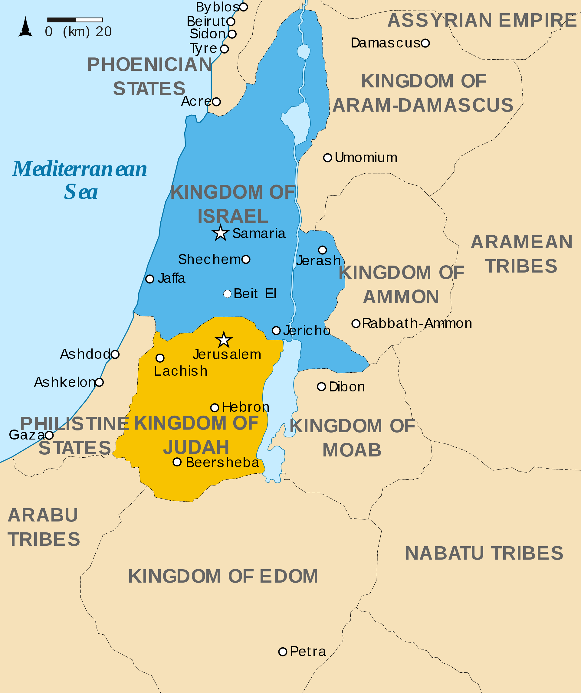
This whole chapter is about the northern kingdom, Israel. During the reign of Asa in the southern kingdom, Judah, there were 7 kings in Israel. (last years of Jeroboam, Nadab, Baasha, Elah, Zimri, Omri, and early years of Ahab) But these kings got from bad to worse when they did not listen to the word of God. The Northern kingdom was relatively democratic and savvy in terms of managing the international relationship with the neighboring nations. But all these were useless. Nothing was more important than maintaining the relationship with the Sovereign Lord. May the Lord help us to have a historic lesson through this passage and to pray earnestly for America to be a kingdom of priests more than anything else! Amen.

- Read verses 1-14. What can we learn from the word of the Lord given to the prophet Jehu? (1-7) How did the Lord fulfill His words through Zimri? (8-14)

1-1, Read verses 1-14.

Then the word of the Lord came to Jehu son of Hanani concerning Baasha: 2 “I lifted you up from the dust and appointed you ruler over my people Israel, but you followed the ways of Jeroboam and caused my people Israel to sin and to arouse my anger by their sins. 3 So I am about to wipe out Baasha and his house, and I will make your house like that of Jeroboam son of Nebat. 4 Dogs will eat those belonging to Baasha who die in the city, and birds will feed on those who die in the country.” 5 As for the other events of Baasha’s reign, what he did and his achievements, are they not written in the book of the annals of the kings of Israel? 6 Baasha rested with his ancestors and was buried in Tirzah. And Elah his son succeeded him as king. 7 Moreover, the word of the Lord came through the prophet Jehu son of Hanani to Baasha and his house, because of all the evil he had done in the eyes of the Lord, arousing his anger by the things he did, becoming like the house of Jeroboam—and also because he destroyed it. 8 In the twenty-sixth year of Asa king of Judah, Elah son of Baasha became king of Israel, and he reigned in Tirzah two years. 9 Zimri, one of his officials, who had command of half his chariots, plotted against him. Elah was in Tirzah at the time, getting drunk in the home of Arza, the palace administrator at Tirzah. 10 Zimri came in, struck him down and killed him in the twenty-seventh year of Asa king of Judah. Then he succeeded him as king. 11 As soon as he began to reign and was seated on the throne, he killed off Baasha’s whole family. He did not spare a single male, whether relative or friend. 12 So Zimri destroyed the whole family of Baasha, in accordance with the word of the Lord spoken against Baasha through the prophet Jehu— 13 because of all the sins Baasha and his son Elah had committed and had caused Israel to commit, so that they aroused the anger of the Lord, the God of Israel, by their worthless idols. 14 As for the other events of Elah’s reign, and all he did, are they not written in the book of the annals of the kings of Israel?

1-2, What can we learn from the word of the Lord given to the prophet Jehu? (1-7)

Then the word of the Lord came to Jehu son of Hanani concerning Baasha: 2 “I lifted you up from the dust and appointed you ruler over my people Israel, but you followed the ways of Jeroboam and caused my people Israel to sin and to arouse my anger by their sins. 3 So I am about to wipe out Baasha and his house, and I will make your house like that of Jeroboam son of Nebat. 4 Dogs will eat those belonging to Baasha who die in the city, and birds will feed on those who die in the country.”

5 As for the other events of Baasha’s reign, what he did and his achievements, are they not written in the book of the annals of the kings of Israel? 6 Baasha rested with his ancestors and was buried in Tirzah. And Elah his son succeeded him as king.

7 Moreover, the word of the Lord came through the prophet Jehu son of Hanani to Baasha and his house, because of all the evil he had done in the eyes of the Lord, arousing his anger by the things he did, becoming like the house of Jeroboam—and also because he destroyed it.

- Although what Baasha had done to remove the whole family of Jeroboam was to fulfill the will of God, he was successful because God allowed him to do so.
- So he could have humbled himself to serve God and to do what is right. But he was short of God’s glory. God revealed His words of warning through Jehu.

1-3, How did the Lord fulfill His words through Zimri? (8-14)

In the twenty-sixth year of Asa king of Judah, Elah son of Baasha became king of Israel, and he reigned in Tirzah two years.

9 Zimri, one of his officials, who had command of half his chariots, plotted against him. Elah was in Tirzah at the time, getting drunk in the home of Arza, the palace administrator at Tirzah. 10 Zimri came in, struck him down and killed him in the twenty-seventh year of Asa king of Judah. Then he succeeded him as king.

11 As soon as he began to reign and was seated on the throne, he killed off Baasha’s whole family. He did not spare a single male, whether relative or friend. 12 So Zimri destroyed the whole family of Baasha, in accordance with the word of the Lord spoken against Baasha through the prophet Jehu— 13 because of all the sins Baasha and his son Elah had committed and had caused Israel to commit, so that they aroused the anger of the Lord, the God of Israel, by their worthless idols.

14 As for the other events of Elah’s reign, and all he did, are they not written in the book of the annals of the kings of Israel?

- Read verses 15-27. Describe how Omri became king over Israel. (15-24) What was his spiritual condition? (25-27)

2-1, Read verses 15-27.

15 In the twenty-seventh year of Asa king of Judah, Zimri reigned in Tirzah seven days. The army was encamped near Gibbethon, a Philistine town. 16 When the Israelites in the camp heard that Zimri had plotted against the king and murdered him, they proclaimed Omri, the commander of the army, king over Israel that very day there in the camp. 17 Then Omri and all the Israelites with him withdrew from Gibbethon and laid siege to Tirzah. 18 When Zimri saw that the city was taken, he went into the citadel of the royal palace and set the palace on fire around him. So he died, 19 because of the sins he had committed, doing evil in the eyes of the Lord and following the ways of Jeroboam and committing the same sin Jeroboam had caused Israel to commit. 20 As for the other events of Zimri’s reign, and the rebellion he carried out, are they not written in the book of the annals of the kings of Israel? 21 Then the people of Israel were split into two factions; half supported Tibni son of Ginath for king, and the other half supported Omri. 22 But Omri’s followers proved stronger than those of Tibni son of Ginath. So Tibni died and Omri became king. 23 In the thirty-first year of Asa king of Judah, Omri became king of Israel, and he reigned twelve years, six of them in Tirzah. 24 He bought the hill of Samaria from Shemer for two talents[a] of silver and built a city on the hill, calling it Samaria, after Shemer, the name of the former owner of the hill.
25 But Omri did evil in the eyes of the Lord and sinned more than all those before him. 26 He followed completely the ways of Jeroboam son of Nebat, committing the same sin Jeroboam had caused Israel to commit, so that they aroused the anger of the Lord, the God of Israel, by their worthless idols. 27 As for the other events of Omri’s reign, what he did and the things he achieved, are they not written in the book of the annals of the kings of Israel? 28 Omri rested with his ancestors and was buried in Samaria. And Ahab his son succeeded him as king.

2-2, Describe how Omri became king over Israel. (15-24)

In the twenty-seventh year of Asa king of Judah, Zimri reigned in Tirzah seven days. The army was encamped near Gibbethon, a Philistine town. 16 When the Israelites in the camp heard that Zimri had plotted against the king and murdered him, they proclaimed Omri, the commander of the army, king over Israel that very day there in the camp. 17 Then Omri and all the Israelites with him withdrew from Gibbethon and laid siege to Tirzah. 18 When Zimri saw that the city was taken, he went into the citadel of the royal palace and set the palace on fire around him. So he died, 19 because of the sins he had committed, doing evil in the eyes of the Lord and following the ways of Jeroboam and committing the same sin Jeroboam had caused Israel to commit.

20 As for the other events of Zimri’s reign, and the rebellion he carried out, are they not written in the book of the annals of the kings of Israel?

Omri King of Israel
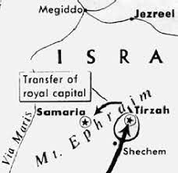
21 Then the people of Israel were split into two factions; half supported Tibni son of Ginath for king, and the other half supported Omri. 22 But Omri’s followers proved stronger than those of Tibni son of Ginath. So Tibni died and Omri became king. 23 In the thirty-first year of Asa king of Judah, Omri became king of Israel, and he reigned twelve years, six of them in Tirzah. 24 He bought the hill of Samaria from Shemer for two talents[a] of silver and built a city on the hill, calling it Samaria, after Shemer, the name of the former owner of the hill.

2-3, What was his spiritual condition? (25-27)

25 But Omri did evil in the eyes of the Lord and sinned more than all those before him. 26 He followed completely the ways of Jeroboam son of Nebat, committing the same sin Jeroboam had caused Israel to commit, so that they aroused the anger of the Lord, the God of Israel, by their worthless idols.

27 As for the other events of Omri’s reign, what he did and the things he achieved, are they not written in the book of the annals of the kings of Israel? 28 Omri rested with his ancestors and was buried in Samaria. And Ahab his son succeeded him as king.

- Read verses 29-34. What did Ahab do more to arouse the anger of the Lord, the God of Israel? (29-33) What did Hiel of Bethel do in accordance with the word of God spoken by Joshua? (34, Joshua 6:26)

3-1, Read verses 29-34.

29 In the thirty-eighth year of Asa king of Judah, Ahab son of Omri became king of Israel, and he reigned in Samaria over Israel twenty-two years. 30 Ahab son of Omri did more evil in the eyes of the Lord than any of those before him. 31 He not only considered it trivial to commit the sins of Jeroboam son of Nebat, but he also married Jezebel daughter of Ethbaal king of the Sidonians, and began to serve Baal and worship him. 32 He set up an altar for Baal in the temple of Baal that he built in Samaria. 33 Ahab also made an Asherah pole and did more to arouse the anger of the Lord, the God of Israel, than did all the kings of Israel before him. 34 In Ahab’s time, Hiel of Bethel rebuilt Jericho. He laid its foundations at the cost of his firstborn son Abiram, and he set up its gates at the cost of his youngest son Segub, in accordance with the word of the Lord spoken by Joshua son of Nun.

3-2, What did Ahab do more to arouse the anger of the Lord, the God of Israel? (29-33)

In the thirty-eighth year of Asa king of Judah, Ahab son of Omri became king of Israel, and he reigned in Samaria over Israel twenty-two years. 30 Ahab son of Omri did more evil in the eyes of the Lord than any of those before him. 31 He not only considered it trivial to commit the sins of Jeroboam son of Nebat, but he also married Jezebel daughter of Ethbaal king of the Sidonians, and began to serve Baal and worship him. 32 He set up an altar for Baal in the temple of Baal that he built in Samaria. 33 Ahab also made an Asherah pole and did more to arouse the anger of the Lord, the God of Israel, than did all the kings of Israel before him.

- Asa reigned for 41 years according to 1 Kings 15:10. During his 41 years there were seven different kings of Israel.
- Ahab the son of Omri did evil in the sight of the LORD, more than all who were before him.
- Each of the previous kings of Israel walked in the wicked pattern of Jeroboam. Ahab distinguished himself in being worse than Jeroboam.
- His father Omri was a political and economic success for Israel but a spiritual failure. He is like his father!
- Jeroboam at least pretended to serve the LORD through counterfeit gods such as idolatrous images (such as the golden calf) and in disobedient ways (altars and high places other than Jerusalem).
- But Ahab introduced the worship of a completely new, pagan god, Baal on top of Asherah.
- He took Jezebel, the daughter of Ethbaal, king of Sidonians. He went and served Baal and worshiped him. His wife must have led him and his nation to idol worship like the footsteps of Solomon.
- The marriage of Ahab and Jezebel would likely have been praised as an excellent political move. Both Phoenicia and Israel were being threatened by Syria, and the marriage gave Ahab political stability. But it was a foolish move before God!

3-3, What did Hiel of Bethel do in accordance with the word of God spoken by Joshua? (34, Joshua 6:26)

In Ahab’s time, Hiel of Bethel rebuilt Jericho. He laid its foundations at the cost of his firstborn son Abiram, and he set up its gates at the cost of his youngest son Segub, in accordance with the word of the Lord spoken by Joshua son of Nun.

Joshua 6:26 reads,
At that time Joshua pronounced this solemn oath: “Cursed before the Lord is the one who undertakes to rebuild this city, Jericho:
“At the cost of his firstborn son
he will lay its foundations;
at the cost of his youngest
he will set up its gates.”

- Either Ahab or Hiel probably wanted to challenge the prophecy of Joshua after the destruction of the city despite Joshua’s prophecy.
- The sons of Hiel might have died as a curse or might have been sacrificed by Hiel. What a practice it was in the northern kingdom of Israel!

Conclusion
This passage makes us humble in that God is in ultimate control even in the midst of any event in the history of the northern kingdom, Israel. Each king wanted to maintain their kingdom by their own evil scheme but failed. The author of this book tried to emphasize how important it is to trust and obey the Sovereign Lord God. May the Lord help each of us to be humble always so that we may live a life to please our Heavenly Father! Amen.
One word: Thy will be done on earth!

