THE ARK BROUGHT INTO THE TEMPLE

1 King 8:1-21
Key Verse 8:21
“I have provided a place there for the ark, in which is the covenant of the Lord that he made with our ancestors when he brought them out of Egypt.”

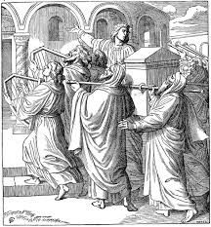
Introduction
The building(temple) proper and furnitures of the temple were very beautiful and glorious. But the dedication of it was more important in a sense that God is pleased with the dedicated hearts of His people. The temple of God was designed for the keeping up of fellowship between God and His people. Chapter 8 will be studied in 3 parts. Today verses 1-21 are about the ark that was brought into the temple. The ark is the most important item among all items so far. May the Lord help us to learn from their heart devotion and work to bring the ark into the temple in the prescribed way under the leadership of Solomon.

1. Read verses 1-5. What was the purpose of a convocation at Jerusalem after the temple’s furnishings had been completed? (1) When did it happen? (2) Who carried the ark, the tent of meeting, and all the sacred furnishings? (3-4) What did the king and the entire assembly of Israel do? (5)
1-1, Read verses 1-5.
Then King Solomon summoned into his presence at Jerusalem the elders of Israel, all the heads of the tribes and the chiefs of the Israelite families, to bring up the ark of the Lord’s covenant from Zion, the City of David. 2 All the Israelites came together to King Solomon at the time of the festival in the month of Ethanim, the seventh month. 3 When all the elders of Israel had arrived, the priests took up the ark, 4 and they brought up the ark of the Lord and the tent of meeting and all the sacred furnishings in it. The priests and Levites carried them up, 5 and King Solomon and the entire assembly of Israel that had gathered about him were before the ark, sacrificing so many sheep and cattle that they could not be recorded or counted.

1-2, What was the purpose of a convocation at Jerusalem after the temple’s furnishings had been completed? (1)
Then King Solomon summoned into his presence at Jerusalem the elders of Israel, all the heads of the tribes and the chiefs of the Israelite families, to bring up the ark of the Lord’s covenant from Zion, the City of David.
- Solomon initiated and intended this to be a spectacular "opening ceremony" for the temple. It was probably on the large scale of formal gathering.
- Convocation is a large formal assembly of people for a special purpose like a graduation ceremony.
- All the leaders such as the elders of Israel, all the heads of the tribes and the chiefs of the Israelite families were asked to gather.
- The purpose was to bring the ark of the covenant of the Lord from the city of David in Jerusalem.
- The temple wasn’t open until the ark of the covenant was set in the most holy place. The ark was the most important item in the temple. So far all the bronze and gold items were equipped in chapter 7.

1-3, When did it happen? (2)
All the Israelites came together to King Solomon at the time of the festival in the month of Ethanim, the seventh month.
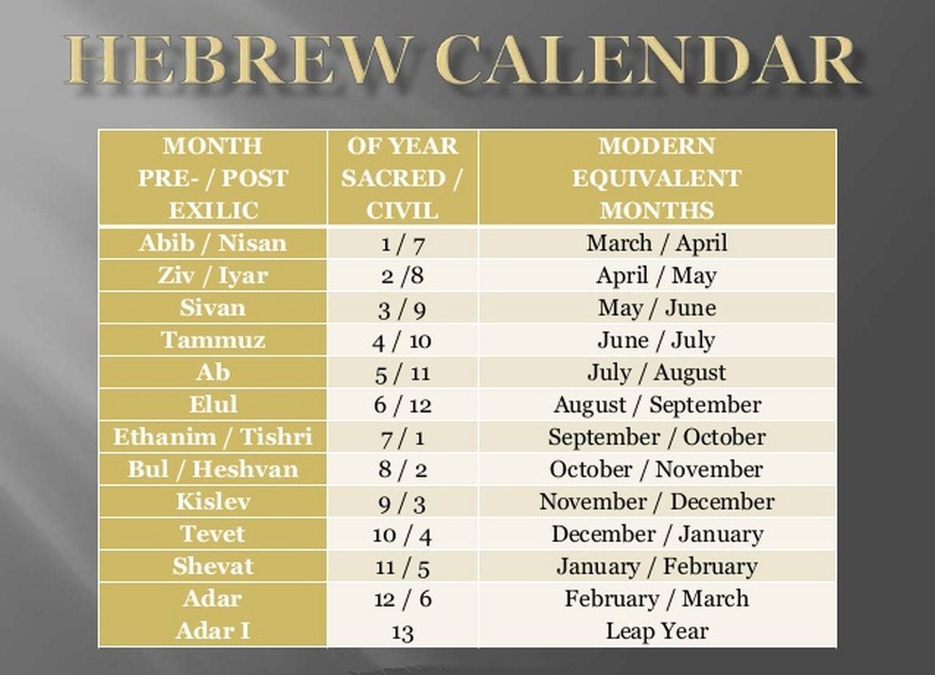
* Solomon wisely chose the seventh month for the dedication to the people’s convenience because now they had gathered in all their fruits and come up to Jerusalem to celebrate the feast of tabernacles and festival of trumpets, the day of atonement and etc.
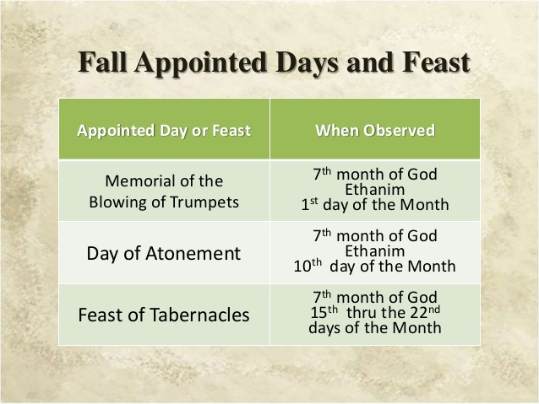
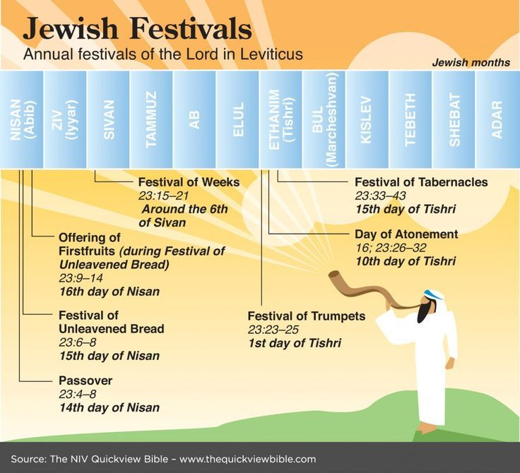

1-4, Who carried the ark, the tent of meeting, and all the sacred furnishings? (3-4)
3 When all the elders of Israel had arrived, the priests took up the ark, 4 and they brought up the ark of the Lord and the tent of meeting and all the sacred furnishings in it. The priests and Levites carried them up,

- Solomon was careful to obey what God commanded about transporting the ark of the covenant, that it was only to be carried by priests. He will not repeat the error of his father David in 2 Samuel 6:1-8.
- Numbers 3:30-31 and 4:15 show that the Kohathite clans were accountable for the care of the ark, the table, the lampstand, the altars, the articles of the sanctuary and so on. They were the Levites. But Solomon was more cautious and ended up asking the priests(technically supervisors Numb 4:19) to get it done.
- Now all the holy furnishings were brought from the tabernacle. They were the lampstand, the table of showbread, and the altar of incense from the tabernacle.
- There were two tabernacles, one at Gibeon, and the other in the city of David, which David had constructed as a temporary residence for the ark.

1-5, What did the king and the entire assembly of Israel do? (5)
5 and King Solomon and the entire assembly of Israel that had gathered about him were before the ark, sacrificing so many sheep and cattle that they could not be recorded or counted.

- Sacrificing sheep and oxen that could not be counted for multitude. It must have been a day of great joy.

2. Read verses 6-9. Where was the ark of the Lord’s covenant placed? (6) Describe the cherubim and the carrying poles. What was in the ark? (9, Exodus 16:33, Numbers 17:6-11, Exodus 25:16)
2-1, Read verses 6-9.
The priests then brought the ark of the Lord’s covenant to its place in the inner sanctuary of the temple, the Most Holy Place, and put it beneath the wings of the cherubim. 7 The cherubim spread their wings over the place of the ark and overshadowed the ark and its carrying poles. 8 These poles were so long that their ends could be seen from the Holy Place in front of the inner sanctuary, but not from outside the Holy Place; and they are still there today. 9 There was nothing in the ark except the two stone tablets that Moses had placed in it at Horeb, where the Lord made a covenant with the Israelites after they came out of Egypt.

2-2, Where was the ark of the Lord’s covenant placed? (6)
6 The priests then brought the ark of the Lord’s covenant to its place in the inner sanctuary of the temple, the Most Holy Place, and put it beneath the wings of the cherubim.

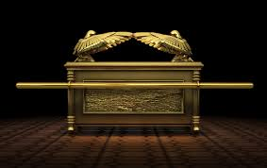
2-3, Describe the cherubim and the carrying poles.
7 The cherubim spread their wings over the place of the ark and overshadowed the ark and its carrying poles. 8 These poles were so long that their ends could be seen from the Holy Place in front of the inner sanctuary, but not from outside the Holy Place; and they are still there today.

2-4, What was in the ark? (9, Exodus 16:33, Numbers 17:6-11, Exodus 25:16)
9 There was nothing in the ark except the two stone tablets that Moses had placed in it at Horeb, where the Lord made a covenant with the Israelites after they came out of Egypt.

- At an earlier point in Israel's history there were three items in the ark of the covenant. Earlier, inside the ark were the golden pot that had the manna (Exodus 16:33), Aaron's rod that budded (Numbers 17:6-11), and the tablets of the covenant (Exodus 25:16).
- We don't know what happened to the golden pot of manna and Aaron's rod, but they were not in the ark when Solomon set it in the most holy place.
- Maybe when the ark was carried away from the Philistines when the priest Eli was in charge, these two might be lost.
- At last, about 500 years after they were led from Egypt, God blessed the king Solomon to build the permanent temple building and furnish all items.

3. Read verses 10-21. When the priests withdrew from the Holy Place, what happened? (10-11) What did Solomon say about the temple? (12-13) What did he teach the people about God who keeps his promises? (14-21)
3-1, Read verses 10-21.
When the priests withdrew from the Holy Place, the cloud filled the temple of the Lord.11 And the priests could not perform their service because of the cloud, for the glory of the Lord filled his temple. 12 Then Solomon said, “The Lord has said that he would dwell in a dark cloud; 13 I have indeed built a magnificent temple for you, a place for you to dwell forever.” 14 While the whole assembly of Israel was standing there, the king turned around and blessed them. 15 Then he said: “Praise be to the Lord, the God of Israel, who with his own hand has fulfilled what he promised with his own mouth to my father David. For he said, 16 ‘Since the day I brought my people Israel out of Egypt, I have not chosen a city in any tribe of Israel to have a temple built so that my Name might be there, but I have chosen David to rule my people Israel.’
17 “My father David had it in his heart to build a temple for the Name of the Lord, the God of Israel. 18 But the Lord said to my father David, ‘You did well to have it in your heart to build a temple for my Name. 19 Nevertheless, you are not the one to build the temple, but your son, your own flesh and blood—he is the one who will build the temple for my Name.’ 20 “The Lord has kept the promise he made: I have succeeded David my father and now I sit on the throne of Israel, just as the Lord promised, and I have built the temple for the Name of the Lord, the God of Israel. 21 I have provided a place there for the ark, in which is the covenant of the Lord that he made with our ancestors when he brought them out of Egypt.”

3-2, When the priests withdrew from the Holy Place, what happened? (10-11)
10 When the priests withdrew from the Holy Place, the cloud filled the temple of the Lord. 11 And the priests could not perform their service because of the cloud, for the glory of the Lord filled his temple.

- This was the cloud of glory, sometimes called the cloud of Shekinah glory. It is hard to define the glory of God; we could call it the radiant outshining of His character and presence. Here it is manifested in a cloud.
- This could be the cloud that was present at the transfiguration of Jesus (Luke 9:34-35) This could the one the cloud that will display the glory of Jesus Christ when He returns in triumph to this earth (Luke 21:27, Revelation 1:7)
- Because God is not only goodness and love, He is also holy-and the holiness of God made the priests feel that they could no longer stand in His presence.

3-3, What did Solomon say about the temple? (12-13)
12 Then Solomon said, “The Lord has said that he would dwell in a dark cloud; 13 I have indeed built a magnificent temple for you, a place for you to dwell forever.”

- Solomon immediately sensed that the presence of the cloud meant that God dwelt in the temple in a special way.
- Solomon might recall Deuteronomy 4:15. “You came near and stood at the foot of the mountain while it blazed with fire to the very heavens, with black clouds and deep darkness.”

3-4, What did he teach the people about God who keeps his promises? (14-21)
14 While the whole assembly of Israel was standing there, the king turned around and blessed them. 15 Then he said:
“Praise be to the Lord, the God of Israel, who with his own hand has fulfilled what he promised with his own mouth to my father David. For he said, 16 ‘Since the day I brought my people Israel out of Egypt, I have not chosen a city in any tribe of Israel to have a temple built so that my Name might be there, but I have chosen David to rule my people Israel.’
17 “My father David had it in his heart to build a temple for the Name of the Lord, the God of Israel. 18 But the Lord said to my father David, ‘You did well to have it in your heart to build a temple for my Name. 19 Nevertheless, you are not the one to build the temple, but your son, your own flesh and blood—he is the one who will build the temple for my Name.’
20 “The Lord has kept the promise he made: I have succeeded David my father and now I sit on the throne of Israel, just as the Lord promised, and I have built the temple for the Name of the Lord, the God of Israel. 21 I have provided a place there for the ark, in which is the covenant of the Lord that he made with our ancestors when he brought them out of Egypt.”

- Solomon recognized that the temple was the fulfillment of God's plan, not David's or Solomon's. David and Solomon were human instruments, but the work was God's.
- Also Solomon remembered the exodus. Though it happened 500 years before, it was just as important and real for Israel as the day it happened. Amen!

Prayer
Praise the Lord our Almighty God who has been faithful to us! May the Lord help us to always remember what God has done for us and we may be faithful to Him for His glory. Amen. One word: The Ark brought to the temple

