THE PALACE AND THE TEMPLE FURNISHINGS

1King 7:1-51
Key Verse 21

“He erected the pillars at the portico of the temple. The pillar to the south he named Jakin and the one to the north Boaz.”

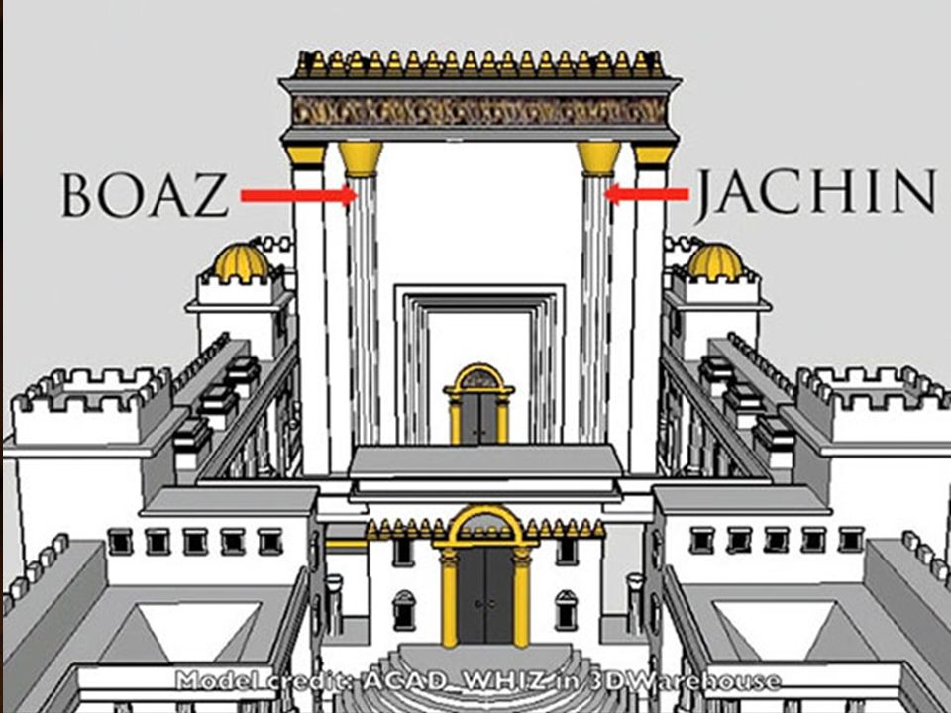
Introduction
After building the temple, Solomon constructed his palace. He loved God and sought first His glory by constructing a temple for the name of the Lord God. When he constructed both God’s temple and his palace, he furnished both the outside and inside of the temple. Especially in the key verse 21, he elected 2 pillars, Boaz and Jachin, meaning “God establishes and in Him is strength.” It may remind us of what Jesus says in Revelation 3:11-13, “I am coming soon. Hold on to what you have, so that no one will take your crown. 12 The one who is victorious I will make a pillar in the temple of my God. Never again will they leave it. I will write on them the name of my God and the name of the city of my God, the new Jerusalem, which is coming down out of heaven from my God; and I will also write on them my new name. 13 Whoever has ears, let them hear what the Spirit says to the churches.” May the Lord help us keep our personal faith to the end so that we may see God’s glory!

1. Read verses 1-12. How long did it take Solomon to build his palace? (1) Describe the structure of his palace. (2-12) What does this spectacular construction show about his heart desire? What was the purpose of the Hall of Justice? (7)

1-1, Read verses 1-12.
It took Solomon thirteen years, however, to complete the construction of his palace. 2 He built the Palace of the Forest of Lebanon a hundred cubits long, fifty wide and thirty high,[a]with four rows of cedar columns supporting trimmed cedar beams. 3 It was roofed with cedar above the beams that rested on the columns—forty-five beams, fifteen to a row. 4 Its windows were placed high in sets of three, facing each other. 5 All the doorways had rectangular frames; they were in the front part in sets of three, facing each other.[b]
6 He made a colonnade fifty cubits long and thirty wide.[c] In front of it was a portico, and in front of that were pillars and an overhanging roof.
7 He built the throne hall, the Hall of Justice, where he was to judge, and he covered it with cedar from floor to ceiling.[d] 8 And the palace in which he was to live, set farther back, was similar in design. Solomon also made a palace like this hall for Pharaoh’s daughter, whom he had married.
9 All these structures, from the outside to the great courtyard and from foundation to eaves, were made of blocks of high-grade stone cut to size and smoothed on their inner and outer faces. 10 The foundations were laid with large stones of good quality, some measuring ten cubits[e] and some eight.[f] 11 Above were high-grade stones, cut to size, and cedar beams.12 The great courtyard was surrounded by a wall of three courses of dressed stone and one course of trimmed cedar beams, as was the inner courtyard of the temple of the Lord with its portico.

1-2, How long did it take Solomon to build his palace? (1)
It took Solomon thirteen years, however, to complete the construction of his palace.

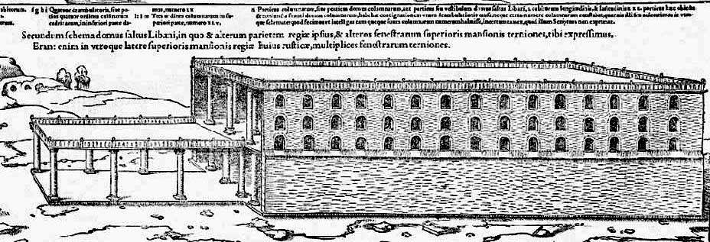

- It took 13 years to build his palace. According to 6:37-38, “The foundation of the temple of the Lord was laid in the fourth year, in the month of Ziv. 38 In the eleventh year in the month of Bul, the eighth month, the temple was finished in all its details according to its specifications. He had spent seven years building it.”
- He spent 7 years building a temple. Maybe he could build a temple faster thanks to a thorough preparation of his father, David.

1-3, Describe the structure of his palace. (2-12)

2 He built the Palace of the Forest of Lebanon a hundred cubits long, fifty wide and thirty high,[a]with four rows of cedar columns supporting trimmed cedar
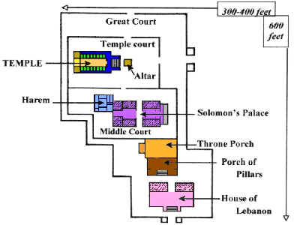
beams. 3 It was roofed with cedar above the beams that rested on the columns—forty-five beams, fifteen to a row. 4 Its windows were placed high in sets of three, facing each other. 5 All the doorways had rectangular frames; they were in the front part in sets of three, facing each other.[b]
6 He made a colonnade fifty cubits long and thirty wide.[c] In front of it was a portico, and in front of that were pillars and an overhanging roof.
7 He built the throne hall, the Hall of Justice, where he was to judge, and he covered it with cedar from floor to ceiling.[d] 8 And the palace in which he was to live, set farther back, was similar in design. Solomon also made a palace like this hall for Pharaoh’s daughter, whom he had married.

9 All these structures, from the outside to the great courtyard and from foundation to eaves, were made of blocks of high-grade stone cut to size and smoothed on their inner and outer faces. 10 The foundations were laid with large stones of good quality, some measuring ten cubits[e] and some eight.[f] 11 Above were high-grade stones, cut to size, and cedar beams.12 The great courtyard was surrounded by a wall of three courses of dressed stone and one course of trimmed cedar beams, as was the inner courtyard of the temple of the Lord with its portico.

- The palace was built so magnificently that it is called the forest of Lebanon. Some of the great architectural features of the palace came from the temple such as the courtyard.
- But Solomon's palace was bigger in size and it is called the great courtyard and it was made of high grade & good quality stone.
- He built his palace in a very complex structure with more compartments, some of which were dedicated to the daughter of Pharaoh.
- When Solomon made his palace more spectacular than the temple, it said something about his values and heart desire.

1-4, What does this spectacular construction show about his heart desire?

- The temple was glorious, but it seems that Solomon wanted a house that was more glorious and complex than the temple. It is hard to understand all the structures of his palace.
- It does show the place which his own personal comfort and luxurious tastes had come to occupy in the life of Solomon. In this way his deepest desires were somewhat revealed. He should have been led by the Lord’s commandments!

- James 5:25 reads, “But whoever looks intently into the perfect law that gives freedom, and continues in it—not forgetting what they have heard, but doing it—they will be blessed in what they do.”
- Solomon could have read God’s words more and more instead after building a temple of God. Why? It was because it was instructed in Deuteronomy 17:16-20.
- The king, moreover, must not acquire great numbers of horses for himself or make the people return to Egypt to get more of them, for the Lord has told you, “You are not to go back that way again.” 17 He must not take many wives, or his heart will be led astray. He must not accumulate large amounts of silver and gold. 18 When he takes the throne of his kingdom, he is to write for himself on a scroll a copy of this law, taken from that of the Levitical priests. 19 It is to be with him, and he is to read it all the days of his life so that he may learn to revere the Lord his God and follow carefully all the words of this law and these decrees 20 and not consider himself better than his fellow Israelites and turn from the law to the right or to the left. Then he and his descendants will reign a long time over his kingdom in Israel.
- Solomon reigned 40 years. He spent 13 years in building his magnificent palace. He spent 7 years building a temple. Half of his time was used for construction. He could use his time wisely by looking intently into the perfect law and come closer to the Lord God.
- There are two kinds of life on earth. One is to focus on external things in visible images. The other is to focus on internal things, that is to look intently into God’s perfect law and gain wisdom and glory of God! It is safe and sound always because God’s truth and His Holy Spirit leads us to the right path always!
- God appeared personally to him 2 times and one more time His word came to Solomon. All these 3 times, God pointed out to him that he must keep God’s commandments. As for the temple, God emphasized that nothing is more important than keeping His commands. May the Lord help us dwell in God’s words and preach them in season and out of season. Amen.

1-5, What was the purpose of the Hall of Justice? (7)
- Solomon wanted to rule over a great people of God and according to his desire he built the hall of justice inside of his palace. Probably the trial in chapter 3 might be held at this hall.

2. Read verses 13-45. Who was Huram? (13-14) Describe what he designed and made. (15-45) What was the meaning and purpose of two pillars named Jachin and Boaz? (21)

2-1, Read verses 13-45.
13 King Solomon sent to Tyre and brought Huram,[g] 14 whose mother was a widow from the tribe of Naphtali and whose father was from Tyre and a skilled craftsman in bronze. Huram was filled with wisdom, with understanding and with knowledge to do all kinds of bronze work. He came to King Solomon and did all the work assigned to him.
15 He cast two bronze pillars, each eighteen cubits high and twelve cubits in circumference.[h] 16 He also made two capitals of cast bronze to set on the tops of the pillars; each capital was five cubits[i] high. 17 A network of interwoven chains adorned the capitals on top of the pillars, seven for each capital. 18 He made pomegranates in two rows[j] encircling each network to decorate the capitals on top of the pillars.[k] He did the same for each capital.19 The capitals on top of the pillars in the portico were in the shape of lilies, four cubits[l]high. 20 On the capitals of both pillars, above the bowl-shaped part next to the network, were the two hundred pomegranates in rows all around. 21 He erected the pillars at the portico of the temple. The pillar to the south he named Jakin[m] and the one to the north Boaz.[n] 22 The capitals on top were in the shape of lilies. And so the work on the pillars was completed.
23 He made the Sea of cast metal, circular in shape, measuring ten cubits from rim to rim and five cubits high. It took a line of thirty cubits[o] to measure around it. 24 Below the rim, gourds encircled it—ten to a cubit. The gourds were cast in two rows in one piece with the Sea.
25 The Sea stood on twelve bulls, three facing north, three facing west, three facing south and three facing east. The Sea rested on top of them, and their hindquarters were toward the center. 26 It was a handbreadth[p] in thickness, and its rim was like the rim of a cup, like a lily blossom. It held two thousand baths.[q]
27 He also made ten movable stands of bronze; each was four cubits long, four wide and three high.[r] 28 This is how the stands were made: They had side panels attached to uprights. 29 On the panels between the uprights were lions, bulls and cherubim—and on the uprights as well. Above and below the lions and bulls were wreaths of hammered work.30 Each stand had four bronze wheels with bronze axles, and each had a basin resting on four supports, cast with wreaths on each side. 31 On the inside of the stand there was an opening that had a circular frame one cubit[s] deep. This opening was round, and with its basework it measured a cubit and a half.[t] Around its opening there was engraving. The panels of the stands were square, not round. 32 The four wheels were under the panels, and the axles of the wheels were attached to the stand. The diameter of each wheel was a cubit and a half. 33 The wheels were made like chariot wheels; the axles, rims, spokes and hubs were all of cast metal.
34 Each stand had four handles, one on each corner, projecting from the stand. 35 At the top of the stand there was a circular band half a cubit[u] deep. The supports and panels were attached to the top of the stand. 36 He engraved cherubim, lions and palm trees on the surfaces of the supports and on the panels, in every available space, with wreaths all around. 37 This is the way he made the ten stands. They were all cast in the same molds and were identical in size and shape.
38 He then made ten bronze basins, each holding forty baths[v] and measuring four cubits across, one basin to go on each of the ten stands. 39 He placed five of the stands on the south side of the temple and five on the north. He placed the Sea on the south side, at the southeast corner of the temple. 40 He also made the pots[w] and shovels and sprinkling bowls.
So Huram finished all the work he had undertaken for King Solomon in the temple of the Lord:
41 the two pillars;
the two bowl-shaped capitals on top of the pillars;
the two sets of network decorating the two bowl-shaped capitals on top of the pillars;
42 the four hundred pomegranates for the two sets of network (two rows of pomegranates for each network decorating the bowl-shaped capitals on top of the pillars);
43 the ten stands with their ten basins;
44 the Sea and the twelve bulls under it;
45 the pots, shovels and sprinkling bowls.

2-2, Who was Huram? (13-14)
13 King Solomon sent to Tyre and brought Huram,[g] 14 whose mother was a widow from the tribe of Naphtali and whose father was from Tyre and a skilled craftsman in bronze. Huram was filled with wisdom, with understanding and with knowledge to do all kinds of bronze work. He came to King Solomon and did all the work assigned to him.

- Solomon was wise enough to find & locate the right skillful person like Huram for the best result in all kinds of bronze work at the court of the temple.
- His father was a gentile and his mom was a Jew, a widow from the tribe of Naphtali. He was filled with wisdom and understanding and knowledge to do all kinds of bronze work.

2-3, Describe what he designed and made. (15-45)
15 He cast two bronze pillars, each eighteen cubits high and twelve cubits in circumference.[h] 16 He also made two capitals of cast bronze to set on the tops of the pillars; each capital was five cubits[i] high. 17 A network of interwoven chains adorned the capitals on top of the pillars, seven for each capital. 18 He made pomegranates in two rows[j] encircling each network to decorate the capitals on top of the pillars.[k] He did the same for each capital.19 The capitals on top of the pillars in the portico were in the shape of lilies, four cubits[l]high. 20 On the capitals of both pillars, above the bowl-shaped part next to the network, were the two hundred pomegranates in rows all around. 21 He erected the pillars at the portico of the temple. The pillar to the south he named Jakin[m] and the one to the north Boaz.[n] 22 The capitals on top were in the shape of lilies. And so the work on the pillars was completed.
23 He made the Sea of cast metal, circular in shape, measuring ten cubits from rim to rim and five cubits high. It took a line of thirty cubits[o] to measure around it. 24 Below the rim, gourds encircled it—ten to a cubit. The gourds were cast in two rows in one piece with the Sea.
25 The Sea stood on twelve bulls, three facing north, three facing west, three facing south and three facing east. The Sea rested on top of them, and their hindquarters were toward the center. 26 It was a handbreadth[p] in thickness, and its rim was like the rim of a cup, like a lily blossom. It held two thousand baths.[q]
27 He also made ten movable stands of bronze; each was four cubits long, four wide and three high.[r] 28 This is how the stands were made: They had side panels attached to uprights. 29 On the panels between the uprights were lions, bulls and cherubim—and on the uprights as well. Above and below the lions and bulls were wreaths of hammered work.30 Each stand had four bronze wheels with bronze axles, and each had a basin resting on four supports, cast with wreaths on each side. 31 On the inside of the stand there was an opening that had a circular frame one cubit[s] deep. This opening was round, and with its basework it measured a cubit and a half.[t] Around its opening there was engraving. The panels of the stands were square, not round. 32 The four wheels were under the panels, and the axles of the wheels were attached to the stand. The diameter of each wheel was a cubit and a half. 33 The wheels were made like chariot wheels; the axles, rims, spokes and hubs were all of cast metal.
34 Each stand had four handles, one on each corner, projecting from the stand. 35 At the top of the stand there was a circular band half a cubit[u] deep. The supports and panels were attached to the top of the stand. 36 He engraved cherubim, lions and palm trees on the surfaces of the supports and on the panels, in every available space, with wreaths all around. 37 This is the way he made the ten stands. They were all cast in the same molds and were identical in size and shape.
38 He then made ten bronze basins, each holding forty baths[v] and measuring four cubits across, one basin to go on each of the ten stands. 39 He placed five of the stands on the south side of the temple and five on the north. He placed the Sea on the south side, at the southeast corner of the temple. 40 He also made the pots[w] and shovels and sprinkling bowls.
So Huram finished all the work he had undertaken for King Solomon in the temple of the Lord:
41 the two pillars;
the two bowl-shaped capitals on top of the pillars;
the two sets of network decorating the two bowl-shaped capitals on top of the pillars;
42 the four hundred pomegranates for the two sets of network (two rows of pomegranates for each network decorating the bowl-shaped capitals on top of the pillars);
43 the ten stands with their ten basins;
44 the Sea and the twelve bulls under it;
45 the pots, shovels and sprinkling bowls.

- Huram was an expert in bronze work, and he used his skill to glorify God. He made 2 bronze pillars named Jakin (he establishes) and Boaz (in him is strength); a great bronze Sea which stood on 12 bronze bulls; 10 basins on ornate movable stands. Verses 41-45 shows a summary of his works.
- There are many things described. When we skim through Leviticus 1-7, we come to know how essential all these things were needed to give offerings to the Lord God.
- For instance, the priests were supposed to prepare animals a lot using the Sea for washing, 10 stands and 10 small basins, pots, and bowls.
- Bronze is a mixture of copper, tin, aluminium, manganese, nickel, or zinc. It indicates that worshippers are sinners and require a cleaning process to come to the Lord God who is holy.

2-4, What was the meaning and purpose of two pillars named Jachin and Boaz? (21)

21 He erected the pillars at the portico of the temple. The pillar to the south he named Jakin and the one to the north Boaz.
- They were called Jachin and Boaz. These pillars may remind us of the pillar of fire by night and the pillar of cloud by day, which were constant reminders of the presence of God in the wilderness.
- Whenever they came to the temple of the LORD in the days of Solomon they said, "Look! There is 'He Shall Establish.' And there is 'In Him Is Strength.'"
- It set them in the right frame of mind to worship the LORD. The temple was established by God, and built by the strength of God.
- The house of God was a place where people experienced what the pillars were all about. At that house, people were established in their relationship with God. At that house, people were given strength from the LORD.

3. Read verses 46-51. In addition to Huram’s work, what else did Solomon do? (46-50) What did the king do after the temple building was completed? (51) What meaning did the temple have for Solomon’s kingdom? (6:13)

3-1, Read verses 46-51.

All these objects that Huram made for King Solomon for the temple of the Lord were of burnished bronze. 46 The king had them cast in clay molds in the plain of the Jordan between Sukkoth and Zarethan. 47 Solomon left all these things unweighed, because there were so many; the weight of the bronze was not determined.
48 Solomon also made all the furnishings that were in the Lord’s temple:
the golden altar;
the golden table on which was the bread of the Presence;
49 the lampstands of pure gold (five on the right and five on the left, in front of the inner sanctuary);
the gold floral work and lamps and tongs;
50 the pure gold basins, wick trimmers, sprinkling bowls, dishes and censers;
and the gold sockets for the doors of the innermost room, the Most Holy Place, and also for the doors of the main hall of the temple.
51 When all the work King Solomon had done for the temple of the Lord was finished, he brought in the things his father David had dedicated—the silver and gold and the furnishings—and he placed them in the treasuries of the Lord’s temple.

3-2, In addition to Huram’s work, what else did Solomon do? (46-50)

All these objects that Huram made for King Solomon for the temple of the Lord were of burnished bronze. 46 The king had them cast in clay molds in the plain of the Jordan between Sukkoth and Zarethan. 47 Solomon left all these things unweighed, because there were so many; the weight of the bronze was not determined.
48 Solomon also made all the furnishings that were in the Lord’s temple:
the golden altar;
the golden table on which was the bread of the Presence;
49 the lampstands of pure gold (five on the right and five on the left, in front of the inner sanctuary);
the gold floral work and lamps and tongs;
50 the pure gold basins, wick trimmers, sprinkling bowls, dishes and censers;
and the gold sockets for the doors of the innermost room, the Most Holy Place, and also for the doors of the main hall of the temple.

- Verses 45-47 show how Solomon engaged in refining the bronze things for the outside court of the temple, probably the bronze altar.
- From verses 48, the furnishings inside the temple were gold: The altar, the table, the lampstand and various pieces of equipment used in worshiping God.
- Outside, the priests offered the sacrifices for the people. But inside the temple, the priests gave honour to God. So they offered no sacrifices on the altar of gold. Instead, they burned incense on this altar. So the altar of gold was called the altar of incense.
- Again the objects inside the temple itself would be gold. Gold is a pure metal. It is also very beautiful. It reminds us that God is perfect. God never sins. He is holy. These things followed the pattern God gave Moses on Mount Sinai for the wilderness tabernacle.

3-3, What did the king do after the temple building was completed? (51)

51 When all the work King Solomon had done for the temple of the Lord was finished, he brought in the things his father David had dedicated—the silver and gold and the furnishings—and he placed them in the treasuries of the Lord’s temple.

3-4, What meaning did the temple have for Solomon’s kingdom? (6:13)

11 The word of the Lord came to Solomon: 12 “As for this temple you are building, if you follow my decrees, observe my laws and keep all my commands and obey them, I will fulfill through you the promise I gave to David your father. 13 And I will live among the Israelites and will not abandon my people Israel.”

Conclusion

Solomon did his best to build both God’s temple and his palace. With all his heart and soul, great buildings were built. So far Solomon’s wisdom and spectacular building projects were displayed. But the path of life leads upward for the wise to keep them from going down to the realm of the dead. (Proverbs 15:24) No matter how busy he was, he still could have read God’s words and carefully followed God’s laws. It seems that what is missing is Bible(Deuteronomy) reading, resulting in obeying the laws carefully. May the Lord Help us dwell in the word of God as a matter of life and death in our times so that we may leave a legacy to our next generation. Amen. One word: In Him we are established and strengthened!

