IF YOU DO WHATEVER I COMMAND YOU

1 Kings 11:14-43
Key Verse 38

“If you do whatever I command you and walk in obedience to me and do what is right in my eyes by obeying my decrees and commands, as David my servant did, I will be with you. I will build you a dynasty as enduring as the one I built for David and will give Israel to you.”

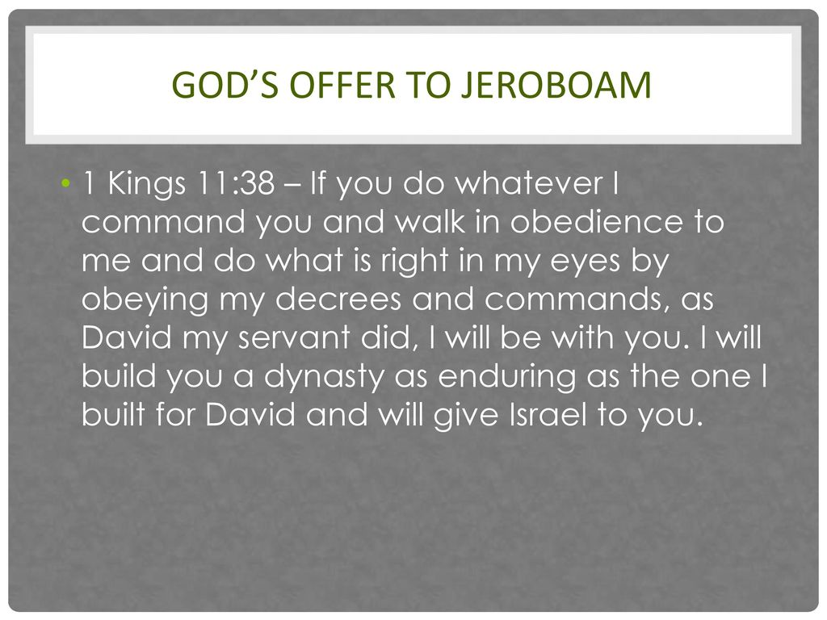
Introduction
Solomon had a great start as a humble servant king. Solomon asked for wisdom to rule God’s great people with justice. God was pleased with him and he was granted wisdom as well as prosperity. All opposing nations were subdued. There was peace on every side, and the conquered nations paid tribute. People from all over the world wanted to come and listen to the wisdom God had given Solomon. But at the later part of his reign despite God’s second time appearing with admonition, he fell into statistics. As God warned, today’s passage reveals its repercussions. May the Lord help us to have a great lesson through this.

- Read verses 14-22. What did the Lord do? (14-18a) What favor did the Pharaoh show to Hadad, the Edomite? (18b-20) What might Hadad have wanted to do? (21-22)

1-1, Read verses 14-22.
Then the Lord raised up against Solomon an adversary, Hadad the Edomite, from the royal line of Edom. 15 Earlier when David was fighting with Edom, Joab the commander of the army, who had gone up to bury the dead, had struck down all the men in Edom. 16 Joab and all the Israelites stayed there for six months, until they had destroyed all the men in Edom. 17 But Hadad, still only a boy, fled to Egypt with some Edomite officials who had served his father. 18 They set out from Midian and went to Paran. Then taking people from Paran with them, they went to Egypt, to the Pharaoh king of Egypt, who gave Hadad a house and land and provided him with food. 19 Pharaoh was so pleased with Hadad that he gave him a sister of his own wife, Queen Tahpenes, in marriage. 20 The sister of Tahpenes bore him a son named Genubath, whom Tahpenes brought up in the royal palace. There Genubath lived with Pharaoh’s own children. 21 While he was in Egypt, Hadad heard that David rested with his ancestors and that Joab the commander of the army was also dead. Then Hadad said to Pharaoh, “Let me go, that I may return to my own country.” 22 “What have you lacked here that you want to go back to your own country?” Pharaoh asked. “Nothing,” Hadad replied, “but do let me go!”

1-2, What did the Lord do? (14-18a)
Then the Lord raised up against Solomon an adversary, Hadad the Edomite, from the royal line of Edom. 15 Earlier when David was fighting with Edom, Joab the commander of the army, who had gone up to bury the dead, had struck down all the men in Edom. 16 Joab and all the Israelites stayed there for six months, until they had destroyed all the men in Edom. 17 But Hadad, still only a boy, fled to Egypt with some Edomite officials who had served his father. 18 They set out from Midian and went to Paran.
- Prior to his idolatry, Solomon had no enemies. There was nothing but the time of peace on all sides. And had he followed God’s commands, God may have protected him still and peaceful time might have been extended.
- But now, because of his idolatry, God is raising up a rod. Hadad was a royal descendant of Edom. He was the first adversary God raised up against Solomon.

1-3, What favor did the Pharaoh show to Hadad, the Edomite? (18b-20)
Then taking people from Paran with them, they went to Egypt, to Pharaoh king of Egypt, who gave Hadad a house and land and provided him with food. 19 Pharaoh was so pleased with Hadad that he gave him a sister of his own wife, Queen Tahpenes, in marriage. 20 The sister of Tahpenes bore him a son named Genubath, whom Tahpenes brought up in the royal palace. There Genubath lived with Pharaoh’s own children.
- He earned Pharaoh’s favor so much so that he became the Pharoah’s brother in law, and his child, Genubath, was also loved by Pharaoh's family.
- Hadad had some friends in high places. Hadad fled from his homeland of Edom as a boy, and probably harbored some resentment toward Israel for slaughtering his people.

1-4, What might Hadad have wanted to do? (21-22)
21 While he was in Egypt, Hadad heard that David rested with his ancestors and that Joab the commander of the army was also dead. Then Hadad said to Pharaoh, “Let me go, that I may return to my own country.” 22 “What have you lacked here that you want to go back to your own country?” Pharaoh asked. “Nothing,” Hadad replied, “but do let me go!”
- After he heard that King David and Joab had died, he now probably saw the opportunity to reclaim the throne, or at least give Solomon a hard time.

- Read verses 23-37. Who was Solomon’s second adversary? How did God raise him up against Solomon? (23-25) Who else did God raise as his adversary? (26-28) How did Ahijah the prophet of Shiloh convince Jeroboam? (29-37)

2-1, Read verses 23-37.
23 And God raised up against Solomon another adversary, Rezon son of Eliada, who had fled from his master, Hadadezer king of Zobah. 24 When David destroyed Zobah’s army, Rezon gathered a band of men around him and became their leader; they went to Damascus,where they settled and took control. 25 Rezon was Israel’s adversary as long as Solomon lived, adding to the trouble caused by Hadad. So Rezon ruled in Aram and was hostile toward Israel. 26 Also, Jeroboam son of Nebat rebelled against the king. He was one of Solomon’s officials, an Ephraimite from Zeredah, and his mother was a widow named Zeruah. 27 Here is the account of how he rebelled against the king: Solomon had built the terraces[a]and had filled in the gap in the wall of the city of David his father. 28 Now Jeroboam was a man of standing, and when Solomon saw how well the young man did his work, he put him in charge of the whole labor force of the tribes of Joseph. 29 About that time Jeroboam was going out of Jerusalem, and Ahijah the prophet of Shiloh met him on the way, wearing a new cloak. The two of them were alone out in the country,30 and Ahijah took hold of the new cloak he was wearing and tore it into twelve pieces.31 Then he said to Jeroboam, “Take ten pieces for yourself, for this is what the Lord, the God of Israel, says: ‘See, I am going to tear the kingdom out of Solomon’s hand and give you ten tribes. 32 But for the sake of my servant David and the city of Jerusalem, which I have chosen out of all the tribes of Israel, he will have one tribe. 33 I will do this because they have[b] forsaken me and worshiped Ashtoreth the goddess of the Sidonians, Chemosh the god of the Moabites, and Molek the god of the Ammonites, and have not walked in obedience to me, nor done what is right in my eyes, nor kept my decrees and laws as David, Solomon’s father, did. 34 “‘But I will not take the whole kingdom out of Solomon’s hand; I have made him ruler all the days of his life for the sake of David my servant, whom I chose and who obeyed my commands and decrees. 35 I will take the kingdom from his son’s hands and give you ten tribes. 36 I will give one tribe to his son so that David, my servant, may always have a lamp before me in Jerusalem, the city where I chose to put my Name. 37 However, as for you, I will take you, and you will rule over all that your heart desires; you will be king over Israel.

2-2, Who was Solomon’s second adversary?
2-3, How did God raise him up against Solomon? (23-25)
23 And God raised up against Solomon another adversary, Rezon son of Eliada, who had fled from his master, Hadadezer king of Zobah. 24 When David destroyed Zobah’s army, Rezon gathered a band of men around him and became their leader; they went to Damascus,where they settled and took control. 25 Rezon was Israel’s adversary as long as Solomon lived, adding to the trouble caused by Hadad. So Rezon ruled in Aram and was hostile toward Israel.
- Another adversary, Rezon, was raised up against Solomon. Because of David, Rezon also had to flee his homeland.
- He fled to Damascus, which today is the capital city of Syria. Although he was a refugee, he soon found himself in power.
- Good news for Rezon, bad news for Solomon. So Hadad gave Solomon trouble in the south, in Edom, and Rezon gave Solomon trouble in the north, from Aram.

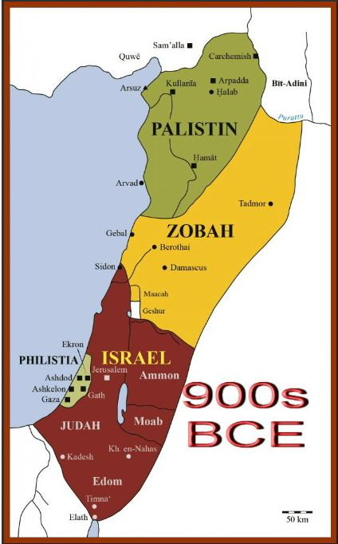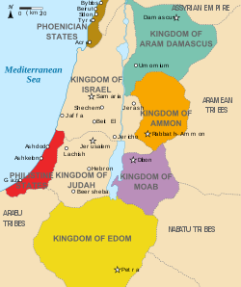

2-4, Who else did God raise as his adversary? (26-28)
26 Also, Jeroboam son of Nebat rebelled against the king. He was one of Solomon’s officials, an Ephraimite from Zeredah, and his mother was a widow named Zeruah. 27 Here is the account of how he rebelled against the king: Solomon had built the terraces[a]and had filled in the gap in the wall of the city of David his father. 28 Now Jeroboam was a man of standing, and when Solomon saw how well the young man did his work, he put him in charge of the whole labor force of the tribes of Joseph.
- The name “Jeroboam” means, "may the people be great." He perhaps was a populist leader.
- He was one of Solomon’s officials, and an Ephraimite. It was important that he was an Ephraimite, which is in the north (more central), because it meant that in the future, he could lead a rebellion against Judah, which is in the south.
- He once worked under King Solomon, and probably before Solomon knew that he would be a potential competitor, Solomon saw that he did a great job, and put him in charge of the whole labor force of the tribes of Joseph.
- He was young, highly respected, and highly capable and became the boss of the labor force of the tribes of Joseph, the largest amount of territory in Israel.
- It means he would soon become a formidable adversary against Solomon's established kingdom.

2-5, How did Ahijah the prophet of Shiloh convince Jeroboam? (29-37)
29 About that time Jeroboam was going out of Jerusalem, and Ahijah the prophet of Shiloh met him on the way, wearing a new cloak. The two of them were alone out in the country, 30 and Ahijah took hold of the new cloak he was wearing and tore it into twelve pieces.31 Then he said to Jeroboam, “Take ten pieces for yourself, for this is what the Lord, the God of Israel, says: ‘See, I am going to tear the kingdom out of Solomon’s hand and give you ten tribes. 32 But for the sake of my servant David and the city of Jerusalem, which I have chosen out of all the tribes of Israel, he will have one tribe. 33 I will do this because they have[b] forsaken me and worshiped Ashtoreth the goddess of the Sidonians, Chemosh the god of the Moabites, and Molek the god of the Ammonites, and have not walked in obedience to me, nor done what is right in my eyes, nor kept my decrees and laws as David, Solomon’s father, did. 34 “‘But I will not take the whole kingdom out of Solomon’s hand; I have made him ruler all the days of his life for the sake of David my servant, whom I chose and who obeyed my commands and decrees. 35 I will take the kingdom from his son’s hands and give you ten tribes. 36 I will give one tribe to his son so that David my servant may always have a lamp before me in Jerusalem, the city where I chose to put my Name. 37 However, as for you, I will take you, and you will rule over all that your heart desires; you will be king over Israel.
- God judged Solomon and would discipline him (and not only him but all of David’s descendants) by raising up adversaries and splitting the kingdom.
- The size of Solomon’s kingdom will be reduced to 1/10 the size, but even this showed God’s grace and mercy in his judgment.
- God is a holy and righteous God who cannot tolerate any sin or wickedness. All of it must be punished. But we see some hope in the midst of his judgment.
- V 36 says, “I will give one tribe to his son so that David my servant may always have a lamp before me in Jerusalem, the city where I chose to put my name.”
- This is the reason why God did not entirely take Solomon’s kingdom away. God allowed 1 tribe to remain to build a dynasty for David, the lamp of Israel.
- Even after the Babylonian exile as we see Matthew 1, David’s dynasty to secure a throne in Jerusalem for a future king continued by God’s grace. Praise God!

- Read verses 38-43. What did the Lord want Jeroboam to do? (38) What was God’s purpose of dividing the kingdom? (39) Describe Solomon’s final days and his death. (40-43)

3-1, Read verses 38-43.
If you do whatever I command you and walk in obedience to me and do what is right in my eyes by obeying my decrees and commands, as David my servant did, I will be with you. I will build you a dynasty as enduring as the one I built for David and will give Israel to you.39 I will humble David’s descendants because of this, but not forever.’” 40 Solomon tried to kill Jeroboam, but Jeroboam fled to Egypt, to Shishak the king, and stayed there until Solomon’s death. 41 As for the other events of Solomon’s reign—all he did and the wisdom he displayed—are they not written in the book of the annals of Solomon? 42 Solomon reigned in Jerusalem over all Israel forty years. 43 Then he rested with his ancestors and was buried in the city of David his father. And Rehoboam his son succeeded him as king.

3-2, What did the Lord want Jeroboam to do? (38)
38 If you do whatever I command you and walk in obedience to me and do what is right in my eyes by obeying my decrees and commands, as David my servant did, I will be with you. I will build you a dynasty as enduring as the one I built for David and will give Israel to you.
- Basically God gives the same promise to the rebel, Jeroboam. We’ll see later that Jeroboam might have forgotten all about this promise, but we can see that God is willing to bless those who obey and follow him whoever he or she is.

3-3, What was God’s purpose of dividing the kingdom? (39)
39 I will humble David’s descendants because of this, but not forever.’”
- All of David’s descendants would be humbled through conflicts with the split kingdom of Israel and with conflicts from foreign nations, but not forever.
- This means that David’s kingdom will be restored, and one of his descendants will be glorified. This descendant will be the Son of David who will always be a lamp before God in Jerusalem.
- This descendant is none other than our Lord and Savior, Jesus Christ, the Son of God, the Son of David. His is the lamp of Israel, the light to all nations.
- He is David’s son who was glorified, and established the throne of David forever. The Son of God came, and humbled himself as a man, and now he’s exalted, and sits at the right hand of God.

3-4, Describe Solomon’s final days and his death. (40-43)
40 Solomon tried to kill Jeroboam, but Jeroboam fled to Egypt, to Shishak the king, and stayed there until Solomon’s death. 41 As for the other events of Solomon’s reign—all he did and the wisdom he displayed—are they not written in the book of the annals of Solomon? 42 Solomon reigned in Jerusalem over all Israel forty years. 43 Then he rested with his ancestors and was buried in the city of David his father. And Rehoboam his son succeeded him as king.

Conclusion
God is angry with sinners every day because He is holy. We sin every single day. Even the wisest king Solomon fell into statistics. Like his prayer at the dedication ceremony, there is no one who does not sin. But there’s good news of great joy. God gave us his one and only Son, Jesus Christ, and sacrificed him for our sins. The wrath that we deserve for all of our sins was poured out on Jesus Christ on the cross. God fulfilled His promise in 2 Sam 7:15, “But my love will never be taken away from him, as I took it away from Saul, whom I removed from before you.” God’s love, God’s mercy, our salvation, does not depend on us, but on God’s mercy. Praise Jesus!
One word: God’s love never fails

