EXCEL IN GIFTS THAT BUILD UP THE CHURCH

1 Corinthians 14:1-40
Key Verse 12

So it is with you. Since you are eager to have spiritual gifts, try to excel in gifts that build up the church.

Introduction

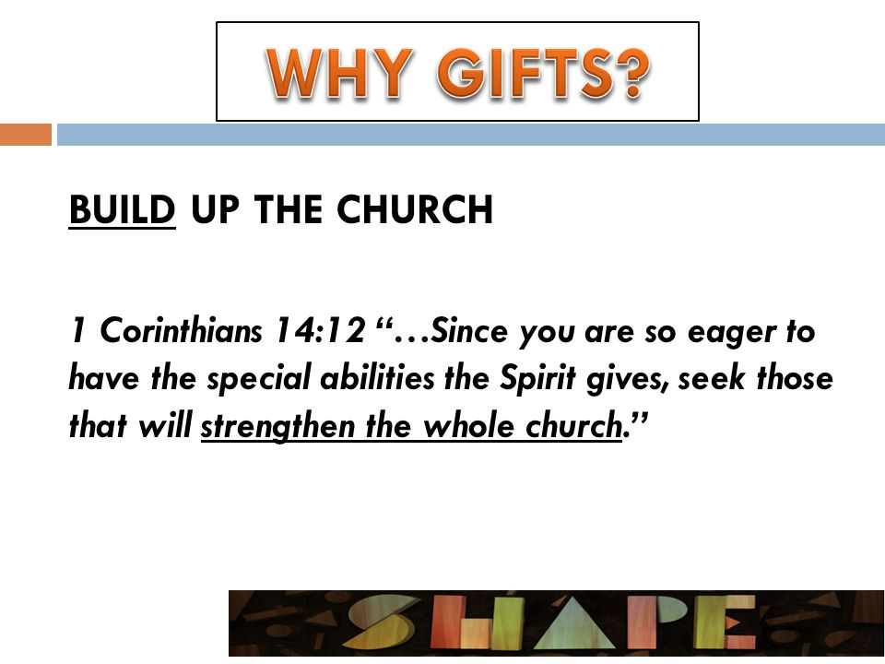
Today's passage is about a controversial issue: speaking in tongues in the church. Apparently this caused problems in the Corinthian church. It still causes problems in some congregations even today. In our LA UBF, we have been there done that. We need to clarify how to use this gift of tongues. Furthermore, rather than speaking in tongues, we learn which spiritual gift we should more eagerly desire. It is the gift of prophecy. Why? It is because it helps us to build the whole church in a healthy and mature way. Let's learn what the gift of prophecy means to each of us practically.

- Read verses 1-19. Why should we eagerly desire gifts of the Spirit, especially prophecy in the church? (1) Why is the gift of prophecy better than speaking in tongues? (2-12) Why should tongues not be used in public unless they are interpreted? (13-17) How did Paul show a good example? (18-19)

1-1, Read verses 1-19.

Follow the way of love and eagerly desire gifts of the Spirit, especially prophecy. 2 For anyone who speaks in a tongue[a] does not speak to people but to God. Indeed, no one understands them; they utter mysteries by the Spirit. 3 But the one who prophesies speaks to people for their strengthening,encouraging and comfort. 4 Anyone who speaks in a tongue edifies themselves, but the one who prophesies edifies the church. 5 I would like every one of you to speak in tongues, but I would rather have you prophesy. The one who prophesies is greater than the one who speaks in tongues, unless someone interprets, so that the church may be edified. 6 Now, brothers and sisters, if I come to you and speak in tongues, what good will I be to you, unless I bring you some revelation or knowledge or prophecy or word of instruction? 7 Even in the case of lifeless things that make sounds, such as the pipe or harp, how will anyone know what tune is being played unless there is a distinction in the notes? 8 Again, if the trumpet does not sound a clear call, who will get ready for battle? 9 So it is with you. Unless you speak intelligible words with your tongue, how will anyone know what you are saying? You will just be speaking into the air. 10 Undoubtedly there are all sorts of languages in the world, yet none of them is without meaning. 11 If then I do not grasp the meaning of what someone is saying, I am a foreigner to the speaker, and the speaker is a foreigner to me. 12 So it is with you. Since you are eager for gifts of the Spirit, try to excel in those that build up the church. 13 For this reason the one who speaks in a tongue should pray that they may interpret what they say.14 For if I pray in a tongue, my spirit prays, but my mind is unfruitful. 15 So what shall I do? I will pray with my spirit, but I will also pray with my understanding; I will sing with my spirit, but I will also sing with my understanding. 16 Otherwise when you are praising God in the Spirit, how can someone else, who is now put in the position of an inquirer, say “Amen” to your thanksgiving, since they do not know what you are saying? 17 You are giving thanks well enough, but no one else is edified. 18 I thank God that I speak in tongues more than all of you. 19 But in the church I would rather speak five intelligible words to instruct others than ten thousand words in a tongue.

1-2, Why should we eagerly desire gifts of the Spirit, especially prophecy in the church? (1)

Follow the way of love
- Paul taught about what love is in the previous chapter. Love is of utmost importance and the basis for using all spiritual gifts. We must follow the way of love if we are people of God.
- Here, the word, "follow", has the implication of a hunter pursuing his prey. The hunter focuses his whole attention on the prey. We must make every effort to focus the love of God, whatever we do.

and eagerly desire gifts of the Spirit, especially prophecy.

- Paul also says that, along with love, we must eagerly desire spiritual gifts, especially the gift of prophecy.
- The Hebrew word for prophet is "nabiy" which literally means spokesman. A prophet is God's spokesman.
- In the Old Testament a prophet delivered God's message to the people of their generation, and his word could become Scriptures.
- In the New Testament, the gift of prophecy is somewhat different. According to Hebrews 1:1, God no longer speaks to us through prophets, but through his Son Jesus Christ.

Hebrews 1:1-2 reads,

In the past God spoke to our ancestors through the prophets at many times and in various ways, 2 but in these last days he has spoken to us by his Son, whom he appointed heir of all things, and through whom also he made the universe.

- The Holy Spirit now makes Christ known to us (Jn 16:14). So, believers who has the gift of prophecy makes Christ known through the Spirit of truth to the people of their generation.
- To prophesy is to reveal who Christ is and what he does through the Scriptures. Some people think of prophecy as telling the future, especially in this unpredictable times. But it is a deviation from the main focus that we ought to do.
- The emphasis is to reveal Christ through God's words. We can say that fruitful Bible teachers have the gift of prophecy.

- There are two things are most important in the life of the Christian church, and for each of its members: the love of God, and the word of God.
- We need both love and prophecy. If there is love without the word of God, there will be many spiritually immature and weak people in the church.
- If there is the word of God without love, the church will be full of legalists. So Paul urges us to follow both. Then our church can be healthy and fruitful.

- Paul advises that the gift of prophecy be desired more than any other gift. And he almost spends the whole chapter explaining why.

1-3, Why is the gift of prophecy better than speaking in tongues? (2-12)

2 For anyone who speaks in a tongue does not speak to people but to God. Indeed, no one understands them; they utter mysteries by the Spirit. 3 But the one who prophesies speaks to people for their strengthening, encouraging and comfort. 4 Anyone who speaks in a tongue edifies themselves, but the one who prophesies edifies the church. 5 I would like every one of you to speak in tongues, but I would rather have you prophesy. The one who prophesies is greater than the one who speaks in tongues, unless someone interprets, so that the church may be edified.

- First of all, it is because tongues edify oneself, but prophecy edifies the church. One who speaks in tongues speaks to God but others cannot understand.
- But prophecy is the gift to share the word of God with others who understand. So Paul encouraged them to prophesy in the church.

- Speaking in tongues is first mentioned in Acts 2. After Jesus ascended into heaven, 120 disciples gathered together to pray constantly.
- Then the Holy Spirit came upon them at Pentecost in the form of a strong wind and tongues of fire. The apostles began to speak in tongues.
- People from all over the world gathered around them, and each one heard the wonders of God in their own native language.
- In Acts 10, Peter preached the gospel in Cornelius' house. Those who accepted the message received the Holy Spirit and began to speak in tongues.
- In Acts 19, Paul laid his hands on some disciples and prayed for them. Then the Holy Spirit came on them and they spoke in tongues and prophesied.

- Some people claim that one who receives the Holy Spirit will speak in tongues and that one who does not speak in tongues has not received the Holy Spirit. That is not true. Tongues do not represent all gifts of the Holy Spirit.
- Many in the New Testament, who received the Holy Spirit, did not speak in tongues. In 1 Cor 12:3, one who confesses "Jesus is Lord" has the Holy Spirit.

- The book of Acts is called the Acts of the Holy Spirit. When we review the book of Acts, we find that the Holy Spirit works through the word of God.
- When Paul preached the word of God, people were changed. Lives were transformed. Broken families were healed and reunited. Society was reshaped.
- Where there is the word of God, there is the work of the Holy Spirit. It is like a needle and thread. Where one is working, the other is working as well.

- Those who have received the Holy Spirit do so through the word of God. In UBF we study the word of God, share the word of God and pray based on the word.
- The Holy Spirit works through the word to transform lives and change us into new creations. This is the work of the Holy Spirit.
- There are people who have been completely changed by the work of the Holy Spirit through Bible study.

- The Corinthian believers highly valued the gift of tongues. Paul wanted them to realize that speaking in tongues was good for their personal growth.
- But speaking in tongues publicly can cause problems. So Paul did not encourage them to speak in tongues in the church, unless there was an interpreter.
- He also did not forbid them from speaking in tongues. They could use their gift to have a deep relationship with God through prayer in their own private room.
- They should not become proud and critical toward others because others don’t speak in tongues, but use their gift to develop their relationship with God.
- On the other hand, in the church, Paul urged the Corinthians to prophesy because this strengthens, encourages, comforts, and builds up the church.
- Therefore, Bible teachers should have confidence that they have the gift of prophecy and use it fervently, because this is the great work of the Holy Spirit.

Now, brothers and sisters, if I come to you and speak in tongues, what good will I be to you, unless I bring you some revelation or knowledge or prophecy or word of instruction? 7 Even in the case of lifeless things that make sounds, such as the pipe or harp, how will anyone know what tune is being played unless there is a distinction in the notes? 8 Again, if the trumpet does not sound a clear call, who will get ready for battle? 9 So it is with you. Unless you speak intelligible words with your tongue, how will anyone know what you are saying? You will just be speaking into the air. 10 Undoubtedly there are all sorts of languages in the world, yet none of them is without meaning. 11 If then I do not grasp the meaning of what someone is saying, I am a foreigner to the speaker, and the speaker is a foreigner to me. 12 So it is with you. Since you are eager for gifts of the Spirit, try to excel in those that build up the church.

- The gift of prophecy is useful to the church because it communicates intelligibly and brings about transformation and spiritual growth.
- There was a great work of God in Corinth because Paul shared the word of God in the language that the people could understand.
- If we go to another country, where English is not known, and speak in English, we will fail in evangelism.

- Paul uses the examples of musical instruments such as the flute or harp or trumpet.
- A harp or a flute can make a beautiful sound. But to do this, the artist must practice hard and play properly, like an orchestra member.
- Otherwise the instruments do not make a beautiful sound, but rather an irritating noise.
- All sorts of languages have meaning. But if we do not grasp the meaning of what someone is saying, we become foreigners.
- So we must speak intelligible words to communicate with others. Otherwise there is no connection between us.
- So when we share a message or teach the Bible we must know how to communicate with others in the church.
- We must use proper and appropriate language. To share God's word effectively we must use language that others understand.

1-4, Why should tongues not be used in public unless they are interpreted? (13-17)

13 For this reason the one who speaks in a tongue should pray that they may interpret what they say. 14 For if I pray in a tongue, my spirit prays, but my mind is unfruitful. 15 So what shall I do? I will pray with my spirit, but I will also pray with my understanding; I will sing with my spirit, but I will also sing with my understanding. 16 Otherwise when you are praising God in the Spirit, how can someone else, who is now put in the position of an inquirer, say “Amen” to your thanksgiving, since they do not know what you are saying? 17 You are giving thanks well enough, but no one else is edified.

- Paul talks about why we should pray or sing in the church with our spirit and also with our mind.
- If we pray or sing only with our spirit, people cannot understand (14). There is no response. No one can respond from their hearts.
- Someone may speak in tongues very powerfully and dramatically, but no one understands (16).
- But when we use both our spirit and mind, then people may understand what we are praying and singing and respond from their hearts and even say "Amen!"

1-5, How did Paul show a good example? (18-19)

18 I thank God that I speak in tongues more than all of you. 19 But in the church I would rather speak five intelligible words to instruct others than ten thousand words in a tongue.

- Paul himself could speak in tongues more than all of them. But because Paul valued on edifying the church, he wanted to speak five intelligible words to instruct others rather than so many words in a tongue.
- Here we learn that in the church, we have to speak intelligible words that others understand in order to edify the church.

- Read verses 20-25. How can speaking in tongues be a hindrance to unbelievers? (20-23) What are the benefits of prophesying in the church? (24-25)

2-1, Read verses 20-25.

Brothers and sisters, stop thinking like children. In regard to evil be infants, but in your thinking be adults. 21 In the Law it is written: “With other tongues and through the lips of foreigners I will speak to this people, but even then they will not listen to me, says the Lord.” 22 Tongues, then, are a sign, not for believers but for unbelievers; prophecy, however, is not for unbelievers but for believers. 23 So if the whole church comes together and everyone speaks in tongues, and inquirers or unbelievers come in, will they not say that you are out of your mind? 24 But if an unbeliever or an inquirer comes in while everyone is prophesying, they are convicted of sin and are brought under judgment by all, 25 as the secrets of their hearts are laid bare. So they will fall down and worship God, exclaiming, “God is really among you!”

2-2, How can speaking in tongues be a hindrance to unbelievers? (20-23)

20 Brothers and sisters, stop thinking like children. In regard to evil be infants, but in your thinking be adults. 21 In the Law it is written: “With other tongues and through the lips of foreigners I will speak to this people, but even then they will not listen to me, says the Lord.”

- An adult's thinking embraces others. An adult has wisdom, the ability to know what is right and what is wrong.
- In the church we need wisdom to know what is edifying to others, and what is not. Wise people know what to say, and what not to say, in the church.
- Wise people know how to speak in a way that strengthens, encourages and comforts others.
- But child's thinking is self-centered, easily hurt others and destroy their faith because they insist on their own ideas and words without any regard for others.
- Those who speak in tongues in the church (without an interpreter/ in a disorderly way) can fall into this trap.
- So we must give our hearts to prophecy, the word of God, in the church, and be mature, growing into spiritual adulthood.

22 Tongues, then, are a sign, not for believers but for unbelievers; prophecy, however, is not for unbelievers but for believers. 23 So if the whole church comes together and everyone speaks in tongues, and inquirers or unbelievers come in, will they not say that you are out of your mind?

- If unbelievers come into a worship service in which everyone is speaking a different language at the same time, with no one understanding anyone else, they will conclude that Christians are crazy.

2-3, What are the benefits of prophesying in the church? (24-25)

24 But if an unbeliever or an inquirer comes in while everyone is prophesying, they are convicted of sin and are brought under judgment by all, 25 as the secrets of their hearts are laid bare. So they will fall down and worship God, exclaiming, “God is really among you!”

- Unbelievers do not come to church for entertainment. They come to church for a reason. That has to do with their heavy burdens of sin and hard life problems.
- Their souls are longing for the word of God. They are weary and tired and they seek real rest. They wonder about the meaning of life and direction.
- They need comfort and true hope. They need the message of the forgiveness of sins. In a word, they need the gospel.

- If all they find are people speaking in tongues they will not understand what is happening. None of their life questions will be answered and they will leave the church possibly never to return again.
- When the word of God is preached with power, people can repent and turn to God. May the Lord bless our church to let many people hear the word of God, repent of their sins, and turn to God in 2018.
- Where there is the word of God, there is the work of the Holy Spirit. People are saved from their sins and become new creations in Christ.
- But without the word of God, no one can solve their sin problems. So the word of God is very important for any church. That is why we must eagerly desire the gift of prophecy, the word of God. Amen!

- Read verses 26-40. What are Paul’s instructions of speaking in tongues and prophesying to keep spiritual order in the church? (26-33) What should women do in public worship? (34-35) What are Paul’s final instructions? (36-40)

3-1, Read verses 26-40.

What then shall we say, brothers and sisters? When you come together, each of you has a hymn, or a word of instruction, a revelation, a tongue or an interpretation. Everything must be done so that the church may be built up. 27 If anyone speaks in a tongue, two—or at the most three—should speak, one at a time, and someone must interpret. 28 If there is no interpreter, the speaker should keep quiet in the church and speak to himself and to God. 29 Two or three prophets should speak, and the others should weigh carefully what is said. 30 And if a revelation comes to someone who is sitting down, the first speaker should stop. 31 For you can all prophesy in turn so that everyone may be instructed and encouraged. 32 The spirits of prophets are subject to the control of prophets. 33 For God is not a God of disorder but of peace—as in all the congregations of the Lord’s people. 34 Women should remain silent in the churches. They are not allowed to speak, but must be in submission, as the law says. 35 If they want to inquire about something, they should ask their own husbands at home; for it is disgraceful for a woman to speak in the church. 36 Or did the word of God originate with you? Or are you the only people it has reached? 37 If anyone thinks they are a prophet or otherwise gifted by the Spirit, let them acknowledge that what I am writing to you is the Lord’s command. 38 But if anyone ignores this, they will themselves be ignored.
39 Therefore, my brothers and sisters, be eager to prophesy, and do not forbid speaking in tongues.40 But everything should be done in a fitting and orderly way.

3-2, What are Paul’s instructions of speaking in tongues and prophesying to keep spiritual order in the church? (26-33)

What then shall we say, brothers and sisters? When you come together, each of you has a hymn, or a word of instruction, a revelation, a tongue or an interpretation. Everything must be done so that the church may be built up. 27 If anyone speaks in a tongue, two—or at the most three—should speak, one at a time, and someone must interpret. 28 If there is no interpreter, the speaker should keep quiet in the church and speak to himself and to God. 29 Two or three prophets should speak, and the others should weigh carefully what is said. 30 And if a revelation comes to someone who is sitting down, the first speaker should stop. 31 For you can all prophesy in turn so that everyone may be instructed and encouraged. 32 The spirits of prophets are subject to the control of prophets. 33 For God is not a God of disorder but of peace—as in all the congregations of the Lord’s people.

- The Corinthians were ancient Greeks in a Mediterranean world. They had a church program suited for their context.
- At the time there were hymns, words of instruction, revelation, tongues and interpretation. But at that time, the Bible as we now have it, had not been completed yet.
- They had the Old Testament and many letters written on scrolls that they shared. They had eyewitnesses accounts. But they needed also needed revelation.
- Now that we have the Bible, we do not need revelation that is apart from the word of God. Anyone who claims to receive direct revelation from God is a false prophet.
- Each nation is different, and each must discover their own appropriate worship program. Our worship here in America is much different than our worship in Africa. The bottom line is to build up the church, not to tear it apart.

- Paul explains how prophecy can edify the church. The point is that all of this must be done for the strengthening of the church. The church must be orderly and peaceful. God is pleased by worship that is orderly and peaceful in nature. (33)

3-3, What should women do in public worship? (34-35)

34 Women should remain silent in the churches. They are not allowed to speak, but must be in submission, as the law says. 35 If they want to inquire about something, they should ask their own husbands at home; for it is disgraceful for a woman to speak in the church.

- We have to understand this in the context of the Corinthian church. At that time, women's social position was very low. They did not even count in the census.
- It would be too shocking to their ancient culture to allow them to speak publicly. It was not the time for the church to take up the banner of woman liberation.
- Now was the time for women to teach and preach the Bible and bear much spiritual fruit for the glory of God.
- We pray that all UBF women to use the gift of prophecy in raising up disciples of Jesus in our generation like Mother Sarah B.

3-4, What are Paul’s final instructions? (36-40)

36 Or did the word of God originate with you? Or are you the only people it has reached? 37 If anyone thinks they are a prophet or otherwise gifted by the Spirit, let them acknowledge that what I am writing to you is the Lord’s command. 38 But if anyone ignores this, they will themselves be ignored. 39 Therefore, my brothers and sisters, be eager to prophesy, and do not forbid speaking in tongues.40 But everything should be done in a fitting and orderly way.

- Paul declares that they should accept his words as the Lord's command. If one ignores this, he will be ignored…ignored by the church and ignored by God.
- Paul concluded that they should be eager to prophesy, but not forbid speaking in tongues. Everything should be done in a fitting and orderly way.

Conclusion

In today's passage we learn that we need two things to be healthy Christians and have a healthy church. First, we must follow the way of love. Second we must eagerly desire the gift of prophecy, which is the word of God. Love and the word of God are essential in our Christian life, and in our Christian fellowship. When we have the love of God and the word of God we can grow spiritually and build up the church.

One word: The way of love and the word of God!

